UNITED STATES
SECURITIES AND EXCHANGE COMMISSION
WASHINGTON, D.C. 20549

FORM 8-K

CURRENT REPORT
Pursuant to Section 13 or 15(d) of the Securities Exchange Act of 1934
Date of Report (Date of earliest event reported) October 19, 2026

EyePoint, Inc.
(Exact name of Registrant as Specified in Its Charter)

Delaware |  |  | 000-51122 | 26-2774444
(State or Other Jurisdiction  of Incorporation) |  |  | (Commission File Number) | (IRS Employer  Identification No.)
480 Pleasant Street
Watertown, Massachusetts |  |  |  | 02472
(Address of Principal Executive Offices) |  |  |  | (Zip Code)

Registrant’s Telephone Number, Including Area Code: (617) 926-5000

(Former Name or Former Address, if Changed Since Last Report)

Check the appropriate box below if the Form 8-K filing is intended to simultaneously satisfy the filing obligation of the registrant under any of the following provisions:
☐Written communications pursuant to Rule 425 under the Securities Act (17 CFR 230.425)
☐Soliciting material pursuant to Rule 14a-12 under the Exchange Act (17 CFR 240.14a-12)
☐Pre-commencement communications pursuant to Rule 14d-2(b) under the Exchange Act (17 CFR 240.14d-2(b))
☐Pre-commencement communications pursuant to Rule 13e-4(c) under the Exchange Act (17 CFR 240.13e-4(c))
Securities registered pursuant to Section 12(b) of the Act:
Title of each class |  | Trading  Symbol(s) |  | Name of each exchange on which registered
Common Stock, par value $0.001 |  | EYPT |  | The Nasdaq Global Market
Indicate by check mark whether the registrant is an emerging growth company as defined in Rule 405 of the Securities Act of 1933 (§ 230.405 of this chapter) or Rule 12b-2 of the Securities Exchange Act of 1934 (§ 240.12b-2 of this chapter).
Emerging growth company ☐
If an emerging growth company, indicate by check mark if the registrant has elected not to use the extended transition period for complying with any new or revised financial accounting standards provided pursuant to Section 13(a) of the Exchange Act. ☐

Item 8.01 Other Events.
On October 19, 2026, EyePoint, Inc. (the “Company”) issued a press release announcing topline data for LUCIA, one of its pivotal Phase 3 clinical trials evaluating DURAVYU for wet age-related macular degeneration (wet AMD). A copy of the press release is attached hereto as Exhibit 99.1 and incorporated by reference herein.
Additionally, on October 19, 2026, the Company posted an updated investor presentation on its website at www.eyepoint.bio. A copy of the presentation is filed herewith as Exhibit 99.2 and is incorporated by reference herein.

Item 9.01 Financial Statements and Exhibits.
(d) Exhibits.
Exhibit No. |  | Description
99.1 |  | Press Release of EyePoint, Inc. dated October 19, 2026
99.2 |  | Investor Presentation of EyePoint, Inc. dated October 19, 2026
104 |  | Cover Page Interactive Data File (embedded within the inline XBRL document)

SIGNATURES
Pursuant to the requirements of the Securities Exchange Act of 1934, the registrant has duly caused this report to be signed on its behalf by the undersigned hereunto duly authorized.
 |  |  | EYEPOINT, INC.
Date: | October 19, 2026 | By: | /s/ George O. Elston
George O. Elston
Executive Vice President and Chief Financial Officer


Exhibit 99.1
EyePoint Announces Topline Results from LUCIA, the Second Pivotal Phase 3 Clinical Trial of DURAVYUTM in Wet AMD
– LUCIA did not achieve the primary endpoint of statistical non-inferiority in mean change in BCVA versus on-label aflibercept control, despite demonstrating visual improvement –
– Key secondary endpoints in LUCIA were met including a superior 38% reduction in treatment burden (nominal p-value <0.0001), with 52% of eyes supplement-free and 71% receiving zero or one supplement up to Week 56, as well as strong anatomic control –
– Continued favorable safety profile for DURAVYU with redosing –
─ DME program remains on track with pivotal Phase 3 topline data from two identical clinical trials anticipated in Q4 2027 –
– Conference call to discuss the results to be held today at 8:00 a.m. EDT –
WATERTOWN, Mass., October 19, 2026 (GLOBE NEWSWIRE) – EyePoint, Inc. (Nasdaq: EYPT), a company committed to developing and commercializing innovative therapeutics to improve the lives of patients with serious retinal diseases, today announced topline results from LUCIA, the second pivotal Phase 3 clinical trial of DURAVYUTM (vorolanib intravitreal insert) for the treatment of wet age-related macular degeneration (wet AMD).
In LUCIA, despite demonstrating visual improvement, DURAVYU did not achieve the primary endpoint of statistical non-inferiority in mean change in best corrected visual acuity (BCVA) versus on-label 2 mg aflibercept control. DURAVYU achieved key secondary endpoints including a continued favorable safety profile with redosing, along with a meaningful reduction in treatment burden, durability as demonstrated by supplement-free rates, and strong anatomic control at Week 56, consistent with the first Phase 3 LUGANO clinical trial. EyePoint will complete additional analyses of the LUCIA and pooled Phase 3 datasets to further assess next steps for DURAVYU as a potential treatment for wet AMD.
“We are disappointed that the LUCIA trial did not meet the primary endpoint given the promising scientific rationale of DURAVYU and its potential to improve outcomes for patients with wet AMD. We sincerely thank the patients, caregivers, clinicians and study teams who participated,” said Jay S. Duker, M.D., President and Chief Executive Officer of EyePoint. “Both LUCIA and LUGANO demonstrated DURAVYU’s ability to control fluid and reduce the treatment burden for patients with wet AMD. These findings support DURAVYU’s therapeutic potential in DME. With the multifactorial and inflammatory nature of DME, as well as compelling results in the Phase 2 VERONA trial, we believe DURAVYU is well positioned to potentially deliver stable vision with fewer injections than standard of care. We remain focused on executing on our Phase 3 DME program and continue to be guided by our unwavering mission of serving the retinal disease community.”
LUCIA enrolled 475 patients and LUGANO enrolled 432 patients. Both trials randomized patients 1:1 to DURAVYU 2.7 mg every 24 weeks or on-label aflibercept 2 mg every eight weeks, with supplemental aflibercept as needed according to pre-specified criteria. LUGANO also did not meet the primary endpoint in its full dataset, despite demonstrating visual improvement. In LUGANO, DURAVYU also demonstrated strong and consistent performance across key secondary endpoints, including a 42% reduction in treatment burden (nominal p-value <0.0001), a favorable safety profile with redosing, durable supplement-free rates and strong anatomic control through Week 56.

“We are encouraged that more than 50% of DURAVYU patients remained supplement-free up to 56 weeks in both Phase 3 trials, providing further evidence of DURAVYU’s durability in retinal disease,” said Ramiro Ribeiro, M.D., Ph.D., Chief Medical Officer of EyePoint. “We remain confident in the DME program, supported by DURAVYU’s biologic activity through inhibition of VEGF and the IL-6/JAK1 pathway, its continued favorable safety profile, and the early visual and anatomic improvements observed in VERONA.”
The Phase 2 VERONA clinical trial in DME met its primary endpoint with extended time to first supplemental injection compared to aflibercept control for both DURAVYU doses. The trial also produced clinically meaningful outcomes, including a favorable safety profile with no DURAVYU-related ocular or systemic serious adverse events (SAEs) and an early and sustained improvement in vision and anatomical control. DURAVYU 2.7mg demonstrated a +7.1 letter BCVA gain and 76-micron central subfield thickness (CST) reduction at Week 24, with a supplement-free rate of 73% versus 50% for patients in the control arm. The Company continues to advance the ongoing pivotal COMO and CAPRI clinical trials, with topline data expected in the fourth quarter of 2027.
Conference Call Information
EyePoint management will host a conference call today, October 19, 2026, at 8:00 a.m. EDT to discuss the LUCIA topline results.
To access the live conference call and webcast, please register via the Events & Presentations page of the Investors section on the Company website at https://investors.eyepoint.bio/events-and-presentations/events. A webcast replay and the data presentation will also be available on the corporate website after the conference call.
About the Phase 3 Wet AMD Program
LUGANO and LUCIA are identical, randomized, double-masked, aflibercept-controlled, non-inferiority Phase 3 trials assessing the efficacy and safety of DURAVYU in patients with active wet AMD, including both treatment-naïve and treatment-experienced patients. More than 900 patients were enrolled across the two trials.
Patients were randomized 1:1 to receive either DURAVYU 2.7 mg every six months or on-label aflibercept every 8 weeks as control, after 3 monthly loading doses. DURAVYU is administered via a standard intravitreal injection in the physician's office, consistent with current retinal treatment practice with FDA-approved anti-VEGF treatments. The primary endpoint is non-inferiority in the average change from baseline in best-corrected visual acuity (BCVA) at the blended Weeks 52 and 56. Secondary endpoints include safety, reduction in treatment burden, percentage of eyes free of supplemental aflibercept injections, and anatomical outcomes as measured by optical coherence tomography (OCT). More information is available at www.clinicaltrials.gov (LUGANO: NCT06668064; LUCIA: NCT06683742).
About Wet AMD
Wet age-related macular degeneration (wet AMD) is a leading cause of vision loss and irreversible blindness in people over the age of fifty. Wet AMD is an advanced form of AMD that develops when abnormal blood vessels grow beneath the retina and leak blood or fluid, which can damage the macula and impair central vision.
Wet AMD is a lifelong disease requiring ongoing treatment to maintain visual function. Despite advances in treatments, frequent intravitreal injections remain a significant burden for patients, caregivers,

physicians and the health care system, potentially leading to patient noncompliance and further vision loss. Current anti-VEGF therapies also primarily target extracellular VEGF signaling. There remains a need for durable therapies that can provide disease control while reducing treatment burden.
About DURAVYUTM
DURAVYU (vorolanib intravitreal insert), is an investigational sustained-delivery treatment for patients suffering from serious retinal diseases. DURAVYU combines vorolanib, a selective and patent-protected tyrosine kinase inhibitor (TKI), with EyePoint’s proprietary next-generation bioerodible Durasert E, a best-in-class intravitreal delivery technology designed to deliver sustained release of drug for at least six months without free-floating drug particles.
DURAVYU brings a potential new multi-mechanism of action and treatment paradigm for retinal diseases beyond existing anti-VEGF large molecule ligand blocking therapies, as vorolanib acts intracellularly to suppress angiogenesis through the inhibition of all VEGF receptors and PDGFR, while also suppressing inflammation through the inhibition of interleukin 6 (IL-6)/JAK1 signaling. In addition, vorolanib has demonstrated neuroprotective activity in an in vivo model of retinal detachment.
DURAVYU has been evaluated across multiple clinical trials in wet AMD and DME, including the Phase 2 DAVIO 2 and Phase 3 LUGANO and LUCIA trials in wet AMD and Phase 2 VERONA trial in DME, and is in ongoing Phase 3 COMO and CAPRI trials in DME. No drug-related safety concerns were observed in over 630 patients across six completed clinical trials, including three Phase 2 trials and 2 Phase 3 trials.
The Phase 2 VERONA trial in DME met the primary and secondary endpoints and demonstrated a rapid and sustained improvement in vision and anatomy and a continued favorable safety and tolerability profile with superior dosing intervals to standard of care. Pivotal data from the Phase 3 DME program is anticipated to be reported in the fourth quarter of 2027.
About EyePoint
EyePoint, Inc. (Nasdaq: EYPT) is a clinical-stage biopharmaceutical company committed to developing and commercializing innovative therapeutics to improve the lives of patients with serious retinal diseases. The Company’s lead product candidate, DURAVYU, is an innovative investigational sustained delivery treatment for serious retinal diseases combining vorolanib, a selective and patent-protected tyrosine kinase inhibitor, with EyePoint’s proprietary bioerodible Durasert E sustained-delivery technology. DURAVYU is currently being evaluated in Phase 3 pivotal trials for diabetic macular edema (DME).
The Company is committed to partnering with the retinal community to improve patient lives while creating long-term value, with four approved drugs over three decades and tens of thousands of eyes treated with EyePoint innovation.
EyePoint is headquartered in Watertown, Massachusetts, with a commercial manufacturing facility in Northbridge, Massachusetts.
Vorolanib is licensed to EyePoint exclusively by Equinox Sciences, a Betta Pharmaceuticals affiliate, for the localized treatment of all ophthalmic diseases outside of China, Macao, Hong Kong and Taiwan.
DURAVYU has been conditionally accepted by the FDA as the proprietary name for EYP-1901. DURAVYU is an investigational product; it has not been approved by the FDA. FDA approval and the timeline for potential approval is uncertain.
Forward Looking Statements

EYEPOINT SAFE HARBOR STATEMENTS UNDER THE PRIVATE SECURITIES LITIGATION ACT OF 1995: To the extent any statements made in this press release deal with information that is not historical, these are forward-looking statements under the Private Securities Litigation Reform Act of 1995. Such statements include, but are not limited to, statements regarding our expectations regarding our clinical development and regulatory plans; our plans to complete additional analyses of the LUCIA and pooled Phase 3 datasets to further assess next steps for DURAVYU as a potential treatment for wet AMD; our expectations regarding DURAVYU’s potential to improve treatment outcomes for patients with wet AMD; our belief that the LUCIA and LUGANO findings support DURAVYU’s therapeutic potential in DME; our belief that DURAVYU brings a potential new multi-mechanism of action and treatment paradigm for retinal diseases beyond existing anti-VEGF large molecule ligand blocking therapies; our belief that DURAVYU is positioned well to potentially deliver stable vision with fewer injections than standard of care; our expectations regarding the timing of the availability and release of DME clinical data, including topline results for Phase 3 COMO and CAPRI clinical trials in DME in the fourth quarter of 2027; our belief that DURAVYU has the potential to maintain patients with active disease with no supplemental anti-VEGF therapy for six months or longer; and other statements regarding the Company’s future plans, objectives, strategies and beliefs, as identified by words such as “will,” “potential,” “could,” “can,” “believe,” “intends,” “continue,” “plans,” “expects,” “anticipates,” “estimates,” “may,” or other words of similar meaning or the use of future dates.
Forward-looking statements by their nature address matters that are, to different degrees, uncertain. Uncertainties and risks may cause EyePoint’s actual results to be materially different than those expressed in or implied by EyePoint’s forward-looking statements. For EyePoint, these risks and uncertainties include the timing, progress and results of the Company’s clinical development activities; uncertainties and delays relating to communications with the U.S. Food and Drug Administration and the ability to obtain regulatory approval from FDA for the commercialization of DURAVYU; unanticipated costs and expenses; the Company’s cash and cash equivalents may not be sufficient to support its operating plan for as long as anticipated; the risk that results of clinical trials may not be predictive of future results, and interim and preliminary data are subject to further analysis and may change as more data becomes available; unexpected safety or efficacy data observed during clinical trials; uncertainties related to the regulatory authorization or approval process, and available development and regulatory pathways for approval of the Company’s product candidates; changes in the regulatory environment; disruptions at the FDA; changes in U.S. and international trade policies; changes in expected or existing competition; the success of current and future license agreements; our dependence on contract research organizations, and other outside vendors and service providers; product liability; the impact of general business and economic conditions; protection of our intellectual property and avoiding intellectual property infringement; retention of key personnel; delays, interruptions or failures in the manufacture and supply of our product candidates, including due to unanticipated regulatory compliance issues or warning letters relating to the Company’s manufacturing facilities; the availability of and the need for additional financing; our ability to obtain additional funding to support our clinical development programs; uncertainties regarding the FDA warning letter pertaining to the Company’s Watertown, MA manufacturing facility; and other factors described in our filings with the Securities and Exchange Commission. We cannot guarantee that the results and other expectations expressed, anticipated or implied in any forward-looking statement will be realized. A variety of factors, including these risks, could cause our actual results and other expectations to differ materially from the anticipated results or other expectations expressed, anticipated or implied in our forward-looking statements. Should known or unknown risks materialize, or should underlying assumptions prove inaccurate, actual results could differ materially from past results and those anticipated, estimated or projected in the forward-looking statements. You should bear this in mind as you consider any forward-looking statements. A more

complete discussion of the risks and uncertainties that may cause our actual results to differ materially from those expressed or implied in the forward-looking statements in this press release are described under the heading “Risk Factors” in our most recent Annual Report on Form 10-K, in our other filings with the Securities and Exchange Commission (SEC) and in our future reports to be filed with the SEC, which are available at www.sec.gov. Our forward-looking statements speak only as of the dates on which they are made. EyePoint undertakes no obligation to update or revise any forward-looking statement, whether as a result of new information, future events, or otherwise.
Investors & Media:
Robin Garner
VP, Corporate Communications & Investor Relations
ir@eyepoint.bio


LUCIA Phase 3 Clinical Trial DURAVYU in Wet AMD Topline Results | October 2026 Exhibit 99.2

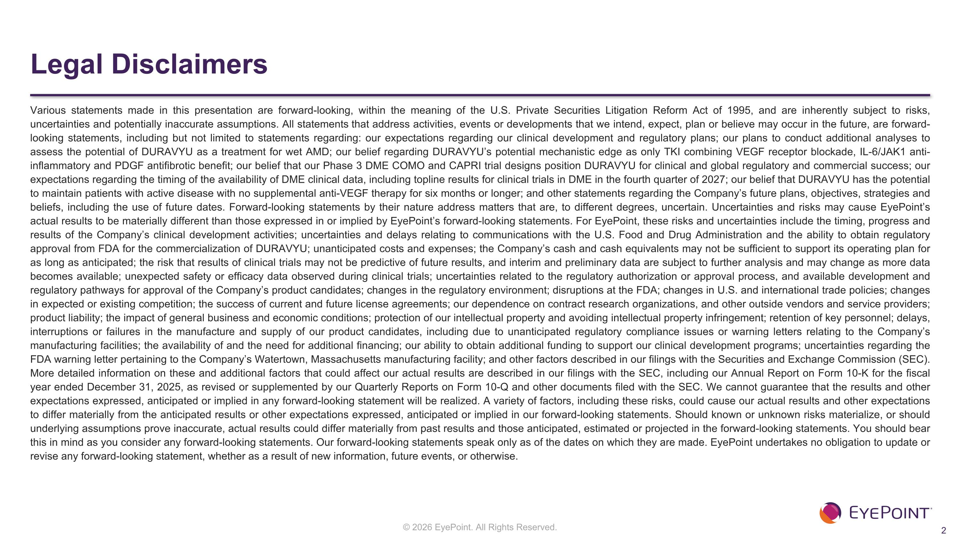
Legal Disclaimers Various statements made in this presentation are forward-looking, within the meaning of the U.S. Private Securities Litigation Reform Act of 1995, and are inherently subject to risks, uncertainties and potentially inaccurate assumptions. All statements that address activities, events or developments that we intend, expect, plan or believe may occur in the future, are forward-looking statements, including but not limited to statements regarding: our expectations regarding our clinical development and regulatory plans; our plans to conduct additional analyses to assess the potential of DURAVYU as a treatment for wet AMD; our belief regarding DURAVYU’s potential mechanistic edge as only TKI combining VEGF receptor blockade, IL-6/JAK1 anti-inflammatory and PDGF antifibrotic benefit; our belief that our Phase 3 DME COMO and CAPRI trial designs position DURAVYU for clinical and global regulatory and commercial success; our expectations regarding the timing of the availability of DME clinical data, including topline results for clinical trials in DME in the fourth quarter of 2027; our belief that DURAVYU has the potential to maintain patients with active disease with no supplemental anti-VEGF therapy for six months or longer; and other statements regarding the Company’s future plans, objectives, strategies and beliefs, including the use of future dates. Forward-looking statements by their nature address matters that are, to different degrees, uncertain. Uncertainties and risks may cause EyePoint’s actual results to be materially different than those expressed in or implied by EyePoint’s forward-looking statements. For EyePoint, these risks and uncertainties include the timing, progress and results of the Company’s clinical development activities; uncertainties and delays relating to communications with the U.S. Food and Drug Administration and the ability to obtain regulatory approval from FDA for the commercialization of DURAVYU; unanticipated costs and expenses; the Company’s cash and cash equivalents may not be sufficient to support its operating plan for as long as anticipated; the risk that results of clinical trials may not be predictive of future results, and interim and preliminary data are subject to further analysis and may change as more data becomes available; unexpected safety or efficacy data observed during clinical trials; uncertainties related to the regulatory authorization or approval process, and available development and regulatory pathways for approval of the Company’s product candidates; changes in the regulatory environment; disruptions at the FDA; changes in U.S. and international trade policies; changes in expected or existing competition; the success of current and future license agreements; our dependence on contract research organizations, and other outside vendors and service providers; product liability; the impact of general business and economic conditions; protection of our intellectual property and avoiding intellectual property infringement; retention of key personnel; delays, interruptions or failures in the manufacture and supply of our product candidates, including due to unanticipated regulatory compliance issues or warning letters relating to the Company’s manufacturing facilities; the availability of and the need for additional financing; our ability to obtain additional funding to support our clinical development programs; uncertainties regarding the FDA warning letter pertaining to the Company’s Watertown, Massachusetts manufacturing facility; and other factors described in our filings with the Securities and Exchange Commission (SEC). More detailed information on these and additional factors that could affect our actual results are described in our filings with the SEC, including our Annual Report on Form 10-K for the fiscal year ended December 31, 2025, as revised or supplemented by our Quarterly Reports on Form 10-Q and other documents filed with the SEC. We cannot guarantee that the results and other expectations expressed, anticipated or implied in any forward-looking statement will be realized. A variety of factors, including these risks, could cause our actual results and other expectations to differ materially from the anticipated results or other expectations expressed, anticipated or implied in our forward-looking statements. Should known or unknown risks materialize, or should underlying assumptions prove inaccurate, actual results could differ materially from past results and those anticipated, estimated or projected in the forward-looking statements. You should bear this in mind as you consider any forward-looking statements. Our forward-looking statements speak only as of the dates on which they are made. EyePoint undertakes no obligation to update or revise any forward-looking statement, whether as a result of new information, future events, or otherwise.


Introduction

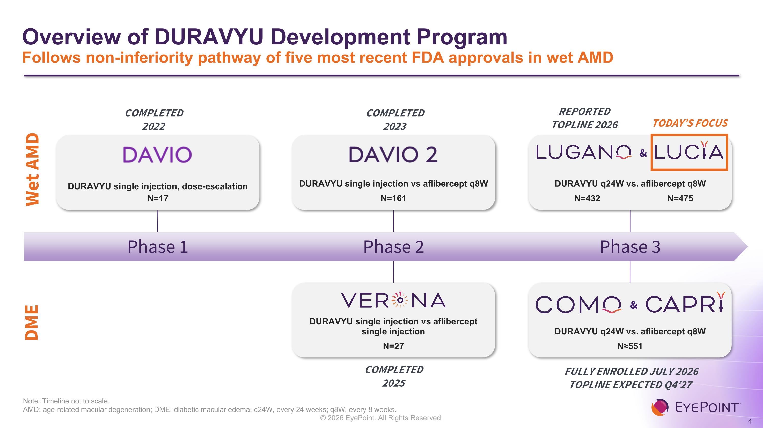
Overview of DURAVYU Development Program?Follows non-inferiority pathway of five most recent FDA approvals in wet AMD Note: Timeline not to scale.?AMD: age-related macular degeneration; DME: diabetic macular edema; q24W, every 24 weeks; q8W, every 8 weeks. Wet AMD DURAVYU single injection, dose-escalation N=17 Phase 1 COMPLETED 2022 DME Phase 2 COMPLETED 2023 COMPLETED?2025 DURAVYU single injection vs aflibercept single injection N=27 DURAVYU single injection vs aflibercept q8W N=161 Phase 3 FULLY ENROLLED JULY 2026?TOPLINE EXPECTED Q4’27 DURAVYU q24W vs. aflibercept q8W N≈551 & DURAVYU q24W vs. aflibercept q8W N=432 N=475 & REPORTED TOPLINE 2026 TODAY’S FOCUS

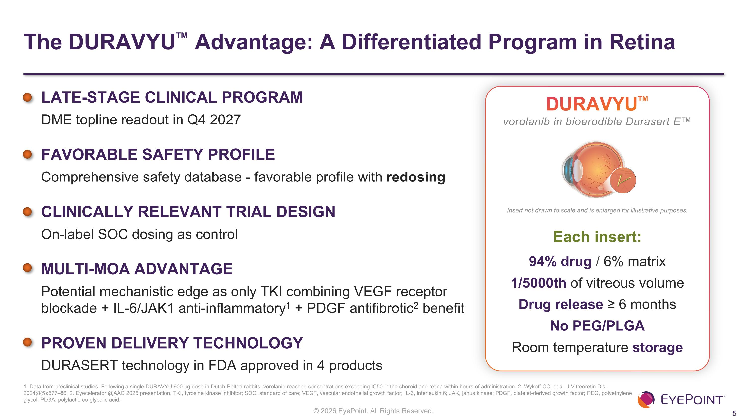
The DURAVYU Advantage: A Differentiated Program in Retina 1. Data from preclinical studies. Following a single DURAVYU 900 µg dose in Dutch-Belted rabbits, vorolanib reached concentrations exceeding IC50 in the choroid and retina within hours of administration. 2. Wykoff CC, et al. J Vitreoretin Dis. 2024;8(5):577–86. 2. Eyecelerator @AAO 2025 presentation. TKI, tyrosine kinase inhibitor; SOC, standard of care; VEGF, vascular endothelial growth factor; IL-6, interleukin 6; JAK, janus kinase; PDGF, platelet-derived growth factor; PEG, polyethylene glycol; PLGA, polylactic-co-glycolic acid. LATE-STAGE CLINICAL PROGRAM DME topline readout in Q4 2027 FAVORABLE SAFETY PROFILE Comprehensive safety database - favorable profile with redosing CLINICALLY RELEVANT TRIAL DESIGN On-label SOC dosing as control MULTI-MOA ADVANTAGE Potential mechanistic edge as only TKI combining VEGF receptor blockade + IL-6/JAK1 anti-inflammatory1 + PDGF antifibrotic2 benefit PROVEN DELIVERY TECHNOLOGY DURASERT technology in FDA approved in 4 products DURAVYU vorolanib in bioerodible Durasert E Each insert: 94% drug / 6% matrix 1/5000th of vitreous volume Drug release ≥ 6 months No PEG/PLGA Room temperature storage Insert not drawn to scale and is enlarged for illustrative purposes.

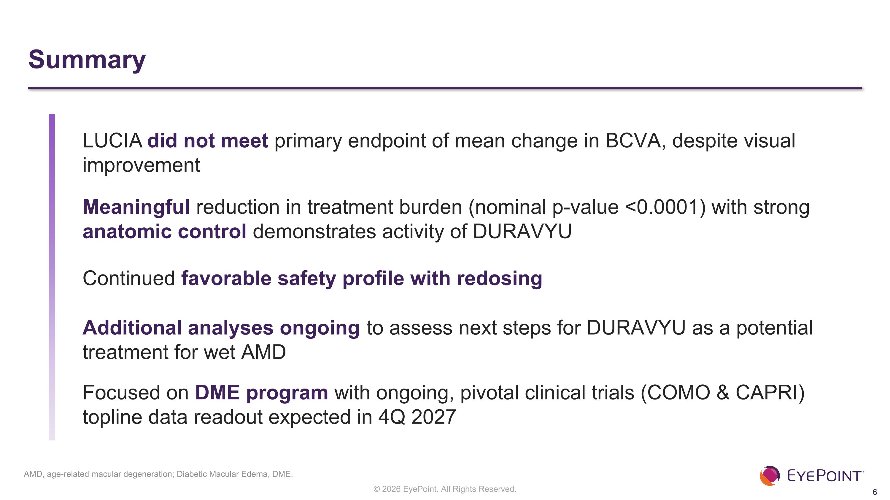
Summary AMD, age-related macular degeneration; Diabetic Macular Edema, DME. LUCIA did not meet primary endpoint of mean change in BCVA, despite visual improvement Meaningful reduction in treatment burden (nominal p-value <0.0001) with strong anatomic control demonstrates activity of DURAVYU Continued favorable safety profile with redosing Additional analyses ongoing to assess next steps for DURAVYU as a potential treatment for wet AMD Focused on DME program with ongoing, pivotal clinical trials (COMO & CAPRI) topline data readout expected in 4Q 2027

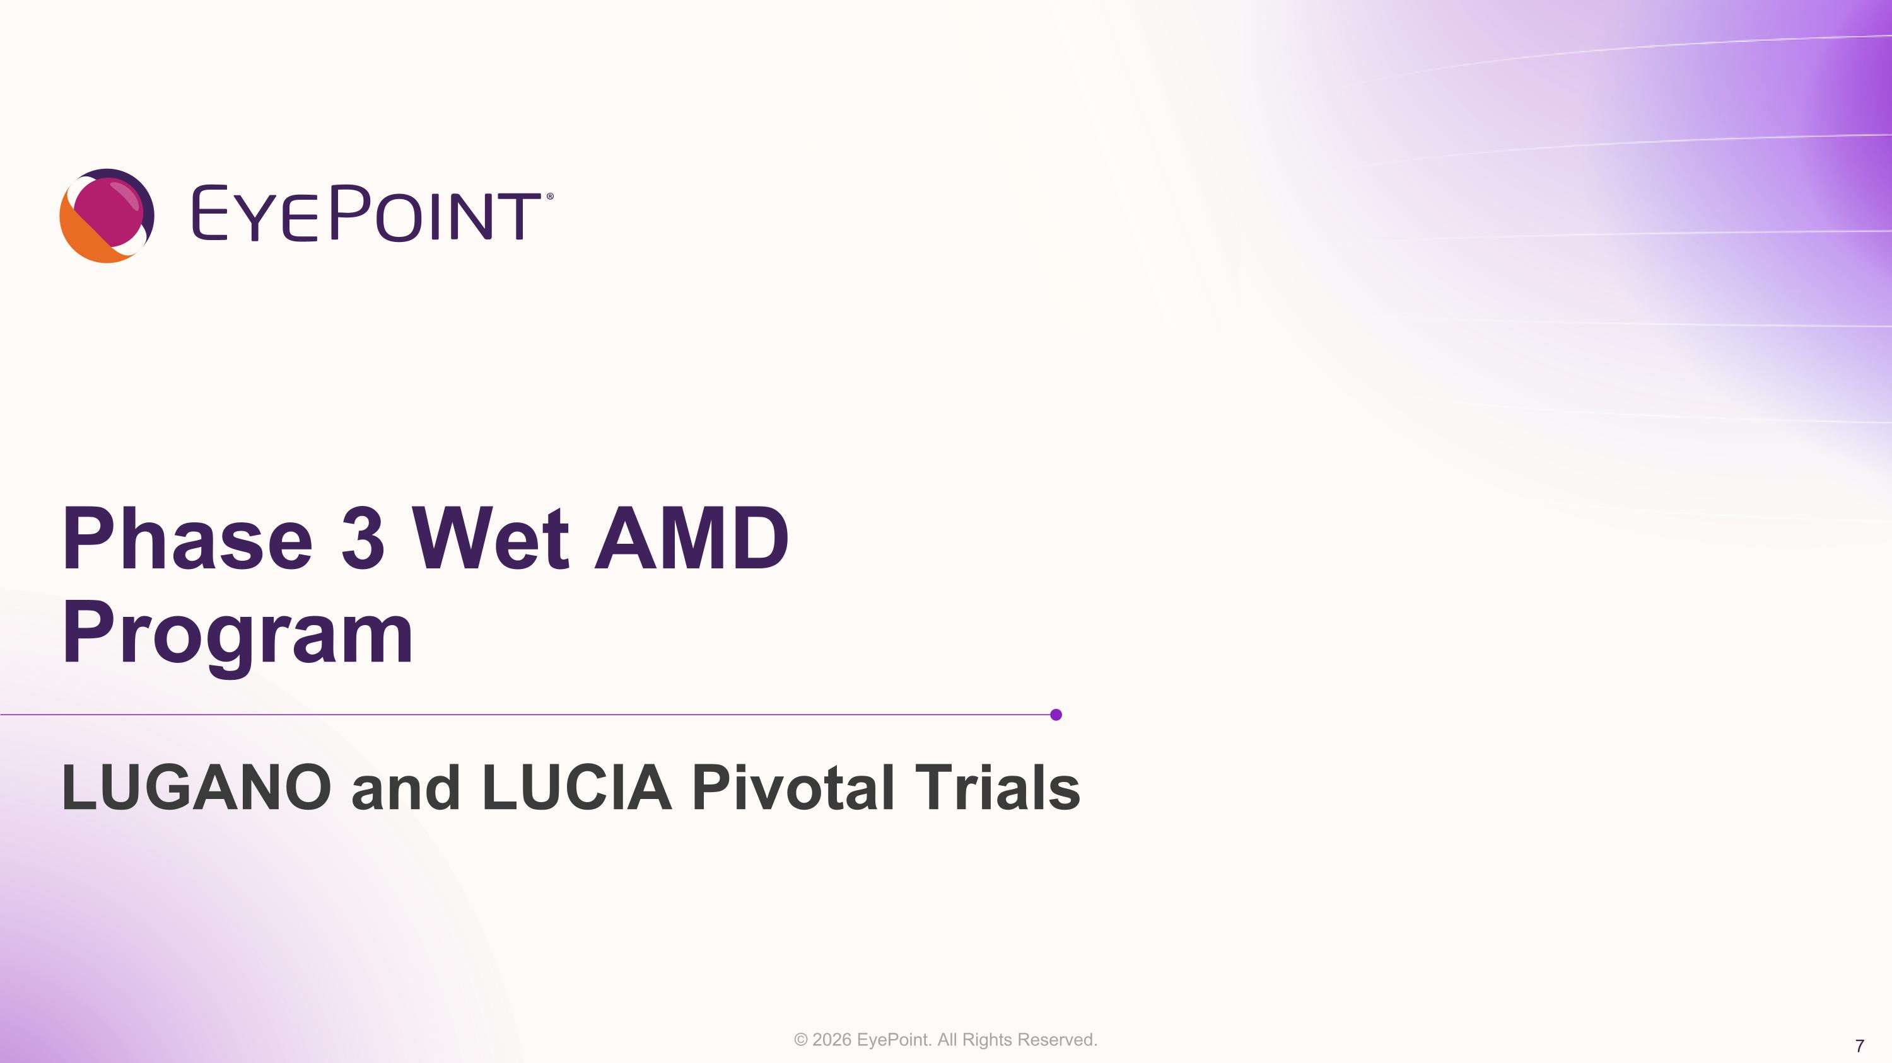
Phase 3 Wet AMD Program LUGANO and LUCIA Pivotal Trials

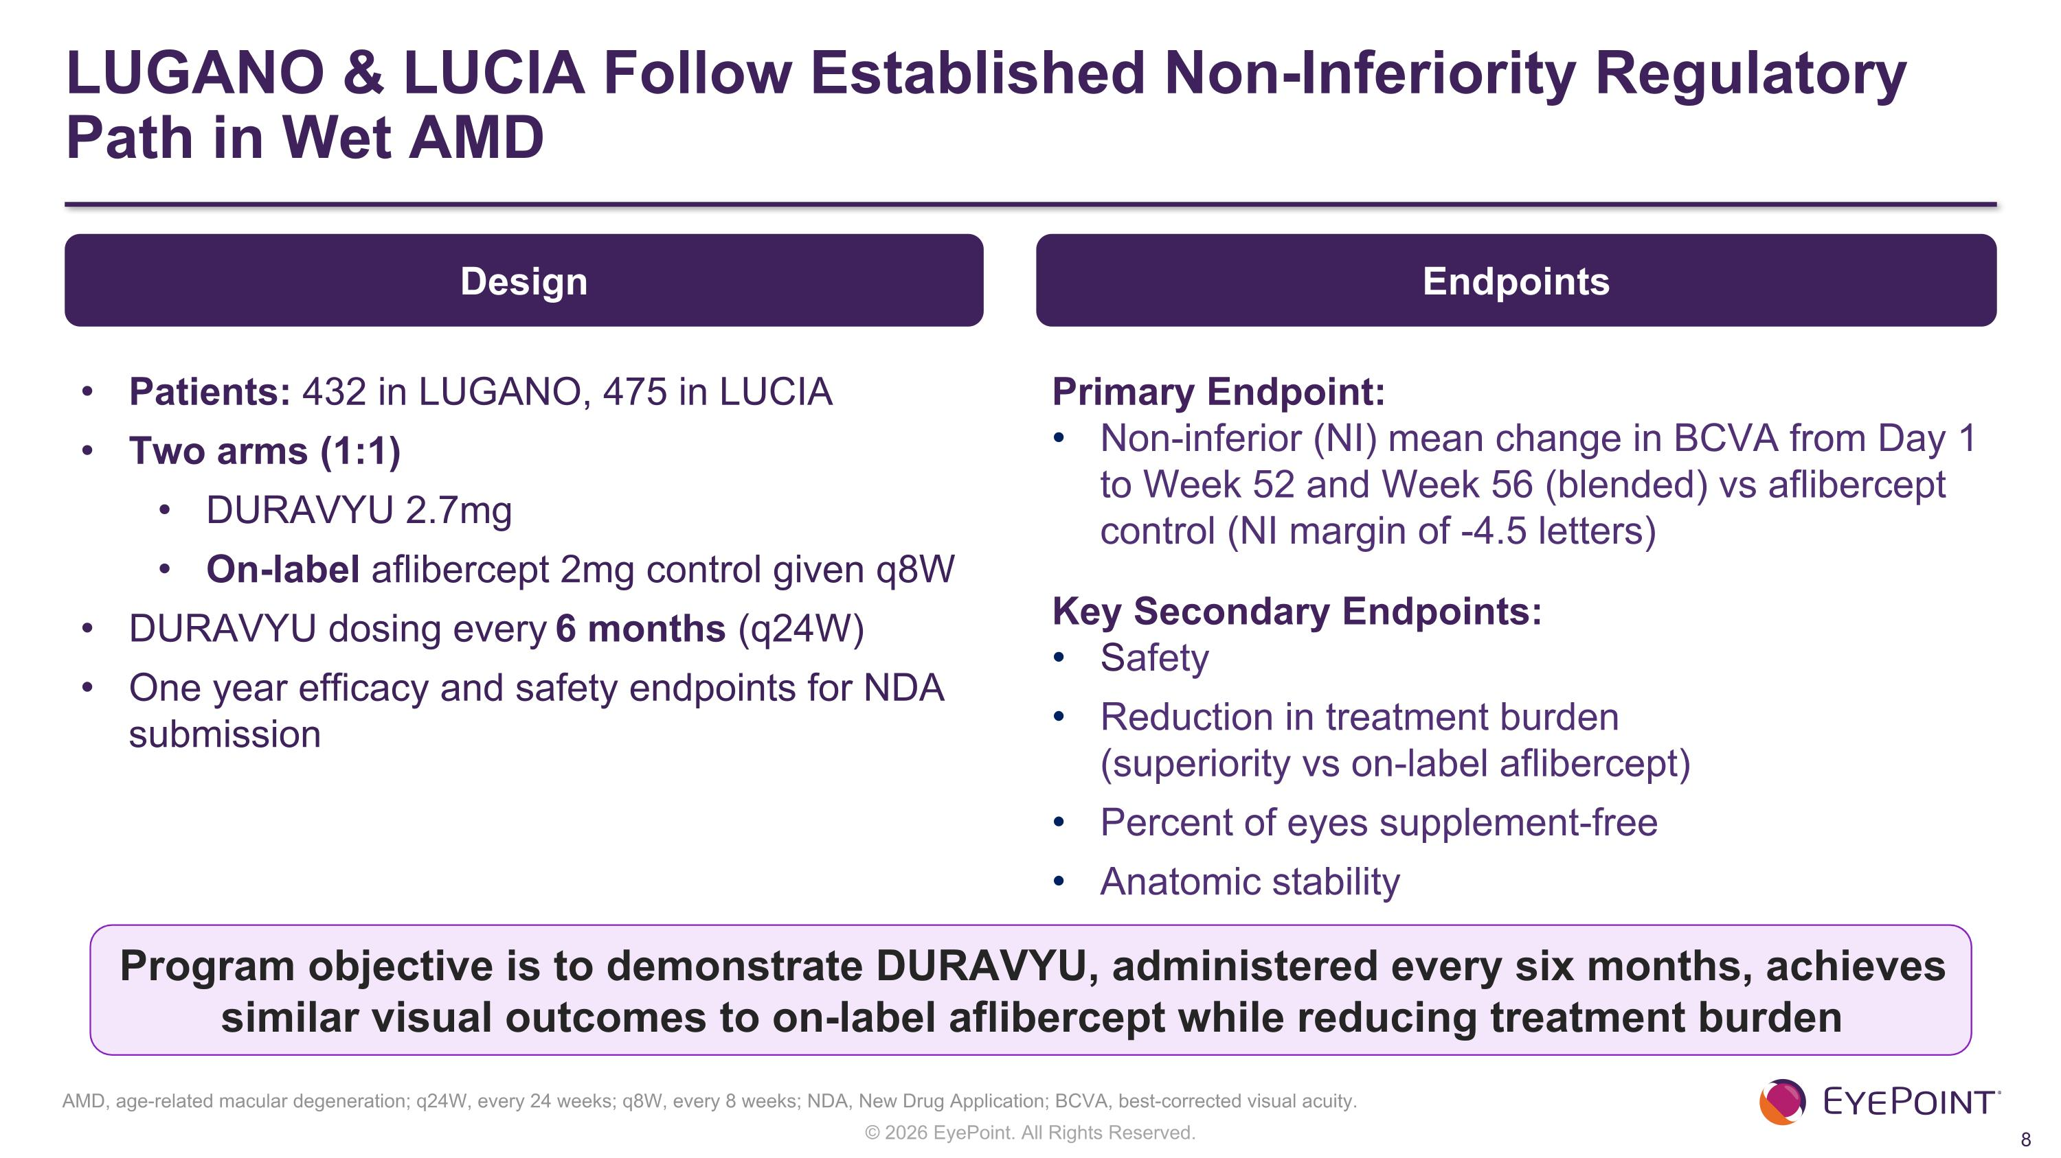
LUGANO & LUCIA Follow Established Non-Inferiority Regulatory Path in Wet AMD Endpoints Primary Endpoint: Non-inferior (NI) mean change in BCVA from Day 1 to Week 52 and Week 56 (blended) vs aflibercept control (NI margin of -4.5 letters) Key Secondary Endpoints: Safety Reduction in treatment burden ?(superiority vs on-label aflibercept) Percent of eyes supplement-free Anatomic stability Program objective is to demonstrate DURAVYU, administered every six months, achieves similar visual outcomes to on-label aflibercept while reducing treatment burden Design Patients: 432 in LUGANO, 475 in LUCIA Two arms (1:1) DURAVYU 2.7mg On-label aflibercept 2mg control given q8W DURAVYU dosing every 6 months (q24W) One year efficacy and safety endpoints for NDA submission AMD, age-related macular degeneration; q24W, every 24 weeks; q8W, every 8 weeks; NDA, New Drug Application; BCVA, best-corrected visual acuity.

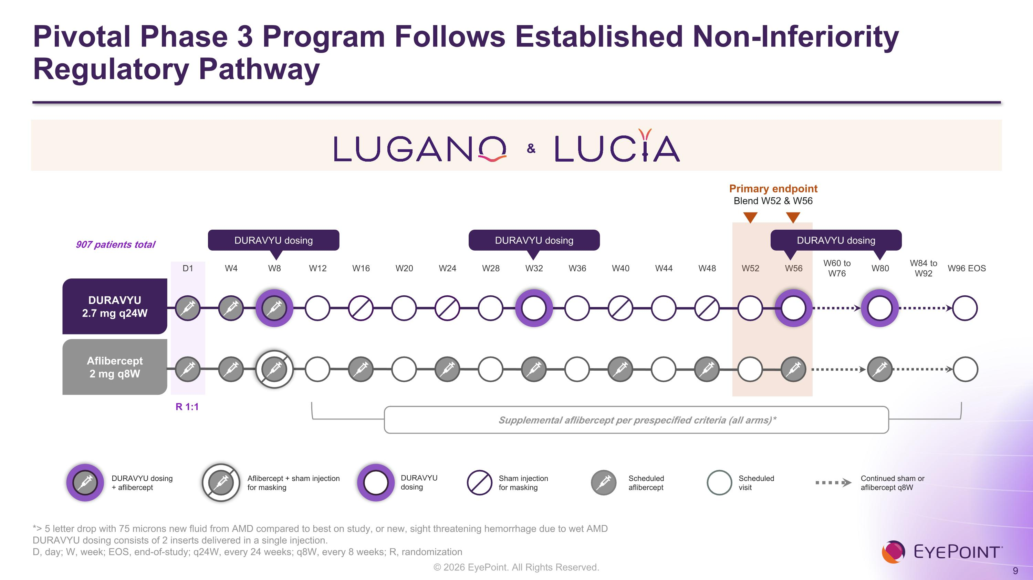
Pivotal Phase 3 Program Follows Established Non-Inferiority Regulatory Pathway *> 5 letter drop with 75 microns new fluid from AMD compared to best on study, or new, sight threatening hemorrhage due to wet AMD DURAVYU dosing consists of 2 inserts delivered in a single injection. D, day; W, week; EOS, end-of-study; q24W, every 24 weeks; q8W, every 8 weeks; R, randomization D1 W4 W8 W12 W16 W20 W24 W28 W32 W36 W40 W44 W48 W52 W56 W60 to W76 W80 W84 to W92 W96 EOS Primary endpoint Blend W52 & W56 DURAVYU 2.7 mg q24W Aflibercept 2 mg q8W DURAVYU dosing DURAVYU dosing DURAVYU dosing 907 patients total R 1:1 Supplemental aflibercept per prespecified criteria (all arms)* Scheduled?aflibercept Scheduled?visit Sham injection?for masking Continued sham or?aflibercept q8W DURAVYU dosing?+ aflibercept Aflibercept + sham injection for masking DURAVYU?dosing &


LUCIA Topline Results Baseline Characteristics

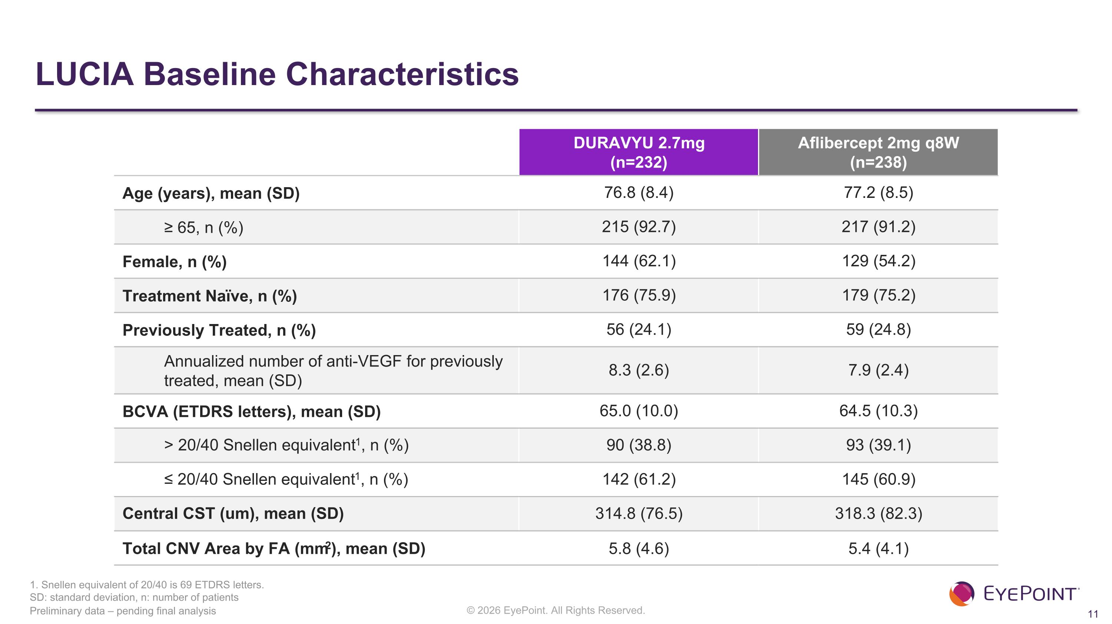
LUCIA Baseline Characteristics Preliminary data – pending final analysis DURAVYU 2.7mg (n=232) Aflibercept 2mg q8W (n=238) Age (years), mean (SD) 76.8 (8.4)​ 77.2 (8.5)​ ≥ 65, n (%) 215 (92.7)​ 217 (91.2)​ Female, n (%) 144 (62.1)​ 129 (54.2)​ Treatment Naïve, n (%) 176 (75.9)​ 179 (75.2)​ Previously Treated, n (%) 56 (24.1)​ 59 (24.8)​ Annualized number of anti-VEGF for previously treated, mean (SD)​ 8.3 (2.6)​ 7.9 (2.4)​ BCVA (ETDRS letters), mean (SD) 65.0 (10.0)​ 64.5 (10.3)​ > 20/40 Snellen equivalent1, n (%)​ 90 (38.8)​ 93 (39.1)​ ≤ 20/40 Snellen equivalent1, n (%)​ 142 (61.2)​ 145 (60.9)​ Central CST (um), mean (SD)​ 314.8 (76.5)​ 318.3 (82.3)​ Total CNV Area by FA (mm2), mean (SD) 5.8 (4.6) 5.4 (4.1) 1. Snellen equivalent of 20/40 is 69 ETDRS letters. SD: standard deviation, n: number of patients


LUCIA Topline Results Visual Acuity

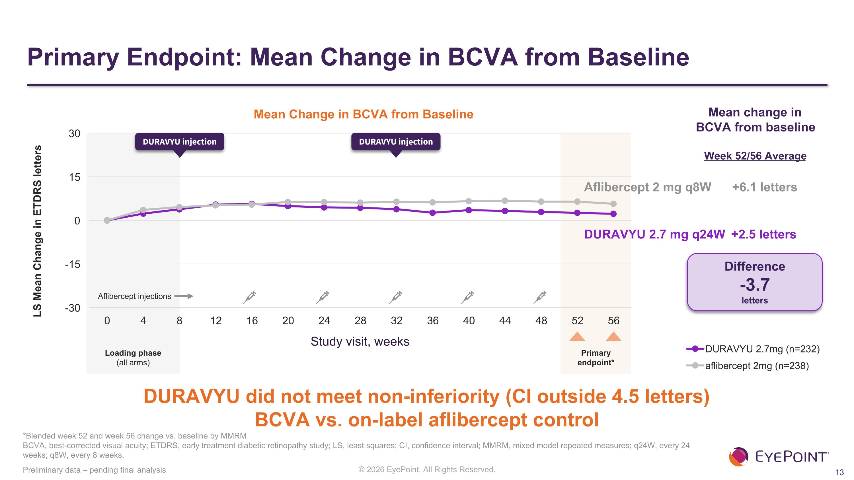
Primary Endpoint: Mean Change in BCVA from Baseline Preliminary data – pending final analysis LS Mean Change in ETDRS letters Mean Change in BCVA from Baseline Study visit, weeks Aflibercept 2 mg q8W +6.1 letters DURAVYU 2.7 mg q24W +2.5 letters Difference -3.7 letters *Blended week 52 and week 56 change vs. baseline by MMRM?BCVA, best-corrected visual acuity; ETDRS, early treatment diabetic retinopathy study; LS, least squares; CI, confidence interval; MMRM, mixed model repeated measures; q24W, every 24 weeks; q8W, every 8 weeks. DURAVYU did not meet non-inferiority (CI outside 4.5 letters)?BCVA vs. on-label aflibercept control Loading phase (all arms) DURAVYU injection DURAVYU injection Primary ?endpoint* Mean change in BCVA from baseline Week 52/56 Average Aflibercept injections


LUCIA Topline Results Reduction in Treatment Burden & Supplement-Free Rates

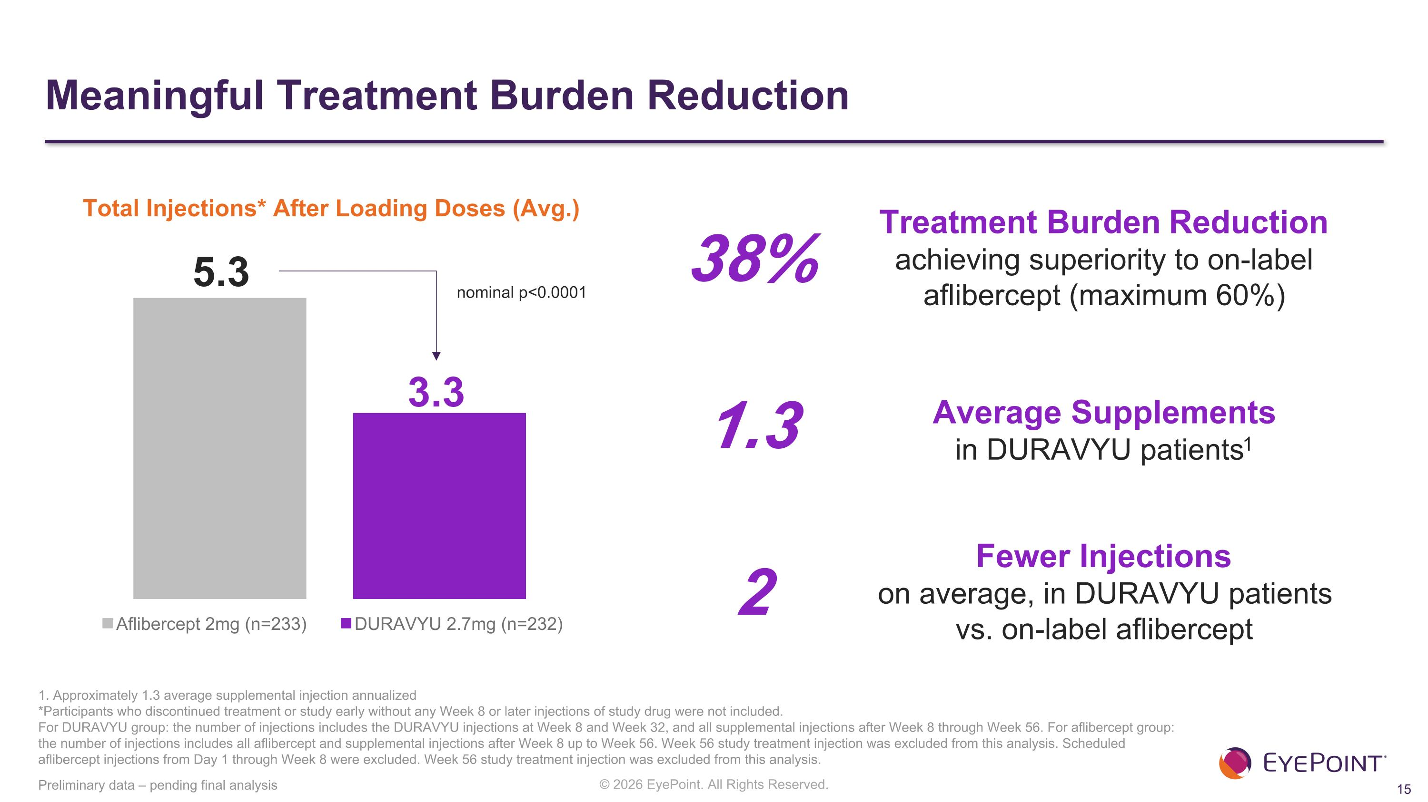
Average Supplements ?in DURAVYU patients1 Meaningful Treatment Burden Reduction Preliminary data – pending final analysis Total Injections* After Loading Doses (Avg.) 1. Approximately 1.3 average supplemental injection annualized *Participants who discontinued treatment or study early without any Week 8 or later injections of study drug were not included.​ For DURAVYU group: the number of injections includes the DURAVYU injections at Week 8 and Week 32, and all supplemental injections after Week 8 through Week 56. For aflibercept group: the number of injections includes all aflibercept and supplemental injections after Week 8 up to Week 56. Week 56 study treatment injection was excluded from this analysis.​ Scheduled aflibercept injections from Day 1 through Week 8 were excluded. Week 56 study treatment injection was excluded from this analysis.​ 5.3 3.3 Treatment Burden Reduction ?achieving superiority to on-label ?aflibercept (maximum 60%) 38% Fewer Injections ?on average, in DURAVYU patients ?vs. on-label aflibercept 1.3 2 nominal p<0.0001

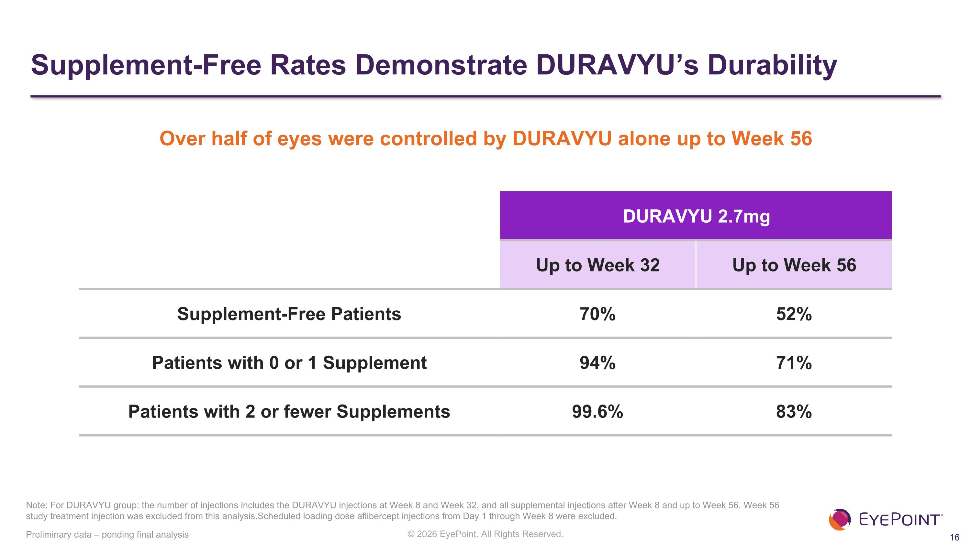
Supplement-Free Rates Demonstrate DURAVYU’s Durability Preliminary data – pending final analysis DURAVYU 2.7mg Up to Week 32 Up to Week 56 Supplement-Free Patients 70% 52% Patients with 0 or 1 Supplement 94% 71% Patients with 2 or fewer Supplements 99.6% 83% Note: For DURAVYU group: the number of injections includes the DURAVYU injections at Week 8 and Week 32, and all supplemental injections after Week 8 and up to Week 56. Week 56 study treatment injection was excluded from this analysis.​Scheduled loading dose aflibercept injections from Day 1 through Week 8 were excluded. Over half of eyes were controlled by DURAVYU alone up to Week 56


LUCIA Topline Results Anatomic Control

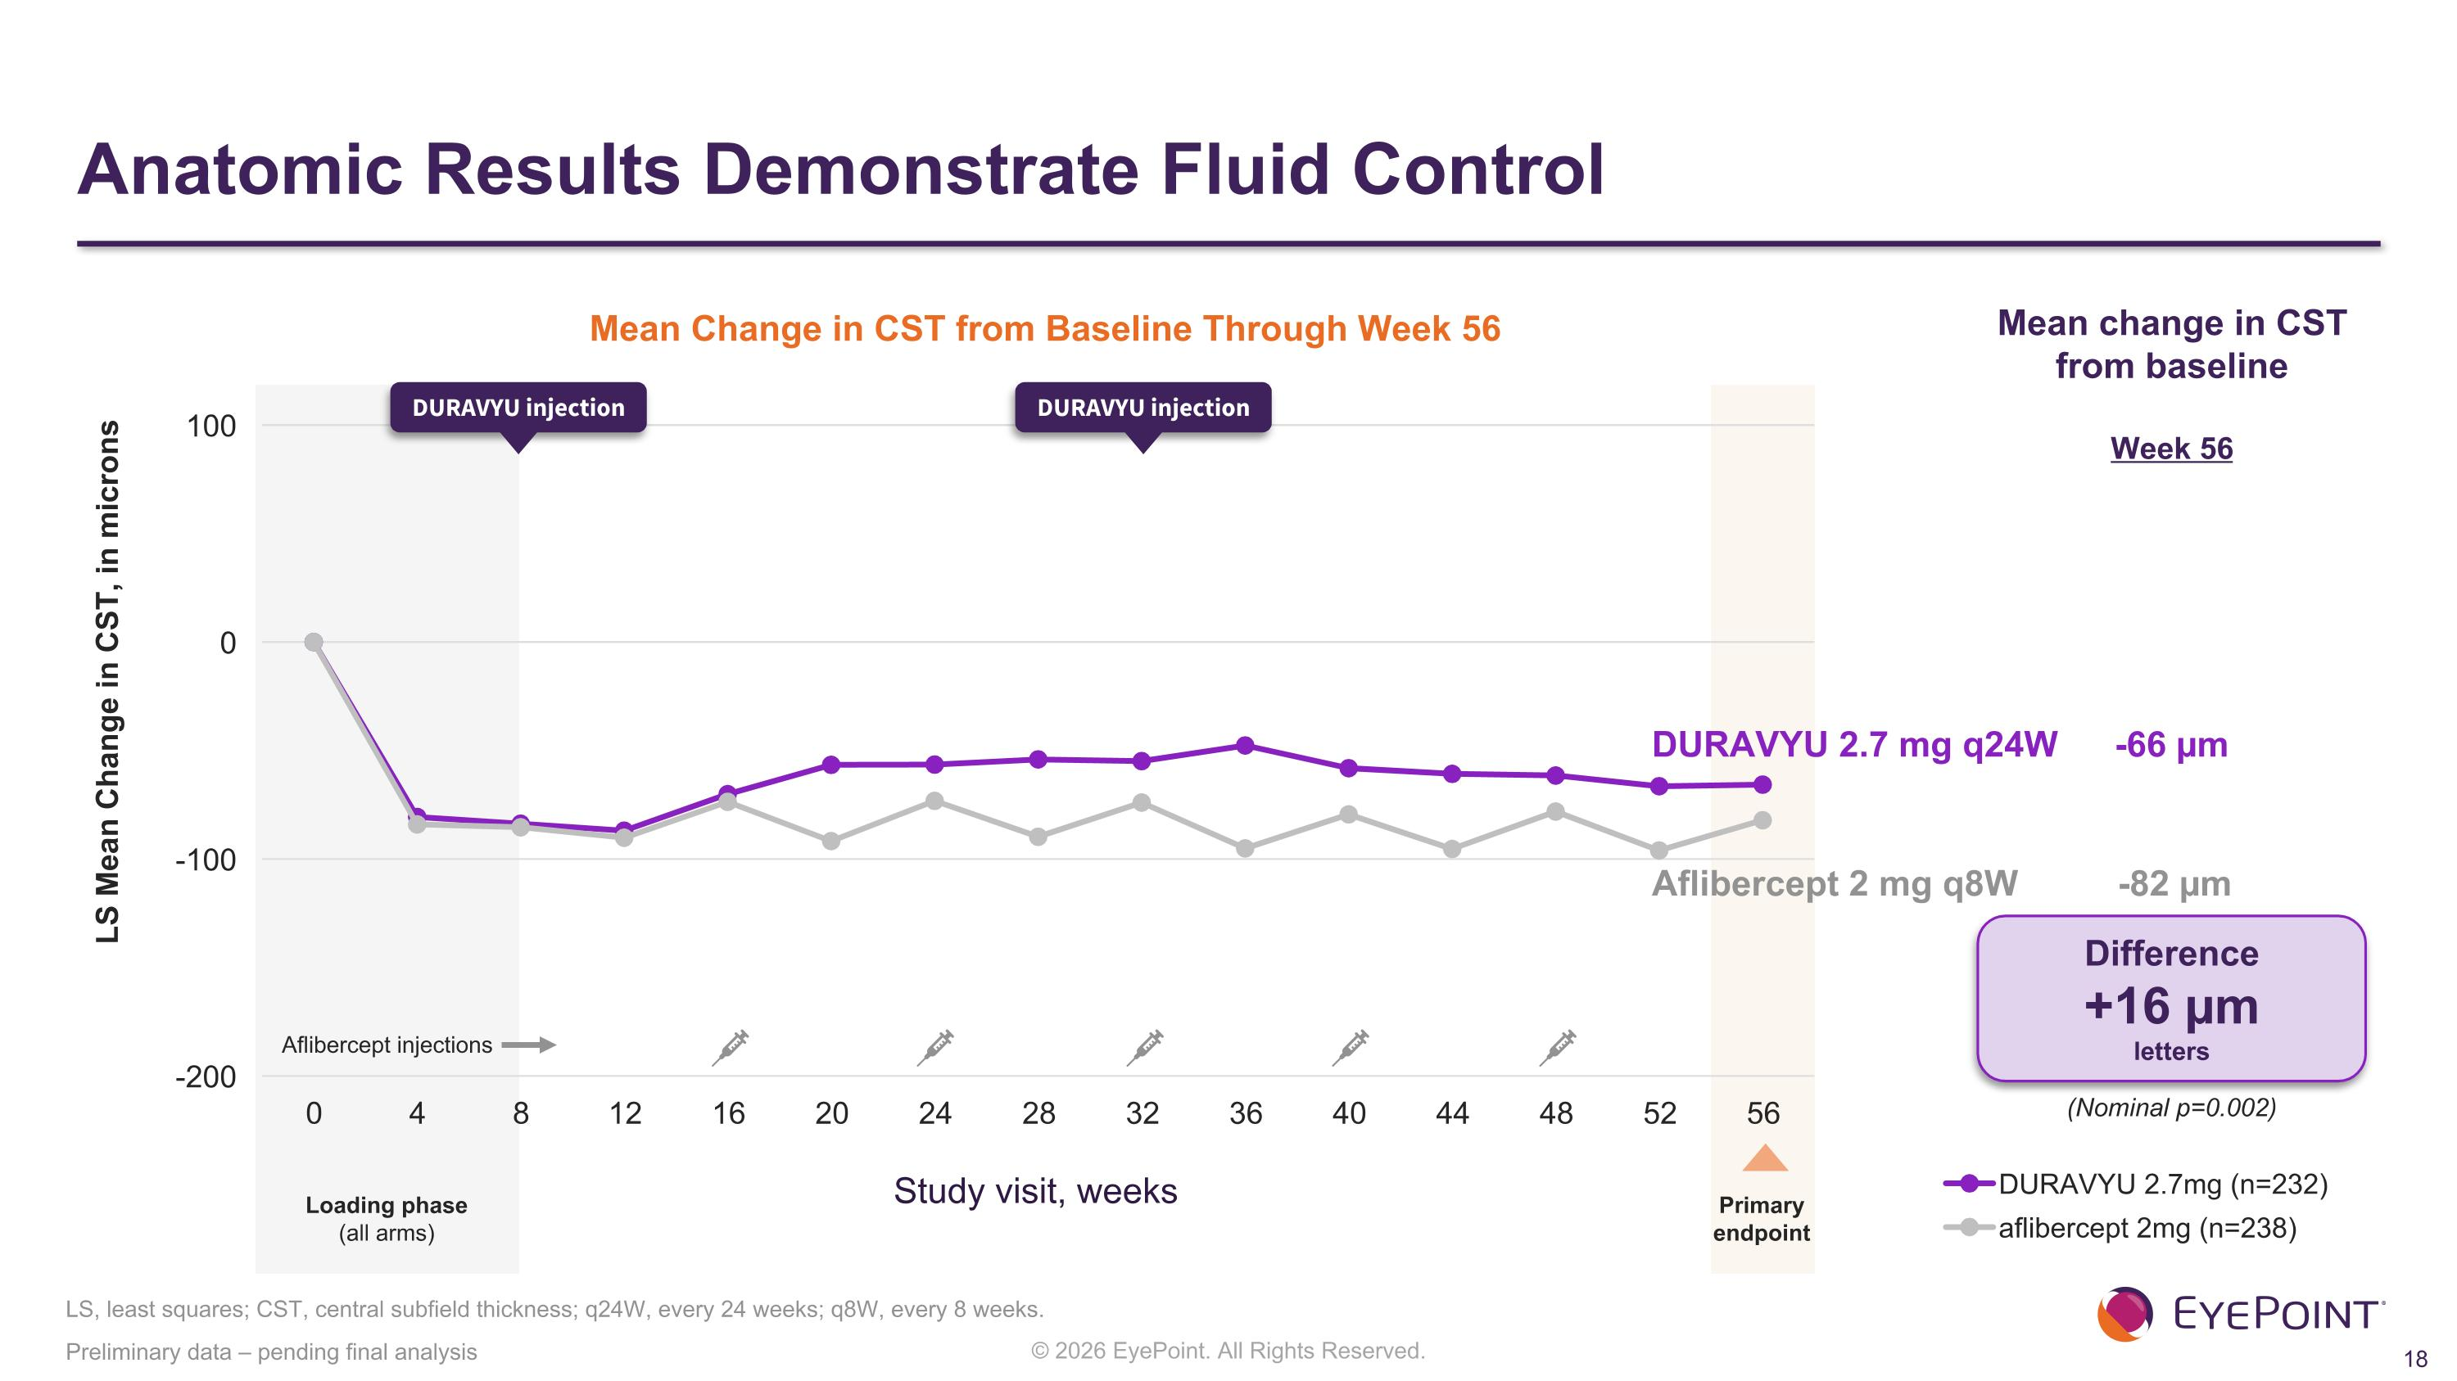
Anatomic Results Demonstrate Fluid Control LS, least squares; CST, central subfield thickness; q24W, every 24 weeks; q8W, every 8 weeks. Preliminary data – pending final analysis LS Mean Change in CST, in microns Mean Change in CST from Baseline Through Week 56 Study visit, weeks Aflibercept 2 mg q8W -82 µm DURAVYU 2.7 mg q24W -66 µm Difference +16 µm letters Loading phase (all arms) DURAVYU injection DURAVYU injection Primary ?endpoint Mean change in CST from baseline Week 56 Aflibercept injections (Nominal p=0.002​)


LUCIA Topline Results Safety Data

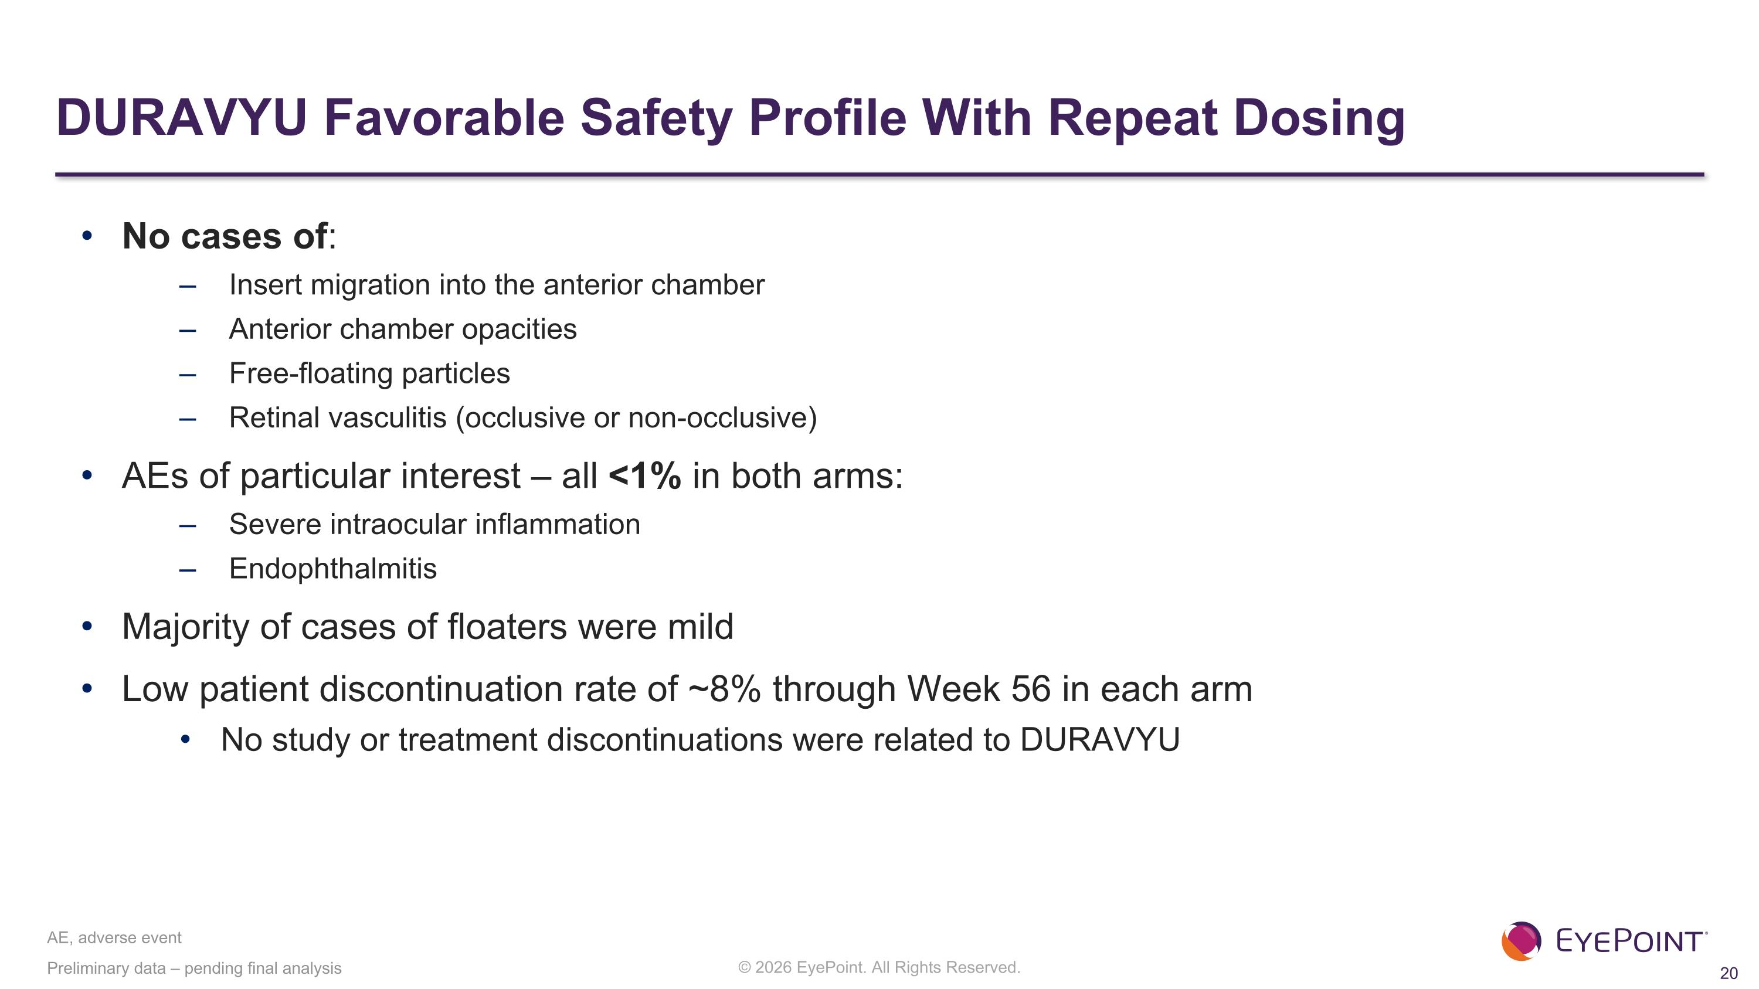
DURAVYU Favorable Safety Profile With Repeat Dosing No cases of: Insert migration into the anterior chamber Anterior chamber opacities Free-floating particles Retinal vasculitis (occlusive or non-occlusive) AEs of particular interest – all <1% in both arms: Severe intraocular inflammation Endophthalmitis Majority of cases of floaters were mild Low patient discontinuation rate of ~8% through Week 56 in each arm No study or treatment discontinuations were related to DURAVYU Preliminary data – pending final analysis AE, adverse event

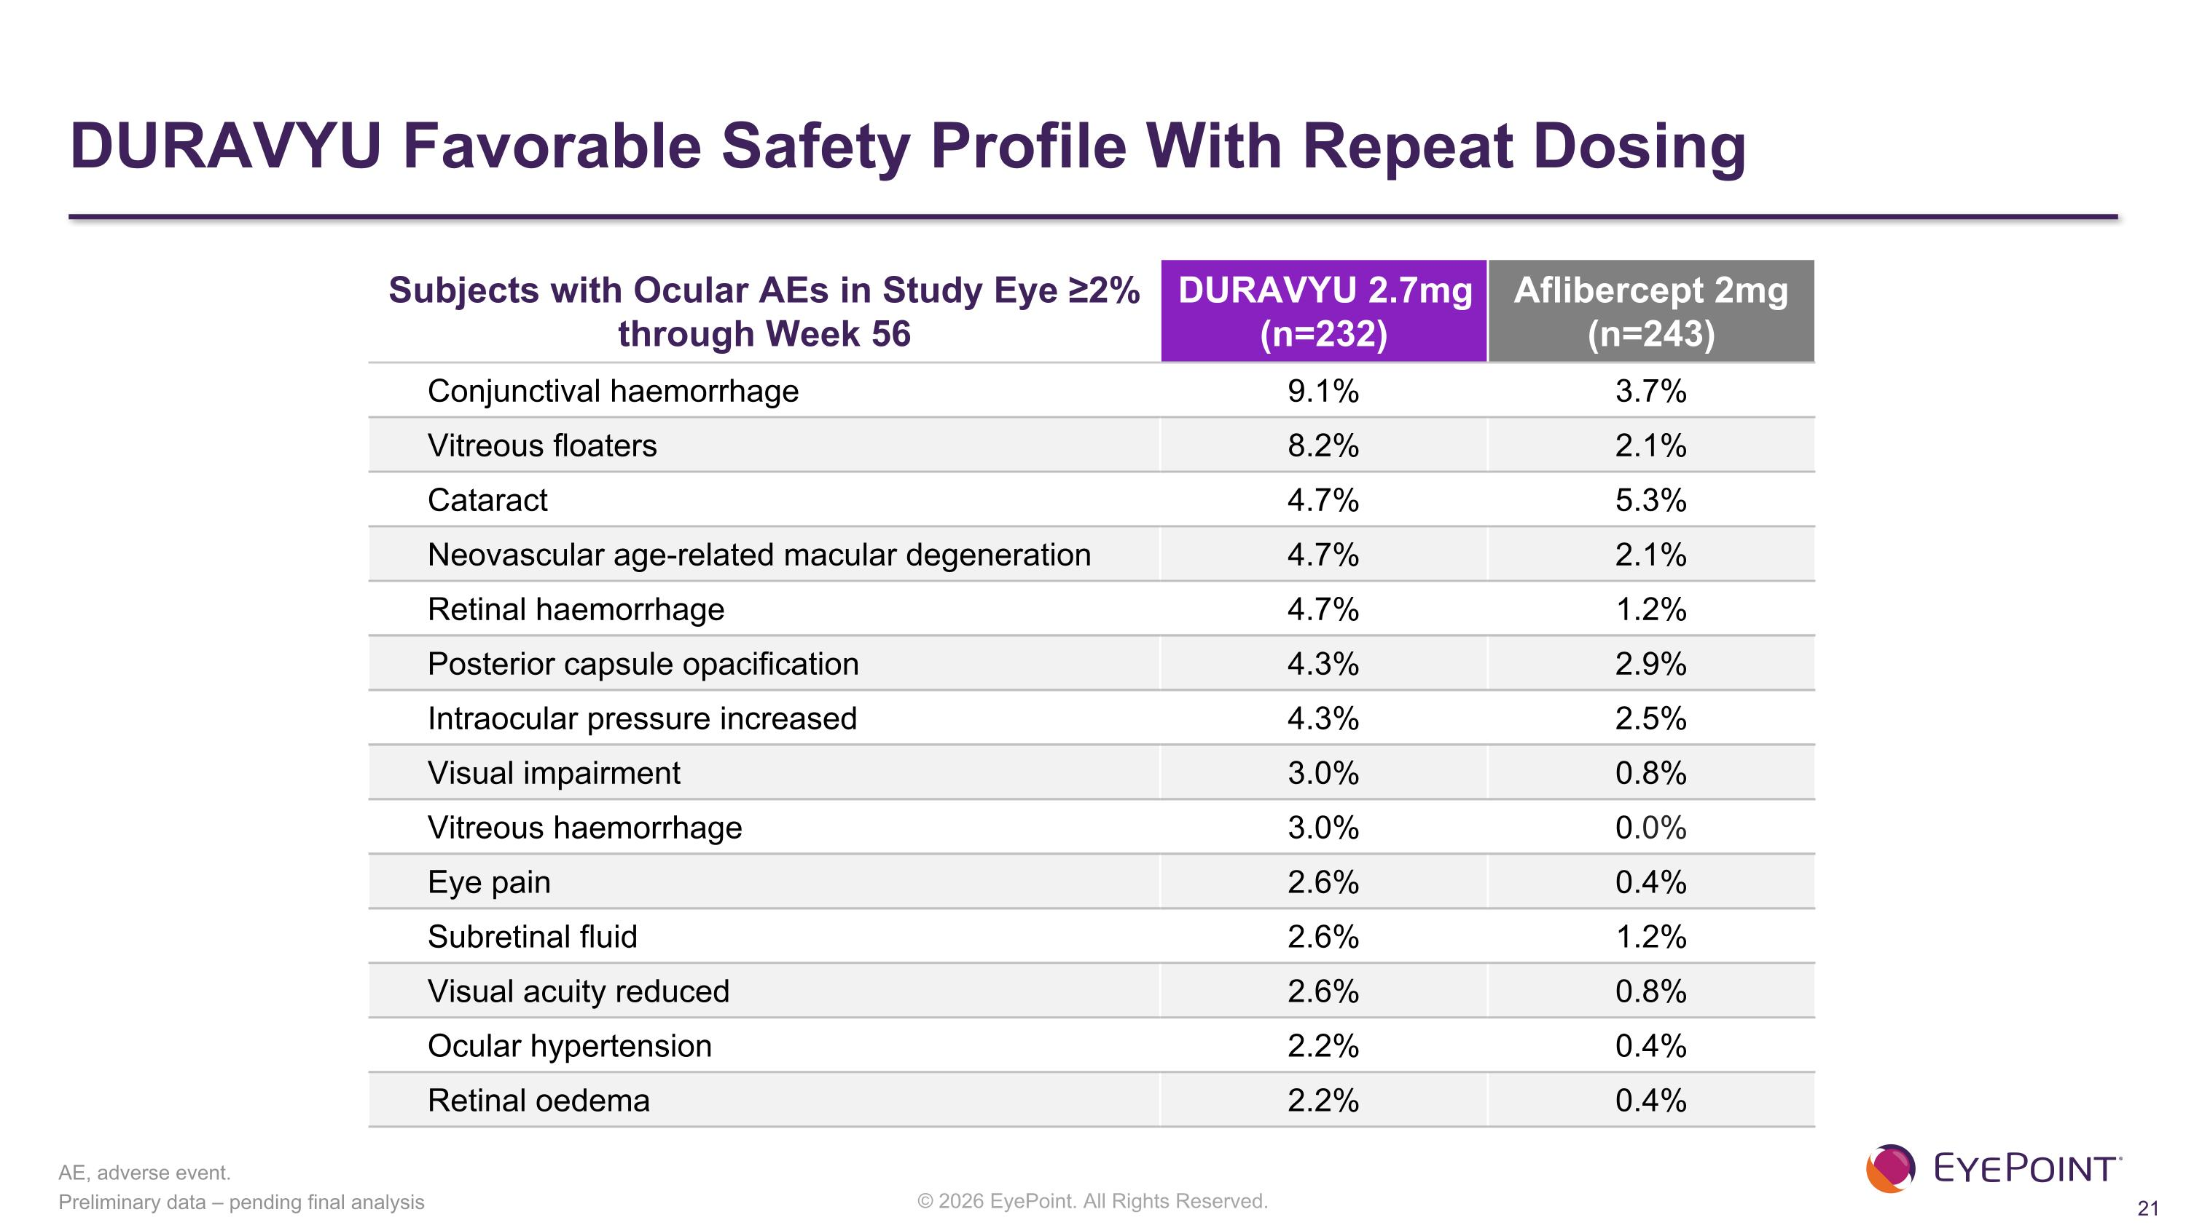
Subjects with Ocular AEs in Study Eye ≥2% through Week 56 DURAVYU 2.7mg (n=232) Aflibercept 2mg (n=243) Conjunctival haemorrhage​ 9.1%​ 3.7%​ Vitreous floaters​ 8.2%​ 2.1%​ Cataract​ 4.7%​ 5.3%​ Neovascular age-related macular degeneration​ 4.7%​ 2.1%​ Retinal haemorrhage​ 4.7%​ 1.2%​ Posterior capsule opacification​ 4.3%​ 2.9%​ Intraocular pressure increased​ 4.3%​ 2.5%​ Visual impairment​ 3.0%​ 0.8%​ Vitreous haemorrhage​ 3.0%​ 0​.0% Eye pain​ 2.6%​ 0.4%​ Subretinal fluid​ 2.6%​ 1.2%​ Visual acuity reduced​ 2.6%​ 0.8%​ Ocular hypertension​ 2.2%​ 0.4%​ Retinal oedema​ 2.2%​ 0.4%​ Preliminary data – pending final analysis AE, adverse event. DURAVYU Favorable Safety Profile With Repeat Dosing


Pooled Results LUGANO and LUCIA

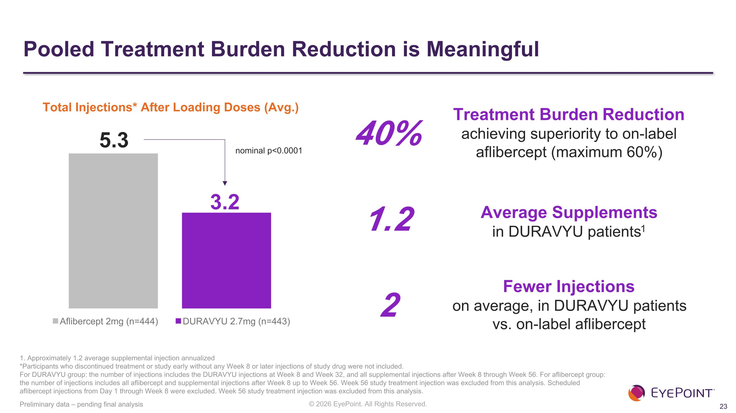
Average Supplements ?in DURAVYU patients1 Pooled Treatment Burden Reduction is Meaningful Preliminary data – pending final analysis Total Injections* After Loading Doses (Avg.) 5.3 3.2 Treatment Burden Reduction ?achieving superiority to on-label ?aflibercept (maximum 60%) 40% Fewer Injections ?on average, in DURAVYU patients ?vs. on-label aflibercept 1.2 2 nominal p<0.0001 1. Approximately 1.2 average supplemental injection annualized *Participants who discontinued treatment or study early without any Week 8 or later injections of study drug were not included.​ For DURAVYU group: the number of injections includes the DURAVYU injections at Week 8 and Week 32, and all supplemental injections after Week 8 through Week 56. For aflibercept group: the number of injections includes all aflibercept and supplemental injections after Week 8 up to Week 56. Week 56 study treatment injection was excluded from this analysis.​ Scheduled aflibercept injections from Day 1 through Week 8 were excluded. Week 56 study treatment injection was excluded from this analysis.​

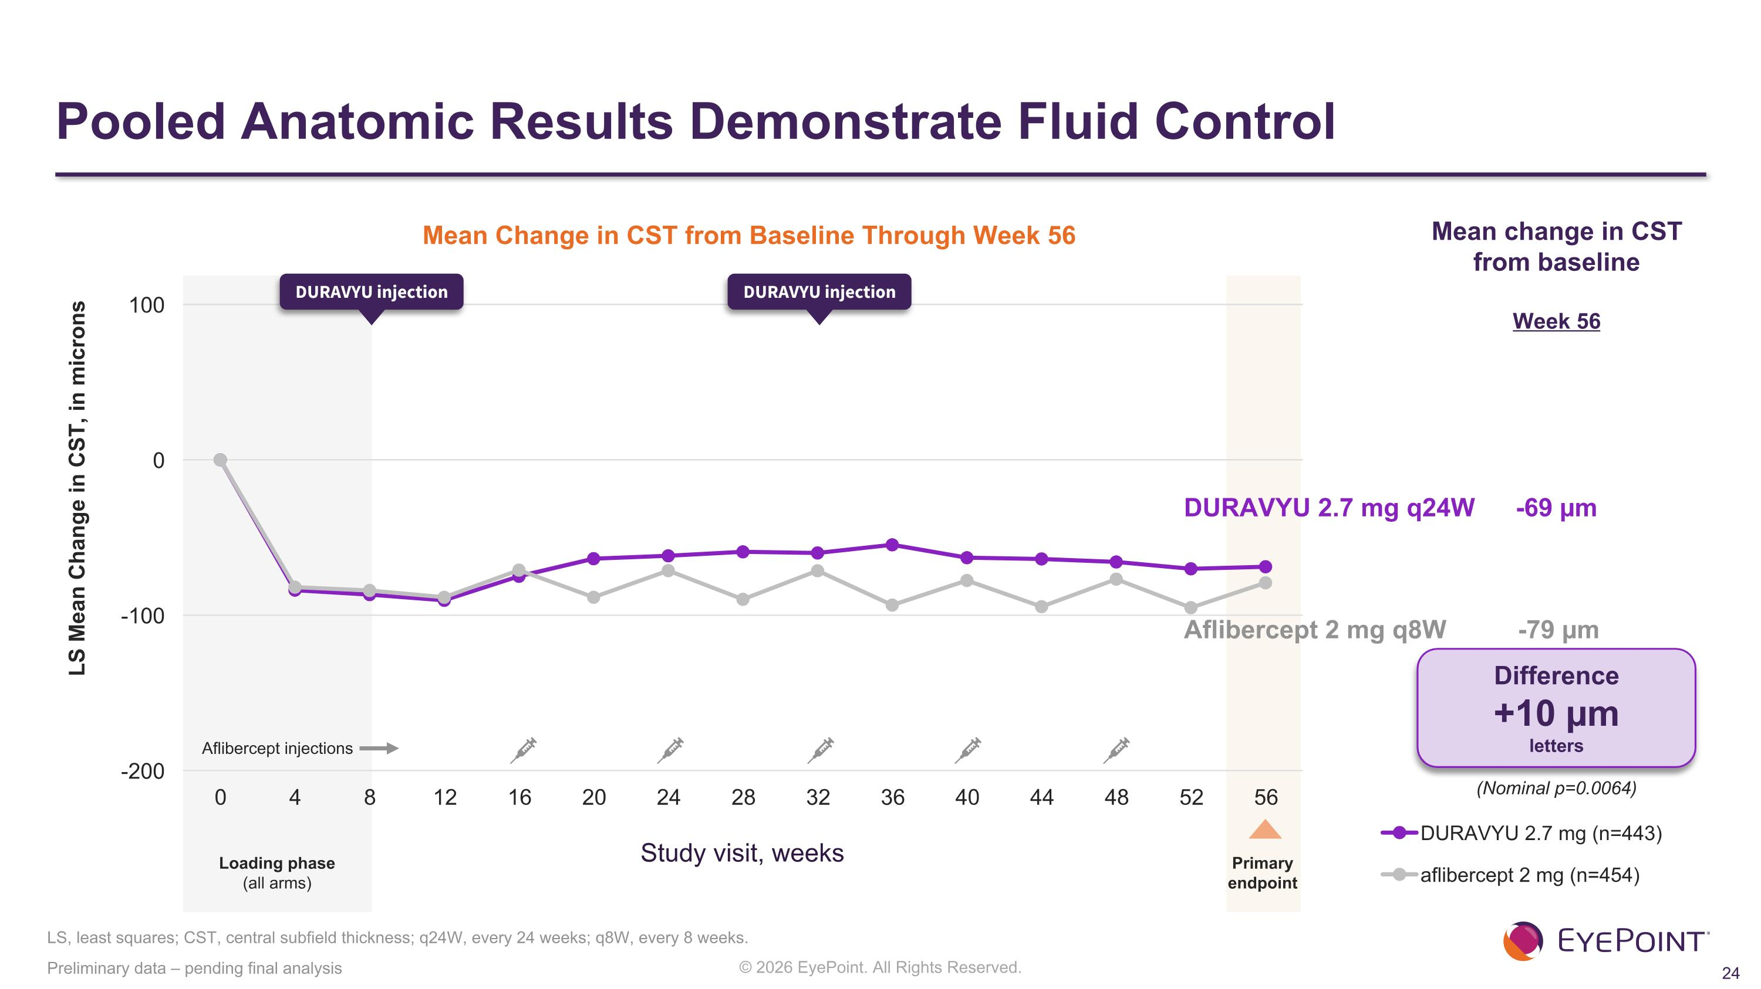
Pooled Anatomic Results Demonstrate Fluid Control Preliminary data – pending final analysis LS Mean Change in CST, in microns Mean Change in CST from Baseline Through Week 56 Study visit, weeks Aflibercept 2 mg q8W -79 µm DURAVYU 2.7 mg q24W -69 µm Difference +10 µm letters Loading phase (all arms) DURAVYU injection DURAVYU injection Mean change in CST from baseline Week 56 Aflibercept injections (Nominal p=0.0064​) LS, least squares; CST, central subfield thickness; q24W, every 24 weeks; q8W, every 8 weeks. Primary ?endpoint

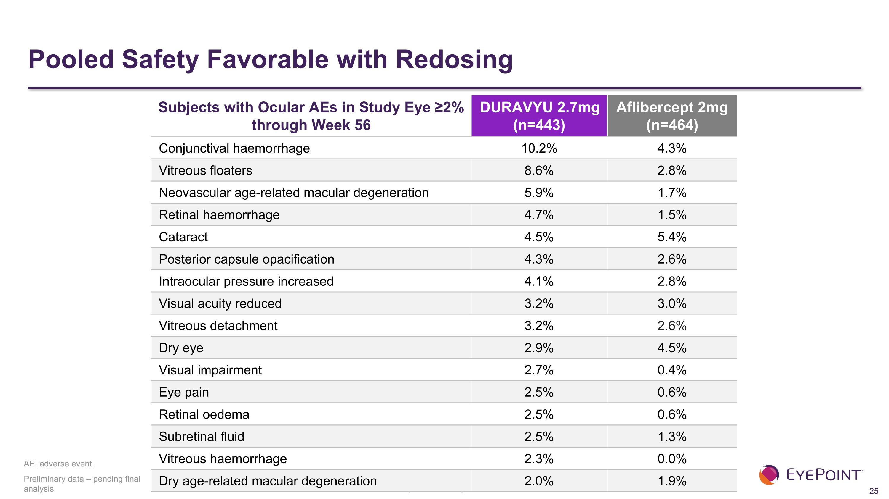
Preliminary data – pending final analysis Subjects with Ocular AEs in Study Eye ≥2% through Week 56 DURAVYU 2.7mg (n=443) Aflibercept 2mg (n=464) Conjunctival haemorrhage 10.2%​ 4.3%​ Vitreous floaters 8.6%​ 2.8%​ Neovascular age-related macular degeneration 5.9%​ 1.7%​ Retinal haemorrhage 4.7%​ 1.5%​ Cataract 4.5%​ 5.4%​ Posterior capsule opacification 4.3%​ 2.6%​ Intraocular pressure increased 4.1%​ 2.8%​ Visual acuity reduced 3.2%​ 3.0%​ Vitreous detachment 3.2%​ 2.6% Dry eye 2.9%​ 4.5%​ Visual impairment 2.7%​ 0.4%​ Eye pain 2.5%​ 0.6%​ Retinal oedema 2.5%​ 0.6%​ Subretinal fluid 2.5%​ 1.3%​ Vitreous haemorrhage 2.3% 0.0% Dry age-related macular degeneration 2.0% 1.9% AE, adverse event. Pooled Safety Favorable with Redosing

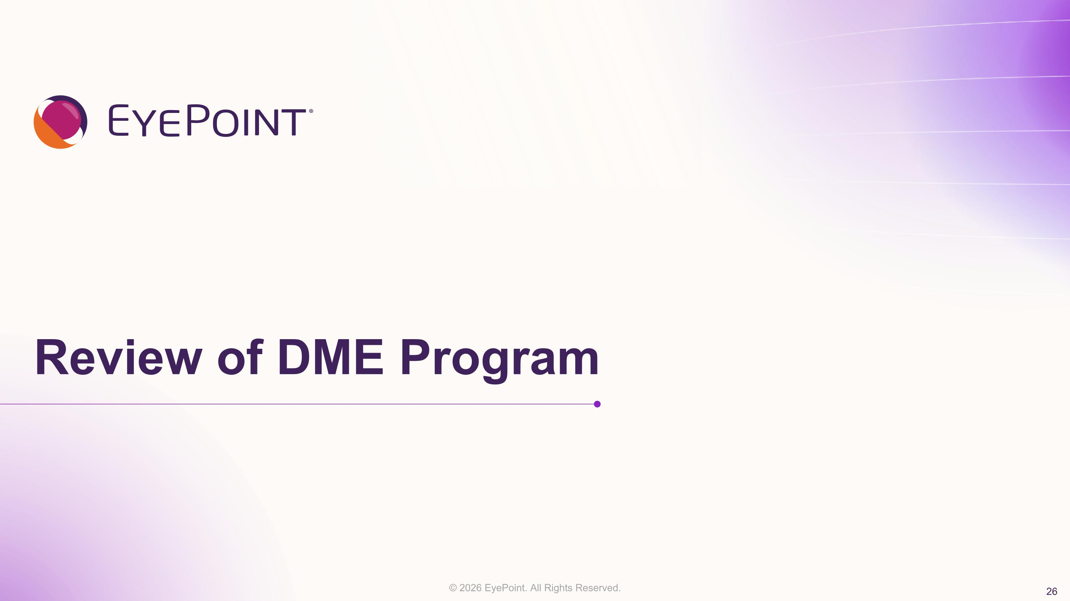
Review of DME Program

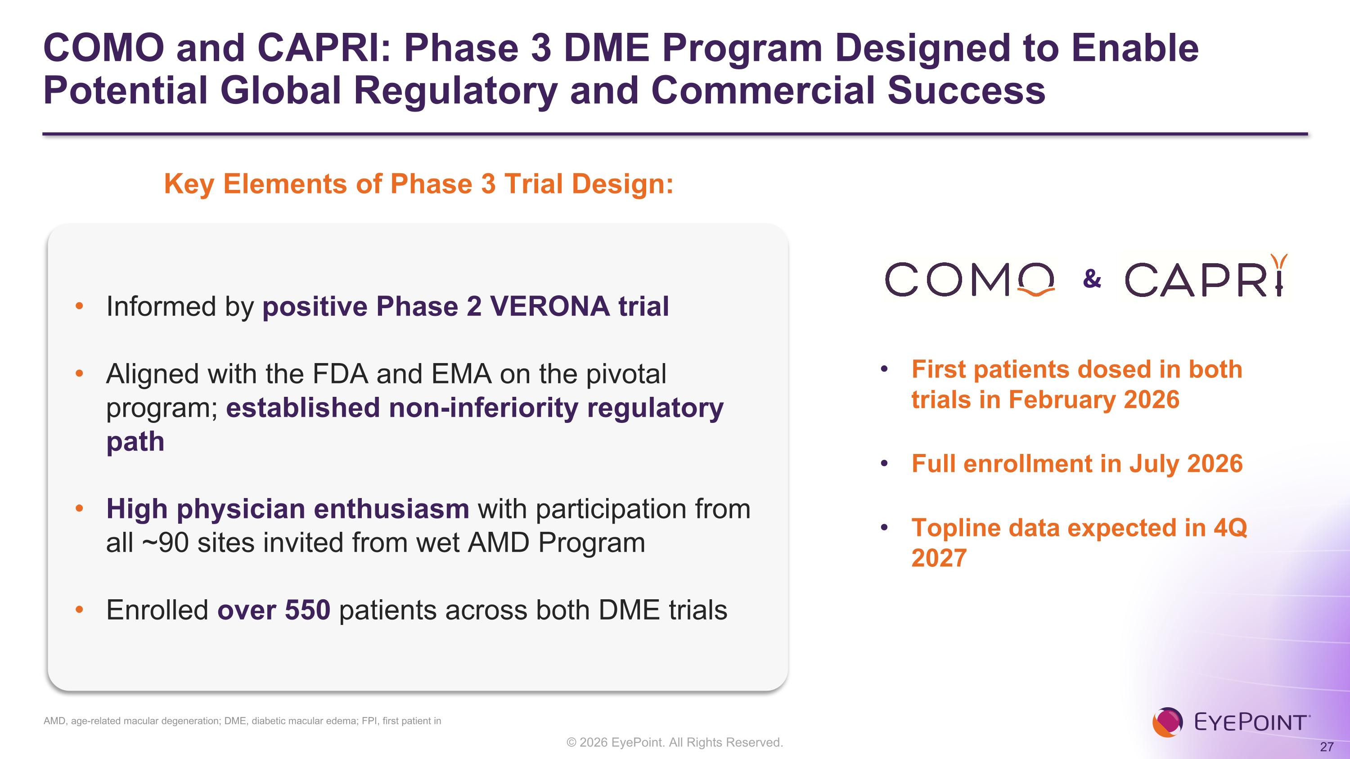
COMO and CAPRI: Phase 3 DME Program Designed to Enable Potential Global Regulatory and Commercial Success First patients dosed in both trials in February 2026 Full enrollment in July 2026 Topline data expected in 4Q 2027 Key Elements of Phase 3 Trial Design: Informed by positive Phase 2 VERONA trial Aligned with the FDA and EMA on the pivotal program; established non-inferiority regulatory path High physician enthusiasm with participation from all ~90 sites invited from wet AMD Program Enrolled over 550 patients across both DME trials & AMD, age-related macular degeneration; DME, diabetic macular edema; FPI, first patient in

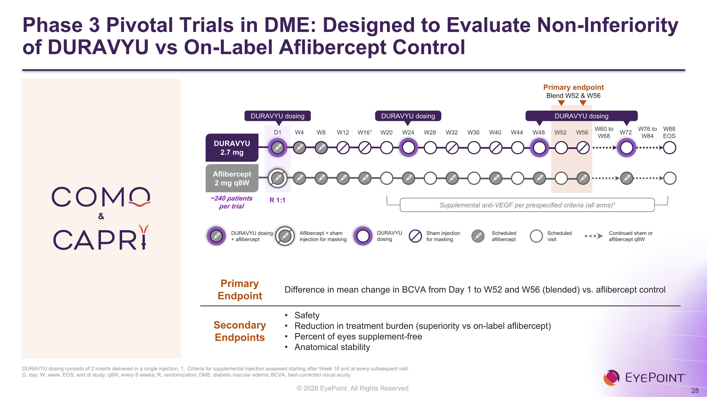
Phase 3 Pivotal Trials in DME: Designed to Evaluate Non-Inferiority of DURAVYU vs On-Label Aflibercept Control D1 W4 W8 W12 W161 W20 W24 W28 W32 W36 W40 W44 W48 W52 W56 W60 to W68 W72 W76 to W84 W88 EOS Primary endpoint Blend W52 & W56 DURAVYU 2.7 mg Aflibercept 2 mg q8W DURAVYU dosing DURAVYU dosing DURAVYU dosing ~240 patients per trial R 1:1 Supplemental anti-VEGF per prespecified criteria (all arms)1 Scheduled?aflibercept Scheduled?visit Sham injection?for masking Continued sham or?aflibercept q8W DURAVYU dosing?+ aflibercept Aflibercept + sham injection for masking DURAVYU?dosing Primary Endpoint Difference in mean change in BCVA from Day 1 to W52 and W56 (blended) vs. aflibercept control Secondary Endpoints Safety Reduction in treatment burden (superiority vs on-label aflibercept) Percent of eyes supplement-free Anatomical stability DURAVYU dosing consists of 2 inserts delivered in a single injection. 1. Criteria for supplemental injection assessed starting after Week 16 and at every subsequent visit.?D, day; W, week. EOS, end of study; q8W, every 8 weeks; R, randomization; DME, diabetic macular edema; BCVA, best-corrected visual acuity &

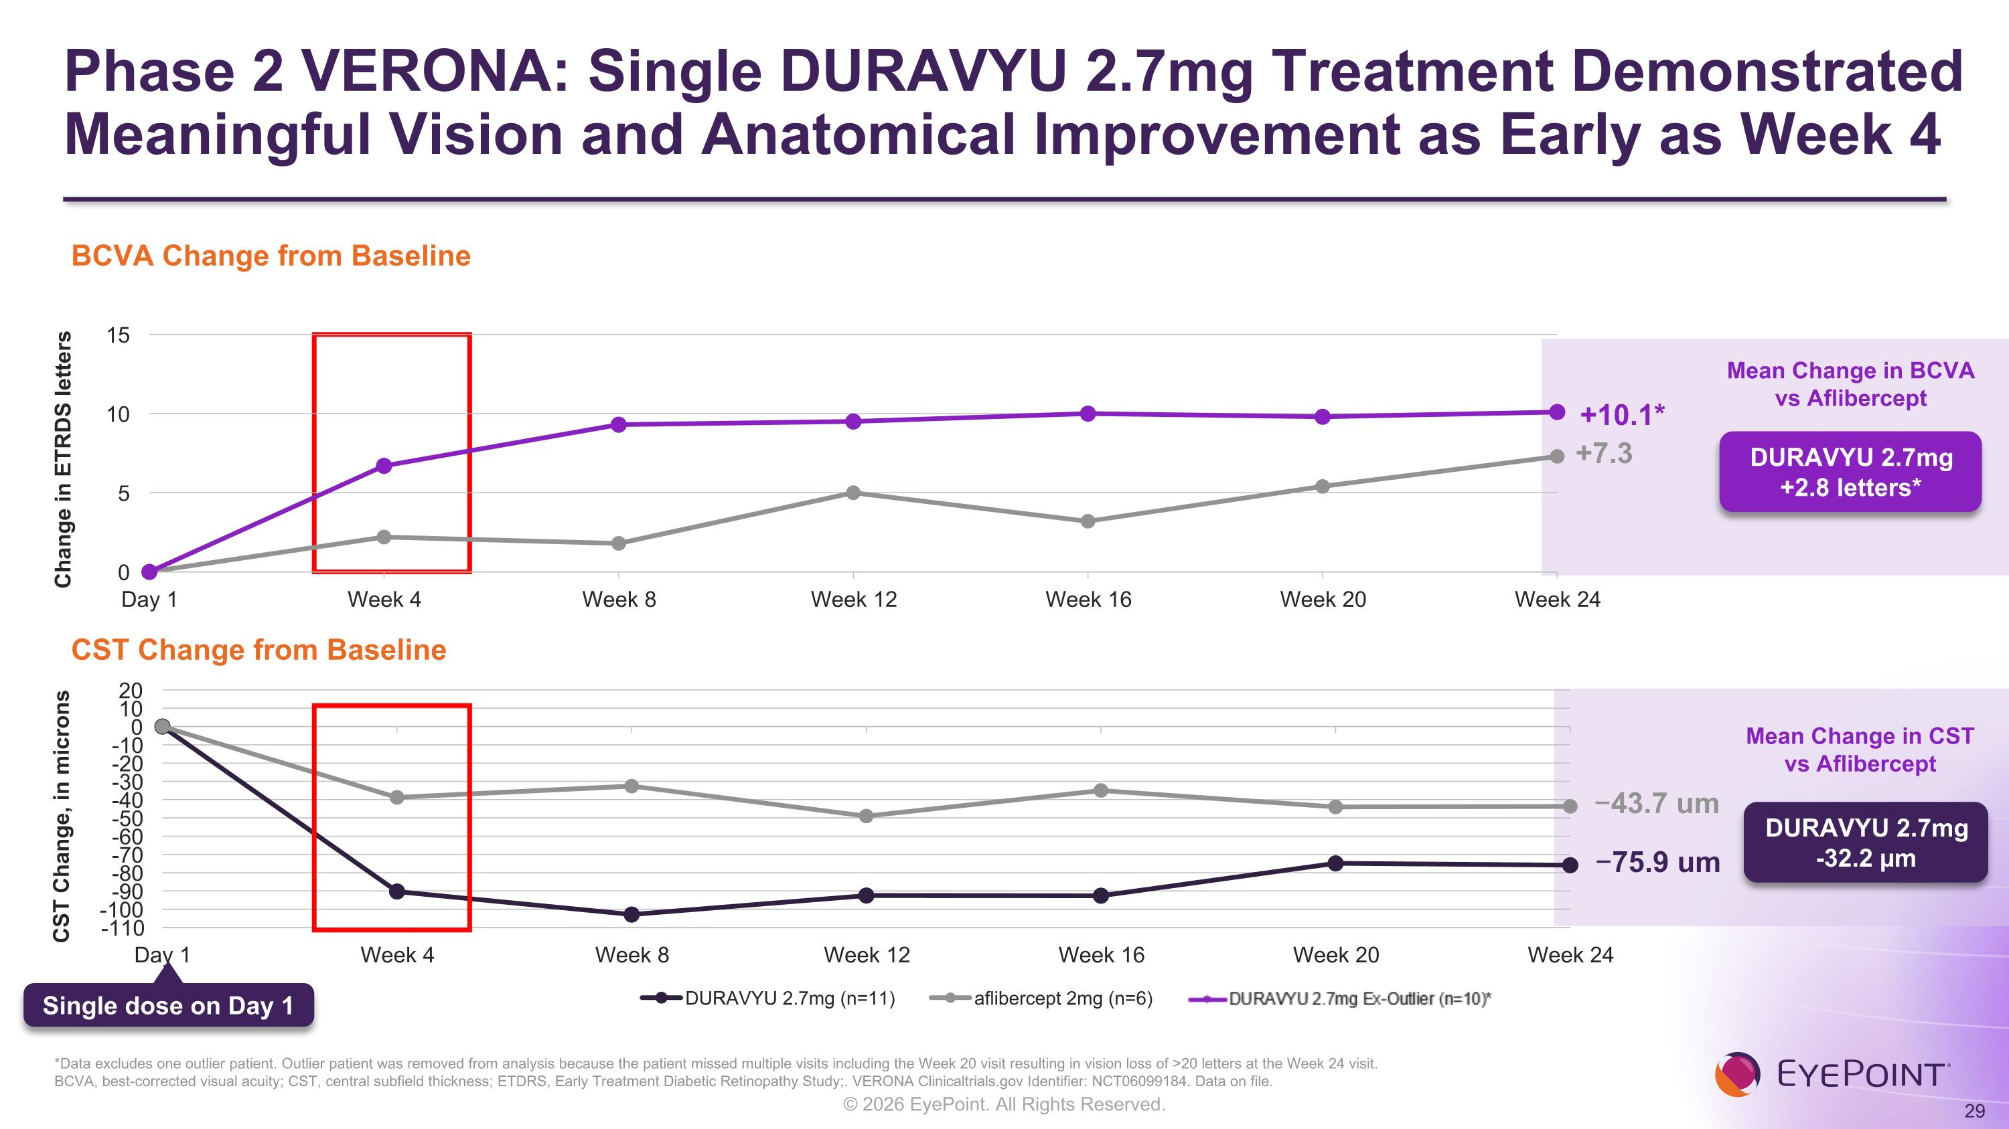
DURAVYU 2.7mg +2.8 letters* Phase 2 VERONA: Single DURAVYU 2.7mg Treatment Demonstrated Meaningful Vision and Anatomical Improvement as Early as Week 4 BCVA, best-corrected visual acuity; CST, central subfield thickness; ETDRS, Early Treatment Diabetic Retinopathy Study;. VERONA Clinicaltrials.gov Identifier: NCT06099184. Data on file. Mean Change in BCVA vs Aflibercept +7.3 −75.9 um −43.7 um Mean Change in CST vs Aflibercept DURAVYU 2.7mg -32.2 µm Single dose on Day 1 BCVA Change from Baseline CST Change from Baseline +10.1* *Data excludes one outlier patient. Outlier patient was removed from analysis because the patient missed multiple visits including the Week 20 visit resulting in vision loss of >20 letters at the Week 24 visit. Change in ETRDS letters

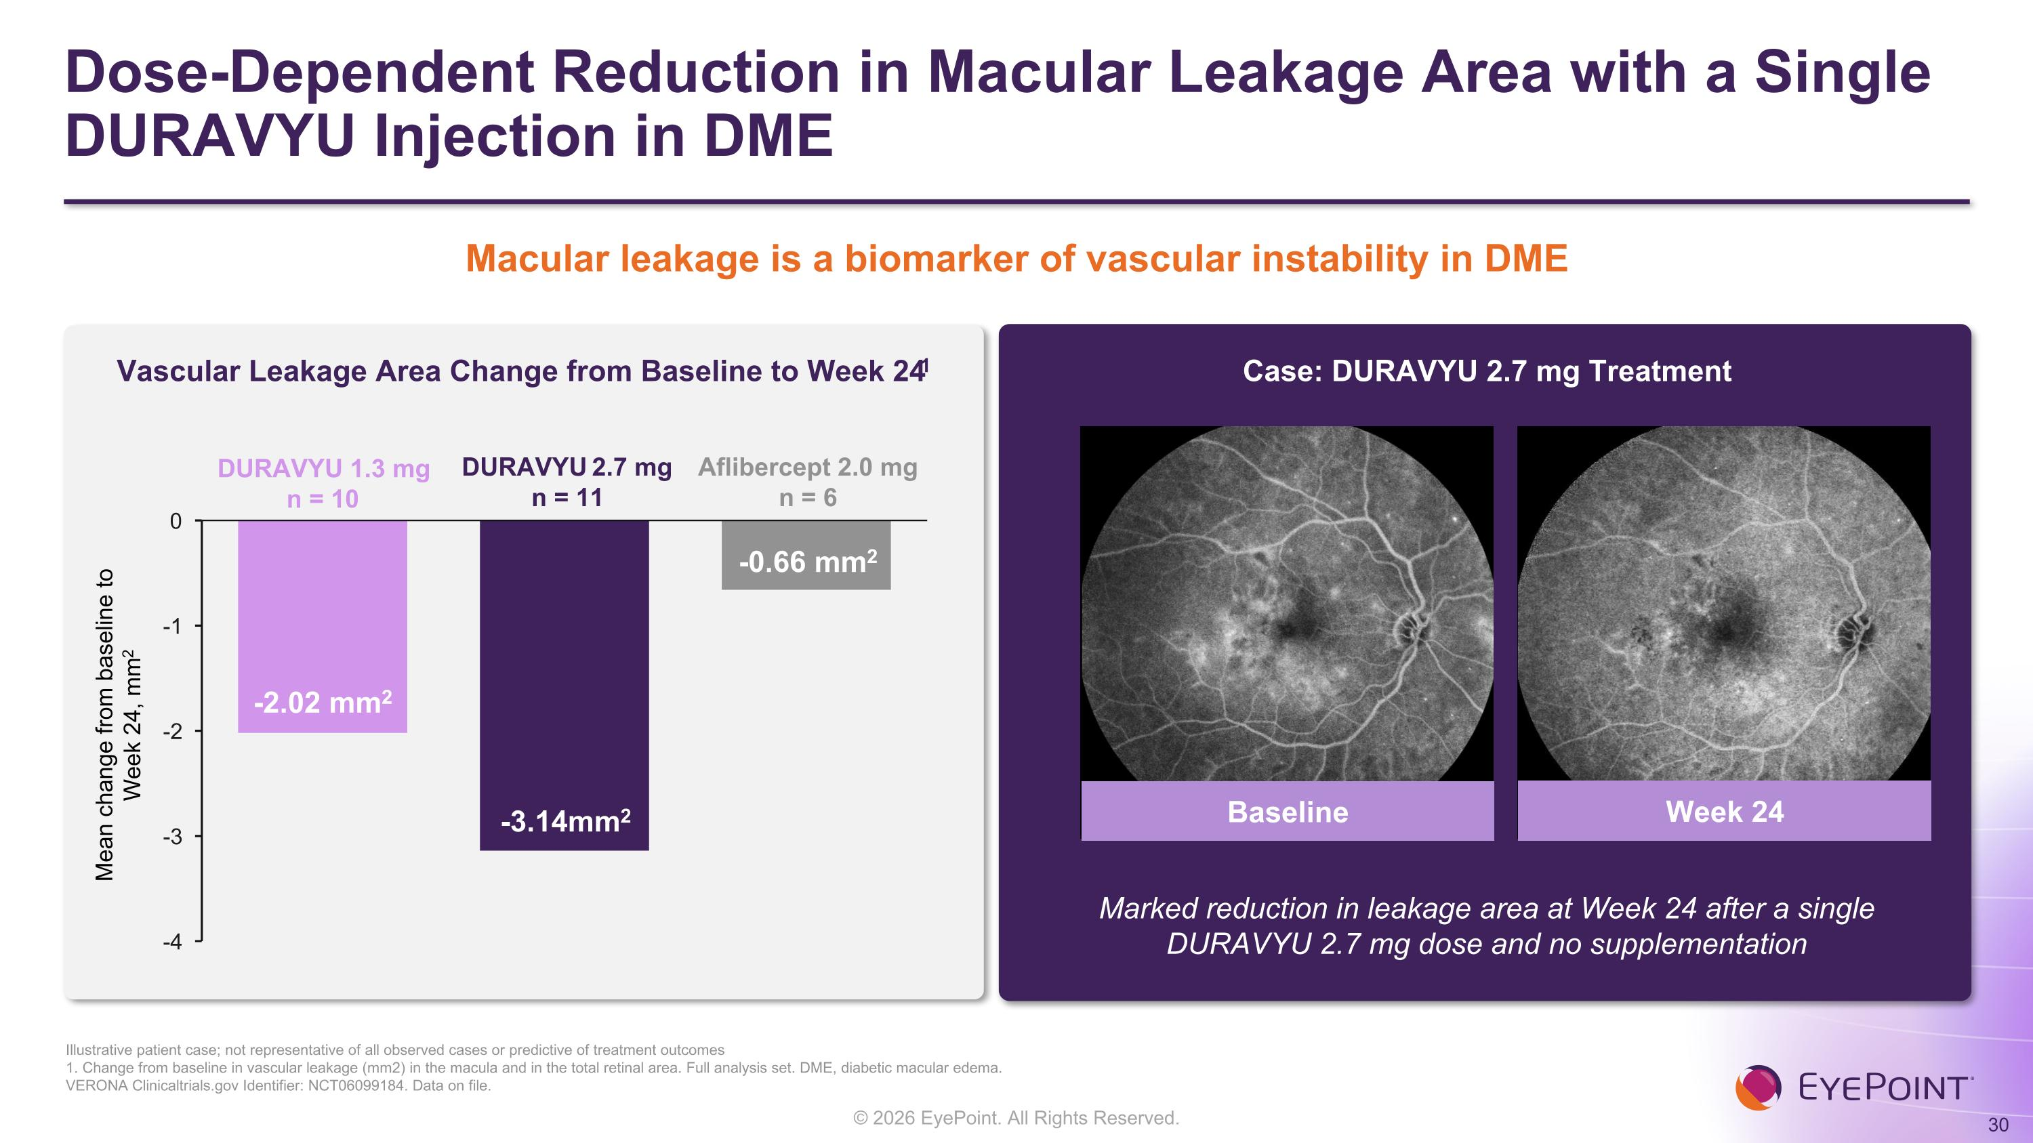
Dose-Dependent Reduction in Macular Leakage Area with a Single DURAVYU Injection in DME Illustrative patient case; not representative of all observed cases or predictive of treatment outcomes 1. Change from baseline in vascular leakage (mm2) in the macula and in the total retinal area. Full analysis set. DME, diabetic macular edema.?VERONA Clinicaltrials.gov Identifier: NCT06099184. Data on file. Vascular Leakage Area Change from Baseline to Week 241 Case: DURAVYU 2.7 mg Treatment Mean change from baseline to ?Week 24, mm2 DURAVYU 1.3 mg n = 10 Baseline Week 24 Marked reduction in leakage area at Week 24 after a single DURAVYU 2.7 mg dose and no supplementation DURAVYU 2.7 mg n = 11 Aflibercept 2.0 mg n = 6 Macular leakage is a biomarker of vascular instability in DME -2.02 mm2 -3.14mm2 -0.66 mm2

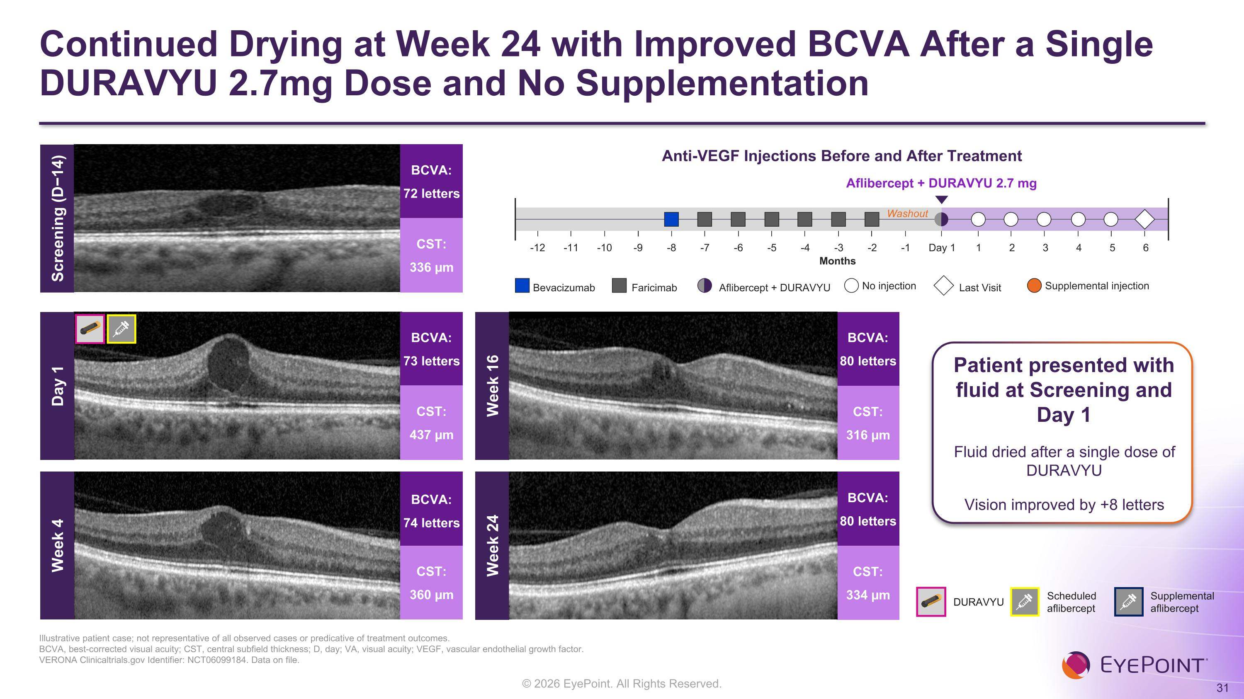
Continued Drying at Week 24 with Improved BCVA After a Single DURAVYU 2.7mg Dose and No Supplementation Illustrative patient case; not representative of all observed cases or predicative of treatment outcomes. BCVA, best-corrected visual acuity; CST, central subfield thickness; D, day; VA, visual acuity; VEGF, vascular endothelial growth factor.?VERONA Clinicaltrials.gov Identifier: NCT06099184. Data on file. Week 4 BCVA: 74 letters CST: 360 µm Week 16 BCVA: 80 letters CST: 316 µm Week 24 BCVA: 80 letters CST: 334 µm Anti-VEGF Injections Before and After Treatment Aflibercept + DURAVYU 2.7 mg Months Washout Day 1 2 1 4 5 6 3 -1 -3 -2 -5 -4 -7 -6 -8 -10 -9 -12 -11 Bevacizumab No injection Supplemental injection Faricimab Last Visit Aflibercept + DURAVYU Patient presented with fluid at Screening and Day 1 Fluid dried after a single dose of DURAVYU Vision improved by +8 letters Screening (D−14) BCVA: 72 letters CST: 336 µm DURAVYU Scheduled aflibercept Supplemental aflibercept BCVA: 73 letters CST: 437 µm Day 1


Conclusions & ?Next Steps

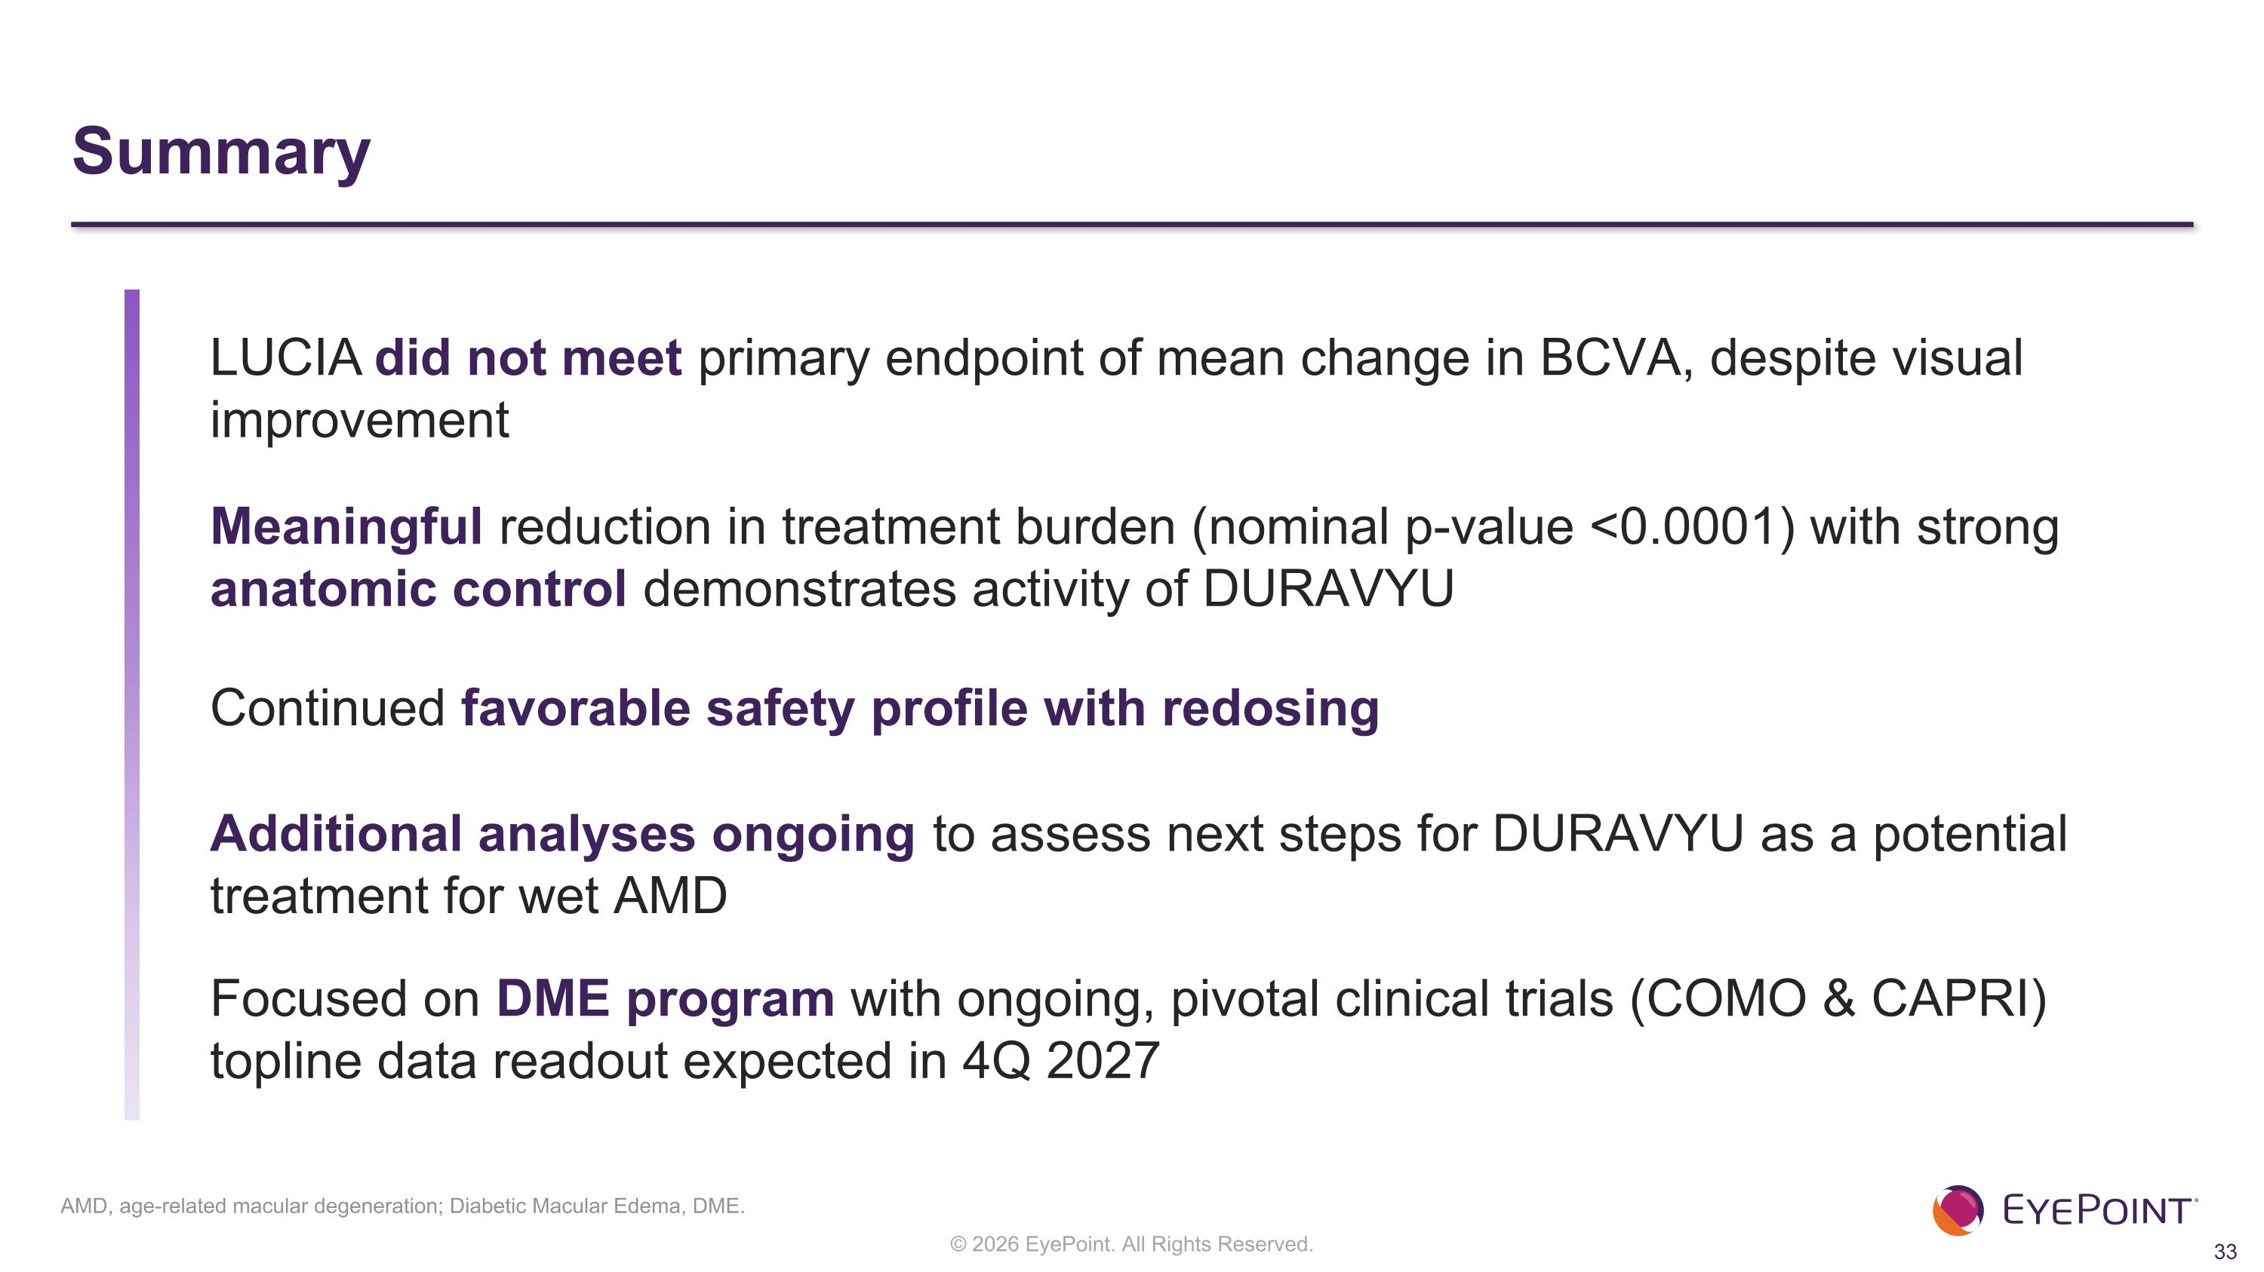
Summary LUCIA did not meet primary endpoint of mean change in BCVA, despite visual improvement Meaningful reduction in treatment burden (nominal p-value <0.0001) with strong anatomic control demonstrates activity of DURAVYU Continued favorable safety profile with redosing Additional analyses ongoing to assess next steps for DURAVYU as a potential treatment for wet AMD Focused on DME program with ongoing, pivotal clinical trials (COMO & CAPRI) topline data readout expected in 4Q 2027 AMD, age-related macular degeneration; Diabetic Macular Edema, DME.


LUCIA Phase 3 Clinical Trial DURAVYU in Wet AMD Topline Results | October 2026

