UNITED STATES
SECURITIES AND EXCHANGE COMMISSION
WASHINGTON, D.C. 20549

FORM 8-K

CURRENT REPORT
Pursuant to Section 13 or 15(d) of the Securities Exchange Act of 1934
Date of Report (Date of earliest event reported) August 17, 2026

EyePoint, Inc.
(Exact name of Registrant as Specified in Its Charter)

Delaware |  |  | 000-51122 | 26-2774444
(State or Other Jurisdiction  of Incorporation) |  |  | (Commission File Number) | (IRS Employer  Identification No.)
480 Pleasant Street
Watertown, Massachusetts |  |  |  | 02472
(Address of Principal Executive Offices) |  |  |  | (Zip Code)

Registrant’s Telephone Number, Including Area Code: (617) 926-5000

(Former Name or Former Address, if Changed Since Last Report)

Check the appropriate box below if the Form 8-K filing is intended to simultaneously satisfy the filing obligation of the registrant under any of the following provisions:
☐Written communications pursuant to Rule 425 under the Securities Act (17 CFR 230.425)
☐Soliciting material pursuant to Rule 14a-12 under the Exchange Act (17 CFR 240.14a-12)
☐Pre-commencement communications pursuant to Rule 14d-2(b) under the Exchange Act (17 CFR 240.14d-2(b))
☐Pre-commencement communications pursuant to Rule 13e-4(c) under the Exchange Act (17 CFR 240.13e-4(c))
Securities registered pursuant to Section 12(b) of the Act:
Title of each class |  | Trading  Symbol(s) |  | Name of each exchange on which registered
Common Stock, par value $0.001 |  | EYPT |  | The Nasdaq Global Market
Indicate by check mark whether the registrant is an emerging growth company as defined in Rule 405 of the Securities Act of 1933 (§ 230.405 of this chapter) or Rule 12b-2 of the Securities Exchange Act of 1934 (§ 240.12b-2 of this chapter).
Emerging growth company ☐
If an emerging growth company, indicate by check mark if the registrant has elected not to use the extended transition period for complying with any new or revised financial accounting standards provided pursuant to Section 13(a) of the Exchange Act. ☐

Item 8.01 Other Events.
On August 17, 2026, EyePoint, Inc. (the “Company”) issued a press release announcing topline data for LUGANO, one of its pivotal Phase 3 clinical trials evaluating DURAVYU for wet age-related macular degeneration (wet AMD). A copy of the press release is attached hereto as Exhibit 99.1 and incorporated by reference herein.
Additionally, on August 17, 2026, the Company posted an updated investor presentation on its website at www.eyepoint.bio. A copy of the presentation is filed herewith as Exhibit 99.2 and is incorporated by reference herein.

Item 9.01 Financial Statements and Exhibits.
(d) Exhibits.
Exhibit No. |  | Description
99.1 |  | Press Release of EyePoint, Inc. dated August 17, 2026
99.2 |  | Investor Presentation of EyePoint, Inc. dated August 17, 2026
104 |  | Cover Page Interactive Data File (embedded within the inline XBRL document)

SIGNATURES
Pursuant to the requirements of the Securities Exchange Act of 1934, the registrant has duly caused this report to be signed on its behalf by the undersigned hereunto duly authorized.
 |  |  | EYEPOINT, INC.
Date: | August 17, 2026 | By: | /s/ George O. Elston
George O. Elston
Executive Vice President and Chief Financial Officer

Exhibit 99.1


EyePoint Announces Topline Data from LUGANO, the First of Two Pivotal Phase 3 Clinical Trials for DURAVYUTM 2.7mg in Wet AMD

–
DURAVYU was non-inferior to on-label aflibercept control (nominal p-value = 0.0096) in an ad hoc analysis excluding a 4% asymmetric cohort (9 of 211 patients) who experienced vision loss (≥ 15 letters) unrelated to wet AMD; primary endpoint not achieved in full dataset, confounded by this asymmetric cohort –
–
LUGANO demonstrated clinically meaningful results that reinforce DURAVYU’s potential to improve the treatment paradigm in wet AMD, with compelling key secondary endpoints, including reduction in treatment burden, supplement-free rates, favorable safety profile with redosing, and strong anatomic control through Week 56 compared to on-label aflibercept –
–
42% reduction in treatment burden achieving superiority versus on-label aflibercept
(nominal p-value of <0.0001) –
–
76% of DURAVYU patients were supplement-free up to Week 32 –
–
54% of DURAVYU patients were supplement-free and 79% received 0 or 1 supplement up to Week 56; pre-specified analysis on change in BCVA in the supplement-free DURAVYU patients showed non-inferiority to supplement-free aflibercept (nominal p-value = 0.0035) –
–
Topline data from LUCIA, the second pivotal Phase 3 clinical trial in wet AMD, expected in Q4 2026 with potential FDA New Drug Application submission planned for 1H 2027 –
–
Conference call to discuss the results to be held today at 8:00 a.m. EDT –

WATERTOWN, Mass., August 17, 2026 (GLOBE NEWSWIRE) – EyePoint, Inc. (Nasdaq: EYPT), a company committed to developing and commercializing innovative therapeutics to improve the lives of patients with serious retinal diseases, today announced topline results from LUGANO, the first pivotal Phase 3 clinical trial for DURAVYUTM (vorolanib intravitreal insert) for the treatment of wet age-related macular degeneration (wet AMD).
DURAVYU was non-inferior to on-label aflibercept (nominal p-value = 0.0096) in an ad hoc analysis excluding a 4% asymmetric cohort (9 of 211 patients) who experienced vision loss (≥ 15 letters) unrelated to wet AMD. Despite the outperformance in key secondary endpoints, the primary endpoint of change from baseline in best corrected visual acuity (BCVA) versus 2 mg aflibercept on-label control was not achieved in the full dataset, confounded by this asymmetric cohort. In contrast, no patients experienced vision loss (≥ 15 letters) unrelated to wet AMD in the aflibercept control arm. In prior reported similar scale pivotal Phase 3 trials, approximately 3-5% of aflibercept patients lost ≥15 letters1, indicating

1 Heier et al. Ophthalmology 2012 (VIEW 1/2), Bayer VIEW combined analysis; CADTH Beovu Clinical Review (NBK565336), HAWK/HARRIER wk48. ClinicalTrials.gov TENAYA Posted Results (NCT03823287). Accessed Aug. 15, 2026. ClinicalTrials.gov LUCERNE Posted Results (NCT03823300). Accessed Aug. 15, 2026. Center for Drug Evaluation and Research Statistical Review, BLA 761355Orig1s000.

Exhibit 99.1

meaningful overperformance of the on-label aflibercept control group in LUGANO that also contributed to the primary endpoint performance.
LUGANO demonstrated clinically meaningful results that reinforce DURAVYU’s potential to improve the treatment paradigm in wet AMD, with compelling key secondary endpoints in reduction in treatment burden, supplement-free rates, a favorable safety profile with redosing, and anatomic control through Week 56 compared to on-label aflibercept. These results represent a meaningful improvement to current wet AMD standard of care.
"We are pleased to see that DURAVYU provided clinically meaningful results in the LUGANO trial. The outstanding outcomes across key secondary endpoints, paired with visual improvement, reinforce our confidence in DURAVYU’s potential to transform the current wet AMD treatment paradigm,” said Jay S. Duker, M.D., President and CEO of EyePoint. “While the primary endpoint result for the full dataset was unexpected, the consistently positive results from the pre-specified secondary endpoints and the ad hoc analysis on the primary endpoint present a compelling case for DURAVYU as a new potential therapeutic option for wet AMD. We look forward to a potential New Drug Application (NDA) filing with FDA in the first half of 2027, pending LUCIA results in the fourth quarter of 2026."
Key Secondary Endpoints Across All Patients
Key secondary endpoints including a favorable safety profile, reduction in treatment burden, supplement-free rates, and anatomic controls were achieved.
•
Favorable Safety Profile
o
DURAVYU observed to be safe and well tolerated with repeat dosing in patients
o
No difference in cataracts, elevated intraocular pressure, or intraocular inflammation between study and control group
o
No observed occurrences of insert migration, anterior chamber opacities, free-floating drug particles, retinal vasculitis, or severe intraocular inflammation (IOI)

•
Reduction in Treatment Burden
o
42% reduction in treatment burden, achieving superiority versus on-label aflibercept (nominal p-value<0.0001) compared to a maximum possible reduction of 60%
o
This reduction translates to two fewer injections on average in DURAVYU patients versus on-label aflibercept up to Week 56
•
Supplement-Free Rates
o
76% of DURAVYU patients were supplement-free up to Week 32
o
94 % of DURAVYU patients received zero or one supplement up to Week 32
o
54% of DURAVYU patients were supplement-free up to Week 56
o
79% of DURAVYU patients received zero or one supplement up to Week 56
o
Pre-specified analysis of change in BCVA from baseline to average Week 52/56 in supplement-free patients showed that DURAVYU was non-inferior (nominal p-value=0.0035) versus on-label aflibercept
•
Anatomic Control

Exhibit 99.1

o
Strong anatomic control demonstrated DURAVYU’s potency with a mean difference of 4 microns versus on-label aflibercept control in central subfield thickness (CST) at Week 56
o
The 54% of DURAVYU eyes that were supplement free up to week 56 showed only a 3-micron difference in CST compared to the on-label aflibercept control

“The LUGANO results are clinically meaningful because the trial compared DURAVYU to on-label aflibercept, the current gold standard control group in wet AMD trials. Nearly 80% of DURAVYU-treated patients received one or no supplemental injections through Week 56. Disease control with this degree of durability, coupled with a favorable safety profile, would meaningfully reduce the treatment burden for our patients,” said Carl D. Regillo, M.D., FACS, Former Director of the Wills Eye Hospital Retina Service, Professor of Ophthalmology, Thomas Jefferson University. “DURAVYU's ability to control disease well in the majority of patients with a six-month redosing interval represents a significant advance for our patients with wet AMD. In clinical practice, keeping patients adequately treated over time is a big challenge, and a sustained delivery option with this kind of profile would be a welcome addition to the armamentarium.”
“DURAVYU demonstrated durable efficacy results with stable retinal anatomy maintained through Week 56, avoiding the sawtooth pattern commonly seen with intermittent anti-VEGF therapy. In addition, the supplement-free anatomic and visual outcomes further validate the potency of DURAVYU,” said Ramiro Ribeiro, M.D., Ph.D., Chief Medical Officer of EyePoint. “These findings represent an important advancement for retinal disease treatment, demonstrating the potential for repeat dosing of a tyrosine kinase inhibitor (TKI), a capability unique to our clinical program, coupled with a favorable safety profile. We extend our sincere gratitude to the patients, caregivers, and investigators whose partnership and dedication made this study possible.”
EyePoint plans to present additional details on the LUGANO dataset, including subgroup-analyses, at major retina conferences in the coming months, beginning at the Retina Society 59th Annual Scientific Meeting from September 23-26, 2026.
The Company remains on track to report topline data from the second wet AMD pivotal Phase 3 LUCIA trial in the fourth quarter of 2026. The Company anticipates potentially filing an NDA for DURAVYU for the potential treatment of wet AMD in the first half of 2027. Additionally, the pivotal Phase 3 COMO and CAPRI clinical trials for DURAVYU in diabetic macular edema (DME) rapidly completed enrollment, with topline data for both trials anticipated in the fourth quarter of 2027.

Conference Call Information
EyePoint management will host a conference call today, August 17, 2026, at 8:00 a.m. EDT to discuss the LUGANO topline results.
To access the live conference call and webcast, please register via the Events & Presentations page of the Investors section of the Company website at https://investors.eyepoint.bio/events-and-presentations/events. A webcast replay and the data presentation will also be available on the corporate website at the conclusion of the call.

Exhibit 99.1

About the Phase 3 Wet AMD Program
LUGANO and LUCIA are identical, randomized, double-masked, aflibercept controlled, non-inferiority Phase 3 trials assessing the efficacy and safety of DURAVYU in patients with active wet AMD including both treatment naïve and treatment experienced patients. Enrollment is complete in both trials with over 900 patients enrolled. At Day 1, patients are randomized 1:1 to receive either DURAVYU 2.7mg every six months or on-label aflibercept as control. All active patients in the treatment arm have reached the Week 32 visit, during which patients received their second DURAVYU dose. The LUGANO and LUCIA trials are the only sustained release wet AMD pivotal Phase 3 trials evaluating 6-month redosing in both trials over two years. DURAVYU is delivered via a standard intravitreal injection in the physician's office, similar to current practice with FDA approved anti-VEGF treatments. The primary endpoint of the Phase 3 pivotal trials is non-inferiority in the average change in best corrected visual acuity (BCVA) at weeks 52 and 56 compared to baseline. Secondary endpoints include safety, reduction in treatment burden, percentage of eyes free of supplemental aflibercept injections, and anatomical results as measured by optical coherence tomography (OCT). More information about the trials is available at www.clinicaltrials.gov (LUGANO identifier: NCT06668064; LUCIA identifier: NCT06683742).

About Wet AMD
Wet age-related macular degeneration (wet AMD) is a leading cause of vision loss and irreversible blindness in people over the age of fifty. Wet AMD is an advanced form of AMD that develops when abnormal blood vessels grow under the macular retina, leaking blood and/or fluid, and leading to potentially severe vision loss. Wet AMD is a lifelong disease that requires continuous treatment so that patients may maintain visual function. Although multiple treatments are now available, challenges still exist as the current standard-of-care is dosed on average every two months in the United States under a treat-and-extend protocol, and these large molecule anti-VEGF treatments only target one pathology of the disease. This lifetime of frequent treatment represents a tremendous burden for patients, physicians, and the health care system, potentially leading to patient noncompliance and further vision loss.

About DURAVYUTM
DURAVYU (vorolanib intravitreal insert), is an investigational sustained-delivery treatment for patients suffering from serious retinal diseases. DURAVYU combines vorolanib, a selective and patent-protected tyrosine kinase inhibitor (TKI), in next-generation bioerodible Durasert E, a proprietary and best-in-class IVT delivery technology designed to provide sustained release of drug for at least six months without free-floating drug particles.
DURAVYU brings a potential new multi-mechanism of action and treatment paradigm for retinal diseases beyond existing anti-VEGF large molecule ligand blocking therapies, as vorolanib acts intracellularly to suppress angiogenesis through the inhibition of all VEGF receptors and PDGFR, while also suppressing inflammation through the inhibition of interleukin 6 (IL-6)/JAK1 signaling. In addition to the safety and efficacy results demonstrated in the DAVIO, DAVIO 2 and VERONA clinical trials, vorolanib has also demonstrated neuroprotection in an in-vivo model of retinal detachment.

Exhibit 99.1

DURAVYU has established safety and efficacy data from both Phase 1 and 2 trials in wet AMD and DME that demonstrate stability in vision and anatomical control with a single dose of DURAVYU. No drug-related safety concerns were observed in over 190 patients across four completed clinical trials, including three Phase 2 trials.
Informed by the robust Phase 2, DAVIO trial, which achieved statistically positive and clinically meaningful results vs. on-label aflibercept, the fully enrolled wet AMD Phase 3 pivotal program (LUGANO and LUCIA) is the only investigational program evaluating every six-month dosing of DURAVYU, which enables the potential to support a compelling competitive label and advantage for DURAVYU. With over 900 patients randomized across both trials, the Phase 3 pivotal program follows a well-established regulatory approval pathway with a patient-centric noninferiority design comparing DURAVYU to on-label standard of care to inform real-word treatment practices. LUCIA topline data results are expected in the fourth quarter of 2026.
DURAVYU is also being evaluated for the treatment of DME, with both Phase 3 trials (COMO and CAPRI) fully enrolled and underway. The Phase 2 VERONA trial in DME met primary and secondary endpoints and demonstrated a rapid and sustained improvement in vision and anatomy and a continued favorable safety and tolerability profile with superior dosing intervals to standard of care. Pivotal data from the Phase 3 DME program is anticipated to be reported in the fourth quarter of 2027.

About EyePoint
EyePoint, Inc. (Nasdaq: EYPT) is a clinical-stage biopharmaceutical company committed to developing and commercializing innovative therapeutics to improve the lives of patients with serious retinal diseases. The Company’s lead product candidate, DURAVYU, is an innovative investigational sustained delivery treatment for serious retinal diseases combining vorolanib, a selective and patent-protected tyrosine kinase inhibitor, in next-generation bioerodible Durasert E technology. Supported by robust safety and efficacy data across multiple clinical trials and indications, DURAVYU is currently being evaluated in Phase 3 pivotal trials for wet age-related macular degeneration (wet AMD) and diabetic macular edema (DME).
The Company is committed to partnering with the retinal community to improve patient lives while creating long-term value, with four approved drugs over three decades and tens of thousands of eyes treated with EyePoint innovation.
EyePoint is headquartered in Watertown, Massachusetts, with a commercial manufacturing facility in Northbridge, Massachusetts.
Vorolanib is licensed to EyePoint exclusively by Equinox Sciences, a Betta Pharmaceuticals affiliate, for the localized treatment of all ophthalmic diseases outside of China, Macao, Hong Kong and Taiwan.
DURAVYU has been conditionally accepted by the FDA as the proprietary name for EYP-1901. DURAVYU is an investigational product; it has not been approved by the FDA. FDA approval and the timeline for potential approval is uncertain.

Forward Looking Statements

Exhibit 99.1

EYEPOINT SAFE HARBOR STATEMENTS UNDER THE PRIVATE SECURITIES LITIGATION ACT OF 1995: To the extent any statements made in this press release deal with information that is not historical, these are forward-looking statements under the Private Securities Litigation Reform Act of 1995. Such statements include, but are not limited to, statements regarding our expectations regarding our clinical development and regulatory plans, including the potential submission of a New Drug Application with FDA for DURAVYU for the potential treatment of wet AMD in the first half of 2027; our confidence in DURAVYU as a potential treatment for wet AMD; our belief that vision loss experienced in the LUGANO Phase 3 clinical trial was not related to DURAVYU or lack of wet AMD control; our belief that DURAVYU’s potential real-world application in multiple retinal disease indications and established trial designs position DURAVYU for clinical and commercial success; our belief that DURAVYU brings a potential new multi-mechanism of action and treatment paradigm for retinal diseases beyond existing anti-VEGF large molecule ligand blocking therapies; our expectations regarding the timing of the availability and release of wet AMD and DME clinical data, including the reporting of LUCIA data in the fourth quarter of 2026 and topline results for Phase 3 COMO and CAPRI clinical trials in diabetic macular edema in the fourth quarter of 2027; our plans to present additional details on the LUGANO dataset, including subgroup-analyses, at major retina conferences in the coming months; our belief that DURAVYU has the potential to maintain patients with active disease with no supplemental anti-VEGF therapy for six months or longer; and other statements regarding the Company’s future plans, objectives, strategies and beliefs, as identified by words such as “will,” “potential,” “could,” “can,” “believe,” “intends,” “continue,” “plans,” “expects,” “anticipates,” “estimates,” “may,” or other words of similar meaning or the use of future dates.
Forward-looking statements by their nature address matters that are, to different degrees, uncertain. Uncertainties and risks may cause EyePoint’s actual results to be materially different than those expressed in or implied by EyePoint’s forward-looking statements. For EyePoint, these risks and uncertainties include the timing, progress and results of the Company’s clinical development activities; uncertainties and delays relating to communications with the U.S. Food and Drug Administration and the ability to obtain regulatory approval from FDA for the commercialization of DURAVYU; unanticipated costs and expenses; the Company’s cash and cash equivalents may not be sufficient to support its operating plan for as long as anticipated; the risk that results of clinical trials may not be predictive of future results, and interim and preliminary data are subject to further analysis and may change as more data becomes available; unexpected safety or efficacy data observed during clinical trials; uncertainties related to the regulatory authorization or approval process, and available development and regulatory pathways for approval of the Company’s product candidates; changes in the regulatory environment; disruptions at the FDA; changes in U.S. and international trade policies; changes in expected or existing competition; the success of current and future license agreements; our dependence on contract research organizations, and other outside vendors and service providers; product liability; the impact of general business and economic conditions; protection of our intellectual property and avoiding intellectual property infringement; retention of key personnel; delays, interruptions or failures in the manufacture and supply of our product candidates, including due to unanticipated regulatory compliance issues or warning letters relating to the Company’s manufacturing facilities; the availability of and the need for additional financing; our ability to obtain additional funding to support our clinical development programs; uncertainties regarding the FDA warning letter pertaining to the Company’s Watertown, MA manufacturing facility; and other factors described in our filings with the Securities and Exchange Commission. We cannot guarantee that the results and other expectations expressed, anticipated or implied in any forward-looking statement will be realized. A variety of factors, including these risks,

Exhibit 99.1

could cause our actual results and other expectations to differ materially from the anticipated results or other expectations expressed, anticipated or implied in our forward-looking statements. Should known or unknown risks materialize, or should underlying assumptions prove inaccurate, actual results could differ materially from past results and those anticipated, estimated or projected in the forward-looking statements. You should bear this in mind as you consider any forward-looking statements. A more complete discussion of the risks and uncertainties that may cause our actual results to differ materially from those expressed or implied in the forward-looking statements in this press release are described under the heading “Risk Factors” in our most recent Annual Report on Form 10-K, in our other filings with the Securities and Exchange Commission (SEC) and in our future reports to be filed with the SEC, which are available at www.sec.gov. Our forward-looking statements speak only as of the dates on which they are made. EyePoint undertakes no obligation to update or revise any forward-looking statement, whether as a result of new information, future events, or otherwise.

Investors:
Robin Garner
EyePoint, Inc.
ir@eyepoint.bio

Media:
Helen O’Gorman
FTI Consulting
media@eyepoint.bio

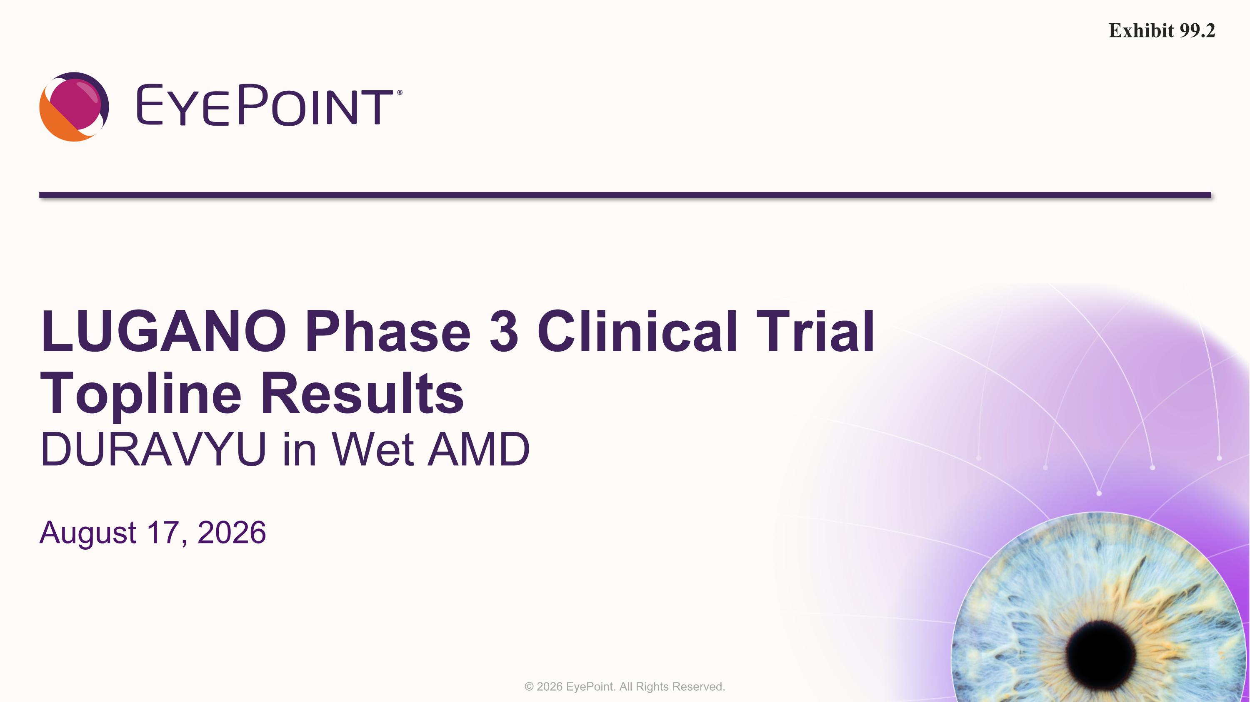
LUGANO Phase 3 Clinical Trial Topline Results DURAVYU in Wet AMD August 17, 2026 Exhibit 99.2

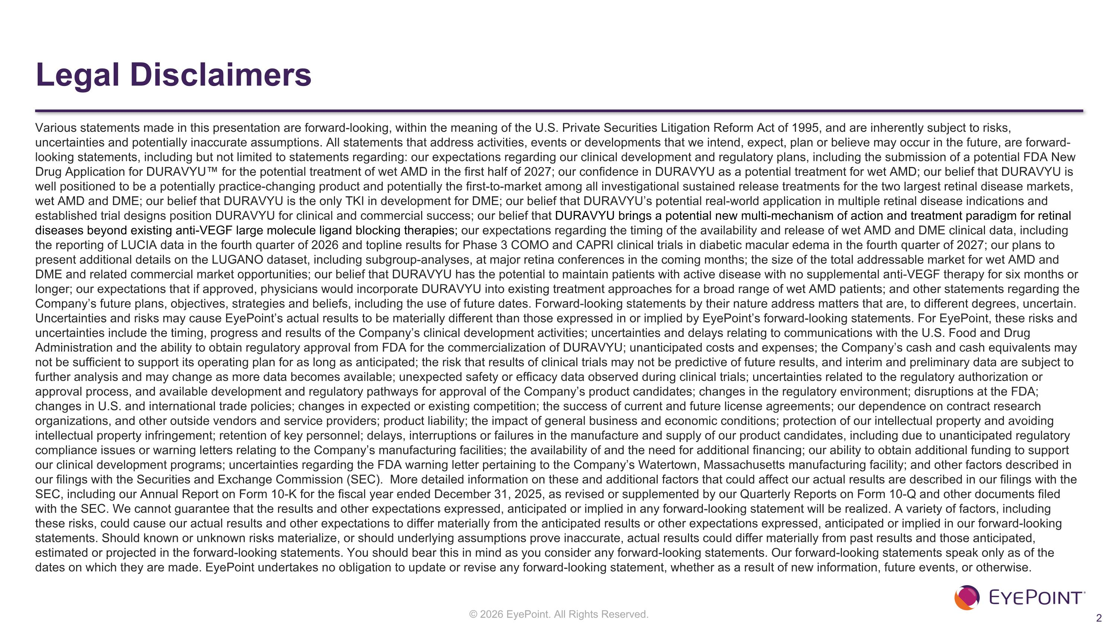
Legal Disclaimers Various statements made in this presentation are forward-looking, within the meaning of the U.S. Private Securities Litigation Reform Act of 1995, and are inherently subject to risks, uncertainties and potentially inaccurate assumptions. All statements that address activities, events or developments that we intend, expect, plan or believe may occur in the future, are forward-looking statements, including but not limited to statements regarding: our expectations regarding our clinical development and regulatory plans, including the submission of a potential FDA New Drug Application for DURAVYU for the potential treatment of wet AMD in the first half of 2027; our confidence in DURAVYU as a potential treatment for wet AMD; our belief that DURAVYU is well positioned to be a potentially practice-changing product and potentially the first-to-market among all investigational sustained release treatments for the two largest retinal disease markets, wet AMD and DME; our belief that DURAVYU is the only TKI in development for DME; our belief that DURAVYU’s potential real-world application in multiple retinal disease indications and established trial designs position DURAVYU for clinical and commercial success; our belief that DURAVYU brings a potential new multi-mechanism of action and treatment paradigm for retinal diseases beyond existing anti-VEGF large molecule ligand blocking therapies; our expectations regarding the timing of the availability and release of wet AMD and DME clinical data, including the reporting of LUCIA data in the fourth quarter of 2026 and topline results for Phase 3 COMO and CAPRI clinical trials in diabetic macular edema in the fourth quarter of 2027; our plans to present additional details on the LUGANO dataset, including subgroup-analyses, at major retina conferences in the coming months; the size of the total addressable market for wet AMD and DME and related commercial market opportunities; our belief that DURAVYU has the potential to maintain patients with active disease with no supplemental anti-VEGF therapy for six months or longer; our expectations that if approved, physicians would incorporate DURAVYU into existing treatment approaches for a broad range of wet AMD patients; and other statements regarding the Company’s future plans, objectives, strategies and beliefs, including the use of future dates. Forward-looking statements by their nature address matters that are, to different degrees, uncertain. Uncertainties and risks may cause EyePoint’s actual results to be materially different than those expressed in or implied by EyePoint’s forward-looking statements. For EyePoint, these risks and uncertainties include the timing, progress and results of the Company’s clinical development activities; uncertainties and delays relating to communications with the U.S. Food and Drug Administration and the ability to obtain regulatory approval from FDA for the commercialization of DURAVYU; unanticipated costs and expenses; the Company’s cash and cash equivalents may not be sufficient to support its operating plan for as long as anticipated; the risk that results of clinical trials may not be predictive of future results, and interim and preliminary data are subject to further analysis and may change as more data becomes available; unexpected safety or efficacy data observed during clinical trials; uncertainties related to the regulatory authorization or approval process, and available development and regulatory pathways for approval of the Company’s product candidates; changes in the regulatory environment; disruptions at the FDA; changes in U.S. and international trade policies; changes in expected or existing competition; the success of current and future license agreements; our dependence on contract research organizations, and other outside vendors and service providers; product liability; the impact of general business and economic conditions; protection of our intellectual property and avoiding intellectual property infringement; retention of key personnel; delays, interruptions or failures in the manufacture and supply of our product candidates, including due to unanticipated regulatory compliance issues or warning letters relating to the Company’s manufacturing facilities; the availability of and the need for additional financing; our ability to obtain additional funding to support our clinical development programs; uncertainties regarding the FDA warning letter pertaining to the Company’s Watertown, Massachusetts manufacturing facility; and other factors described in our filings with the Securities and Exchange Commission (SEC). More detailed information on these and additional factors that could affect our actual results are described in our filings with the SEC, including our Annual Report on Form 10-K for the fiscal year ended December 31, 2025, as revised or supplemented by our Quarterly Reports on Form 10-Q and other documents filed with the SEC. We cannot guarantee that the results and other expectations expressed, anticipated or implied in any forward-looking statement will be realized. A variety of factors, including these risks, could cause our actual results and other expectations to differ materially from the anticipated results or other expectations expressed, anticipated or implied in our forward-looking statements. Should known or unknown risks materialize, or should underlying assumptions prove inaccurate, actual results could differ materially from past results and those anticipated, estimated or projected in the forward-looking statements. You should bear this in mind as you consider any forward-looking statements. Our forward-looking statements speak only as of the dates on which they are made. EyePoint undertakes no obligation to update or revise any forward-looking statement, whether as a result of new information, future events, or otherwise.

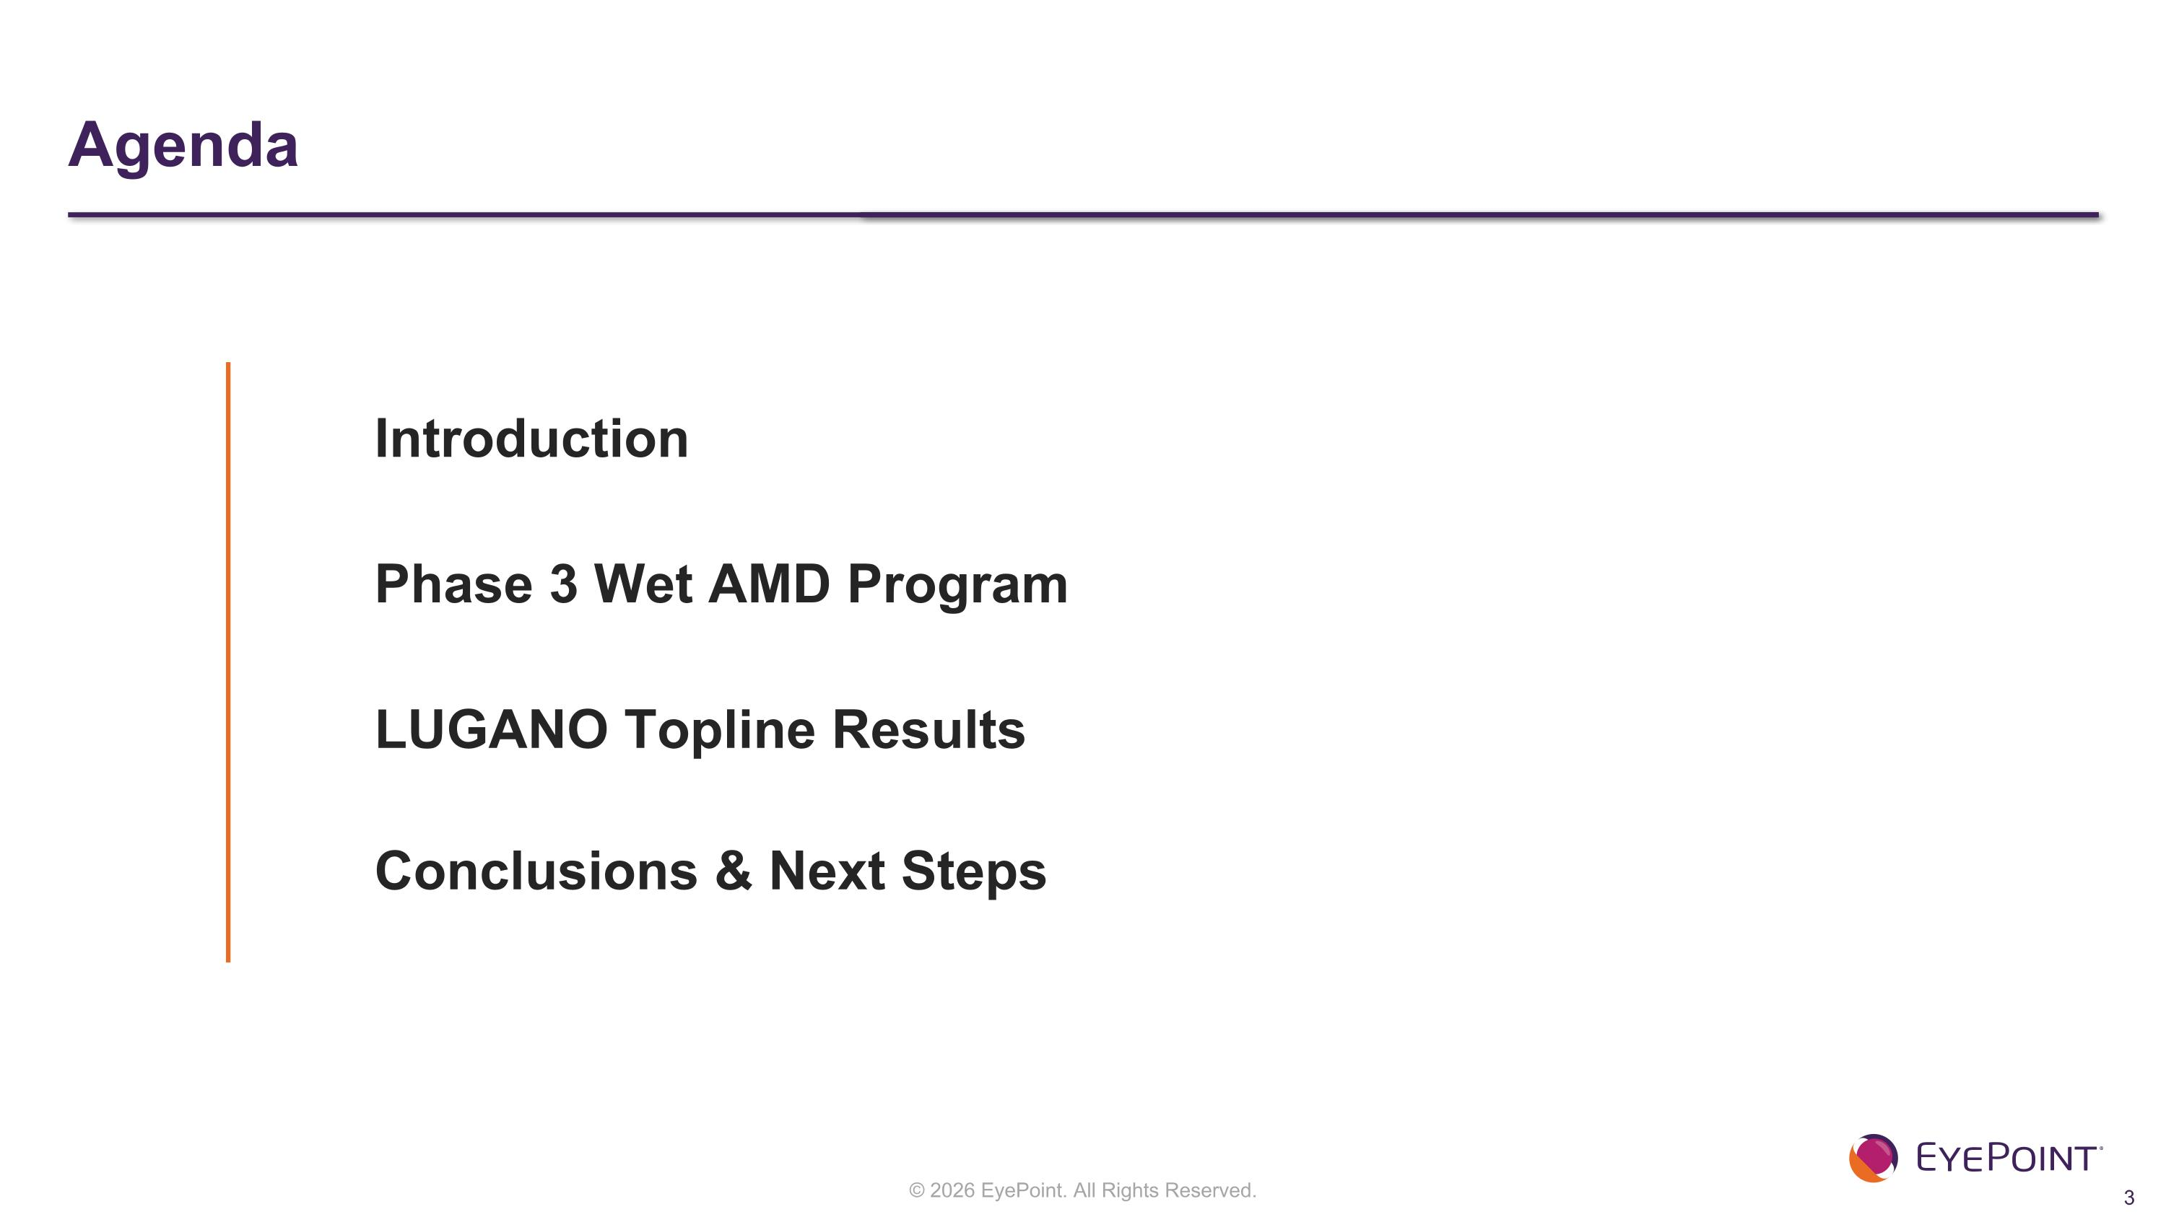
Agenda Introduction Phase 3 Wet AMD Program LUGANO Topline Results Conclusions & Next Steps


Introduction

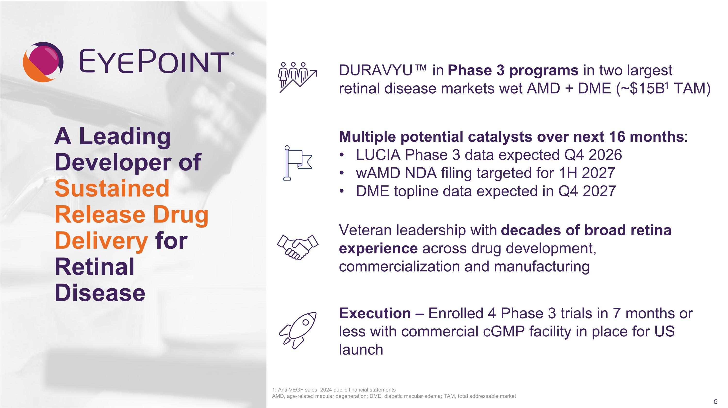
A Leading Developer of Sustained Release Drug Delivery for Retinal Disease 1: Anti-VEGF sales, 2024 public financial statements ?AMD, age-related macular degeneration; DME, diabetic macular edema; TAM, total addressable market Multiple potential catalysts over next 16 months: LUCIA Phase 3 data expected Q4 2026 wAMD NDA filing targeted for 1H 2027 DME topline data expected in Q4 2027 Veteran leadership with decades of broad retina experience across drug development, commercialization and manufacturing DURAVYU in Phase 3 programs in two largest retinal disease markets wet AMD + DME (~$15B1 TAM) Execution – Enrolled 4 Phase 3 trials in 7 months or less with commercial cGMP facility in place for US launch

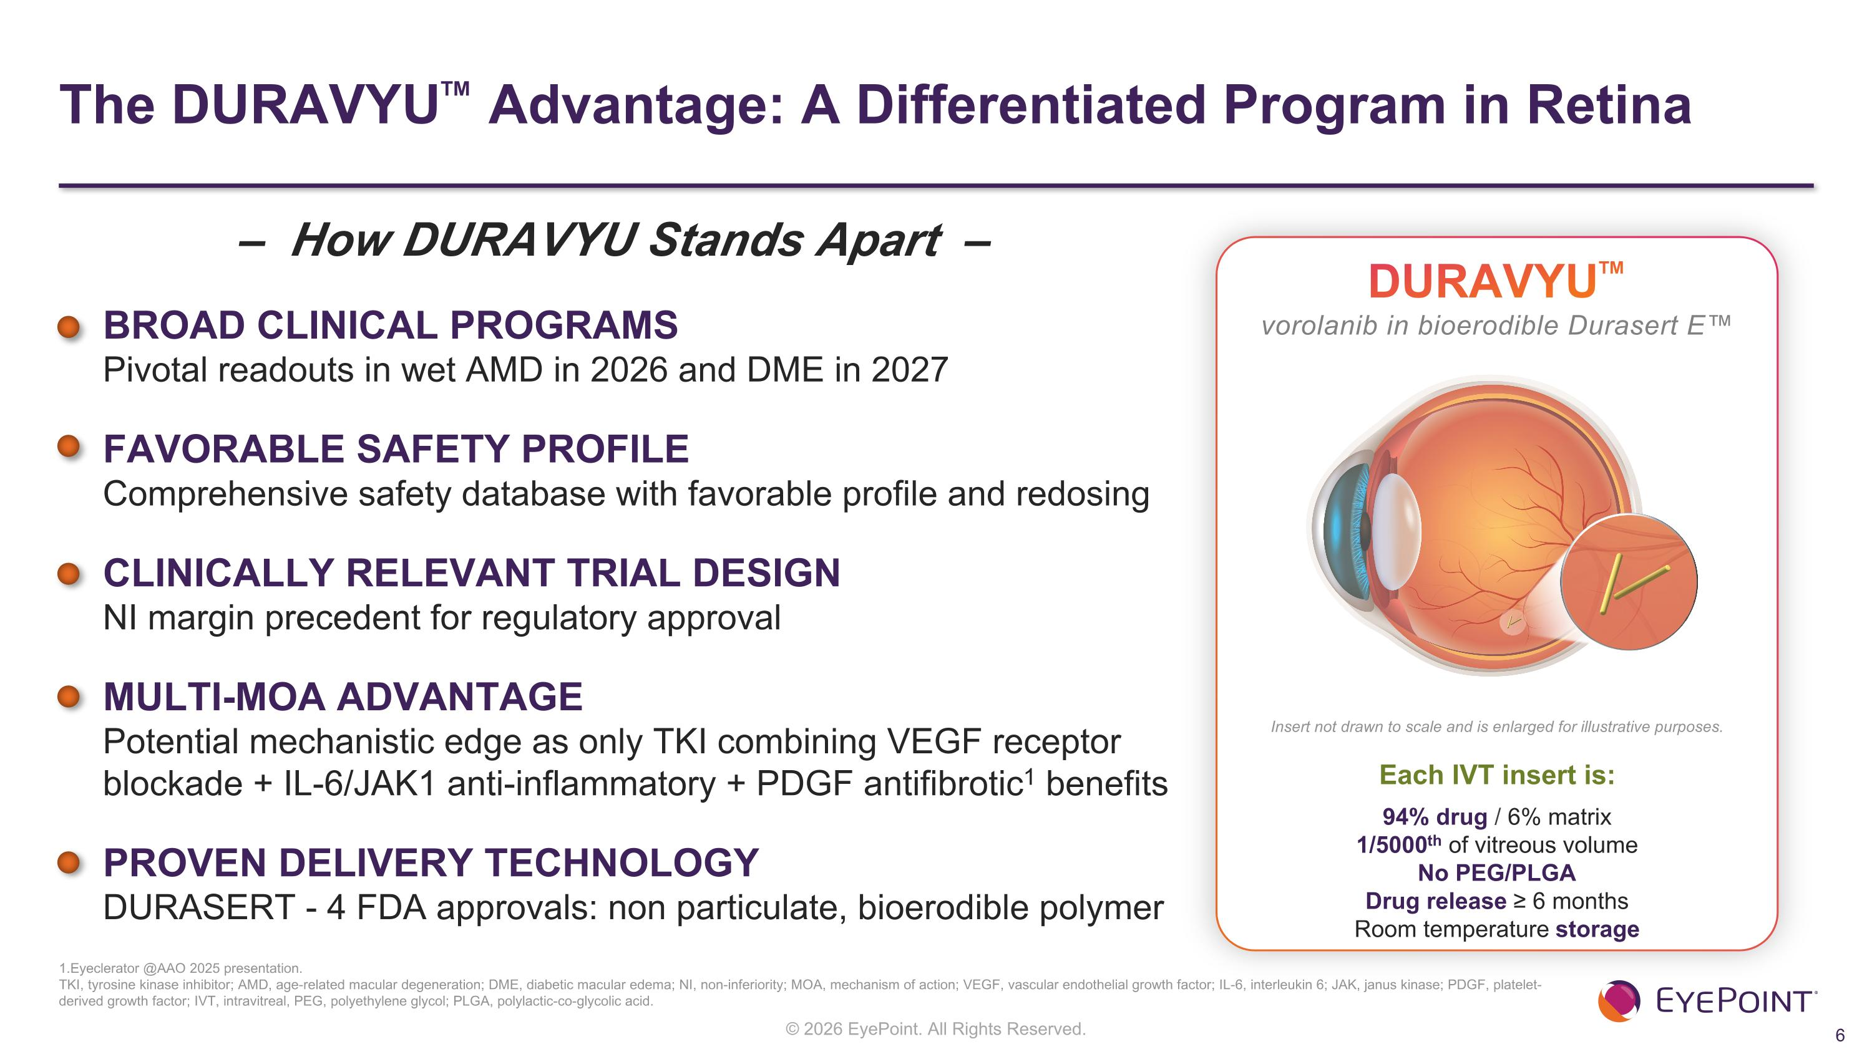
The DURAVYU Advantage: A Differentiated Program in Retina 1.Eyeclerator @AAO 2025 presentation. ?TKI, tyrosine kinase inhibitor; AMD, age-related macular degeneration; DME, diabetic macular edema; NI, non-inferiority; MOA, mechanism of action; VEGF, vascular endothelial growth factor; IL-6, interleukin 6; JAK, janus kinase; PDGF, platelet-derived growth factor; IVT, intravitreal, PEG, polyethylene glycol; PLGA, polylactic-co-glycolic acid. BROAD CLINICAL PROGRAMS Pivotal readouts in wet AMD in 2026 and DME in 2027 FAVORABLE SAFETY PROFILE Comprehensive safety database with favorable profile and redosing CLINICALLY RELEVANT TRIAL DESIGN NI margin precedent for regulatory approval MULTI-MOA ADVANTAGE Potential mechanistic edge as only TKI combining VEGF receptor blockade + IL-6/JAK1 anti-inflammatory + PDGF antifibrotic1 benefits PROVEN DELIVERY TECHNOLOGY DURASERT - 4 FDA approvals: non particulate, bioerodible polymer DURAVYU vorolanib in bioerodible Durasert E Each IVT insert is: 94% drug / 6% matrix 1/5000th of vitreous volume?No PEG/PLGA?Drug release ≥ 6 months?Room temperature storage Insert not drawn to scale and is enlarged for illustrative purposes. – How DURAVYU Stands Apart –

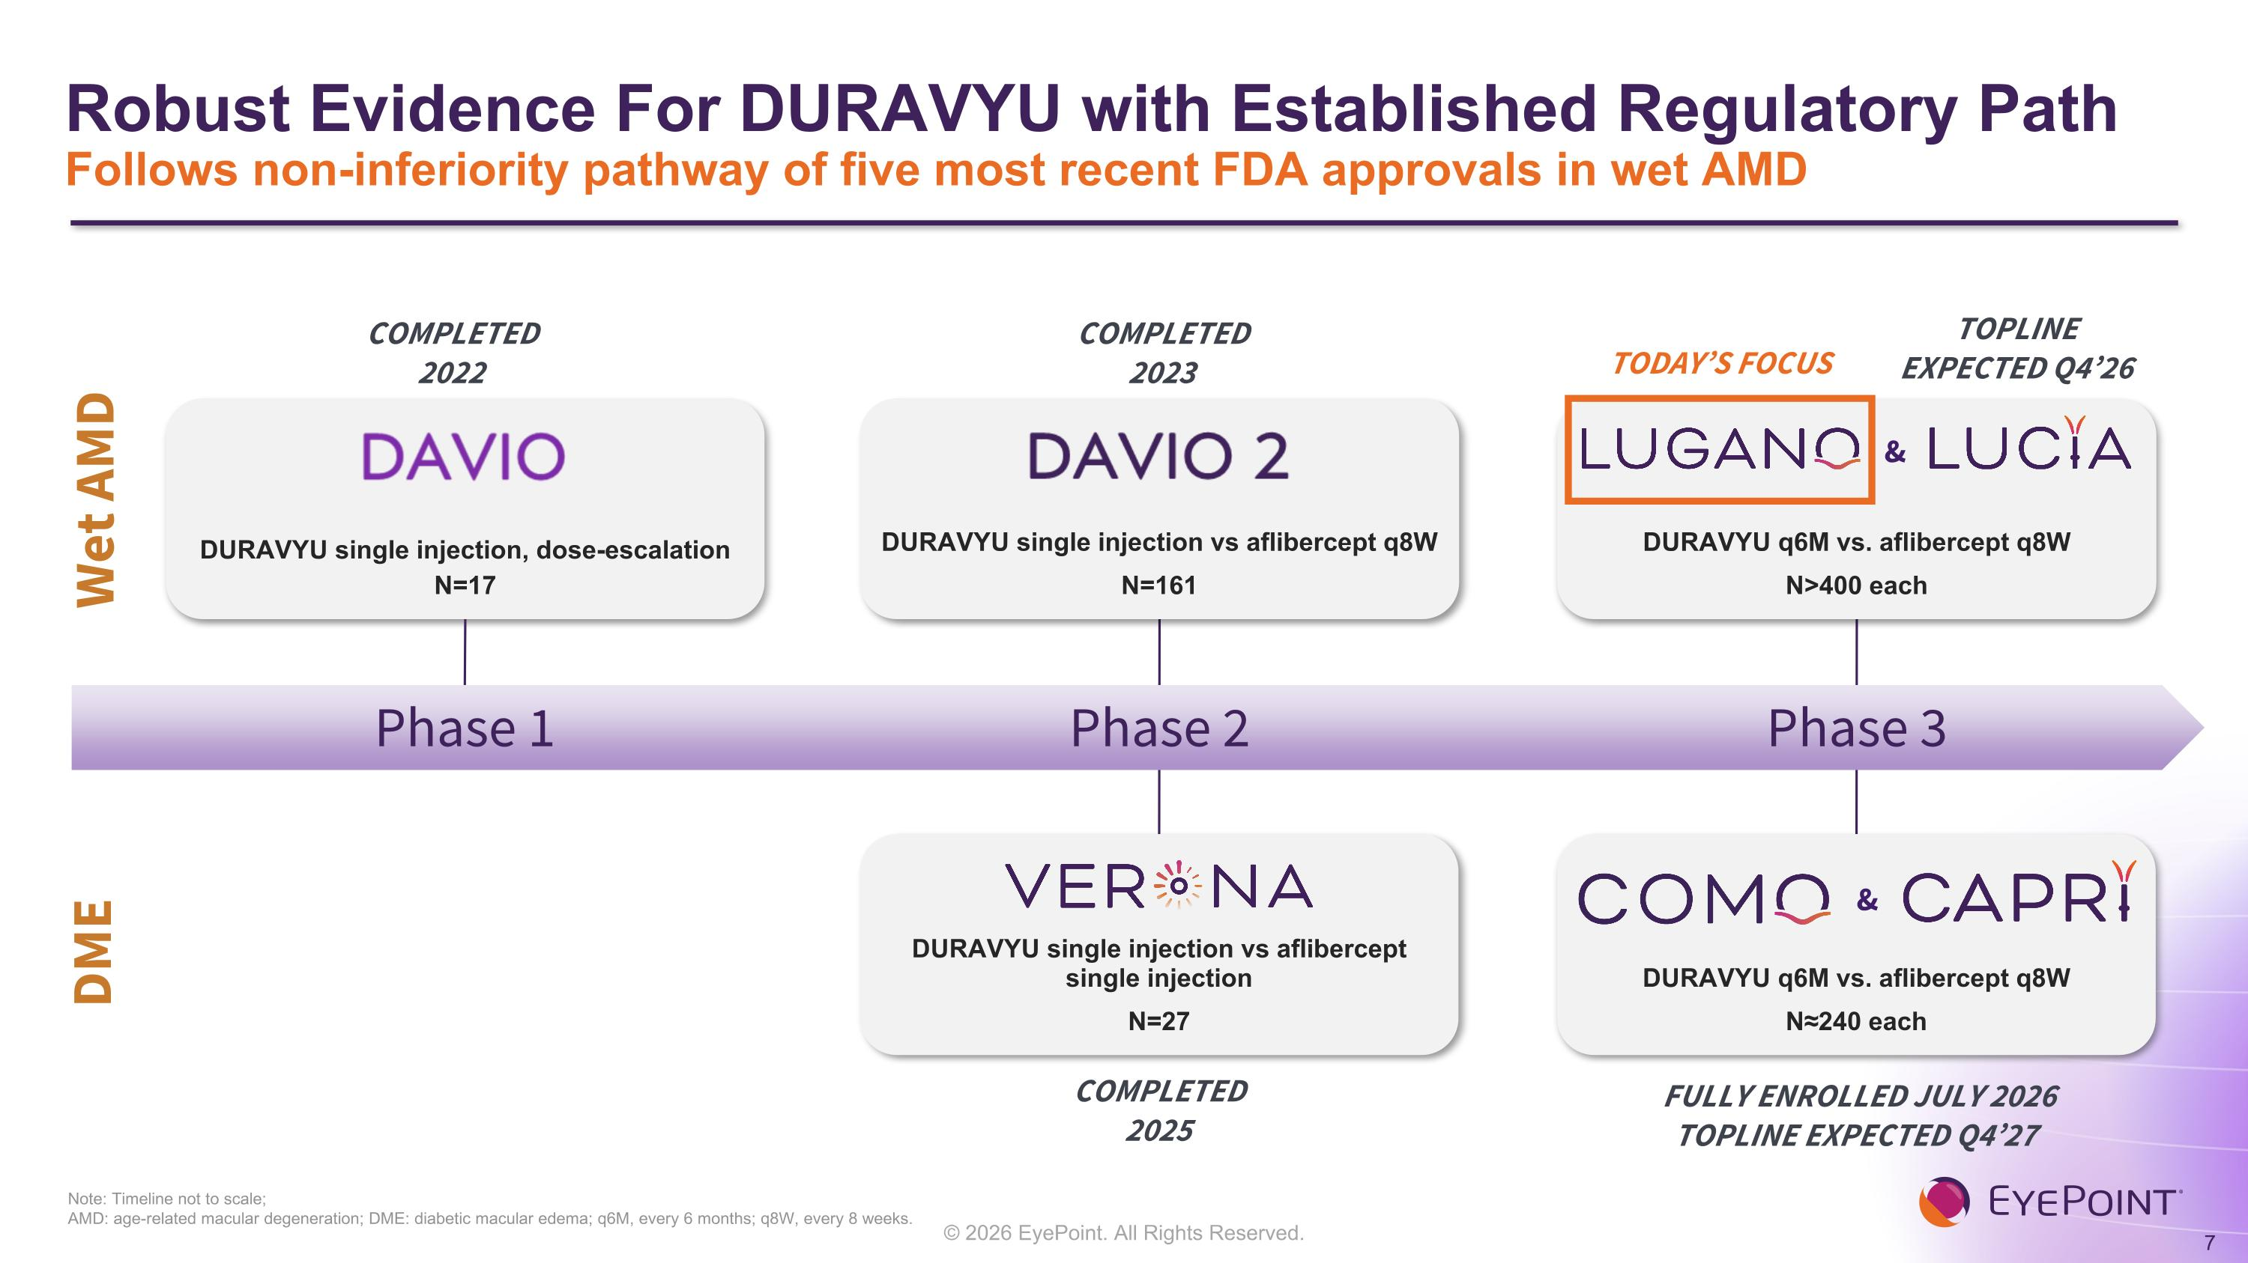
Robust Evidence For DURAVYU with Established Regulatory Path?Follows non-inferiority pathway of five most recent FDA approvals in wet AMD Note: Timeline not to scale; ?AMD: age-related macular degeneration; DME: diabetic macular edema; q6M, every 6 months; q8W, every 8 weeks. Wet AMD DURAVYU single injection, dose-escalation N=17 Phase 1 COMPLETED 2022 DME Phase 2 COMPLETED 2023 COMPLETED?2025 DURAVYU single injection vs aflibercept single injection N=27 DURAVYU single injection vs aflibercept q8W N=161 Phase 3 FULLY ENROLLED JULY 2026?TOPLINE EXPECTED Q4’27 DURAVYU q6M vs. aflibercept q8W N≈240 each & DURAVYU q6M vs. aflibercept q8W N>400 each & TOPLINE EXPECTED Q4’26 TODAY’S FOCUS

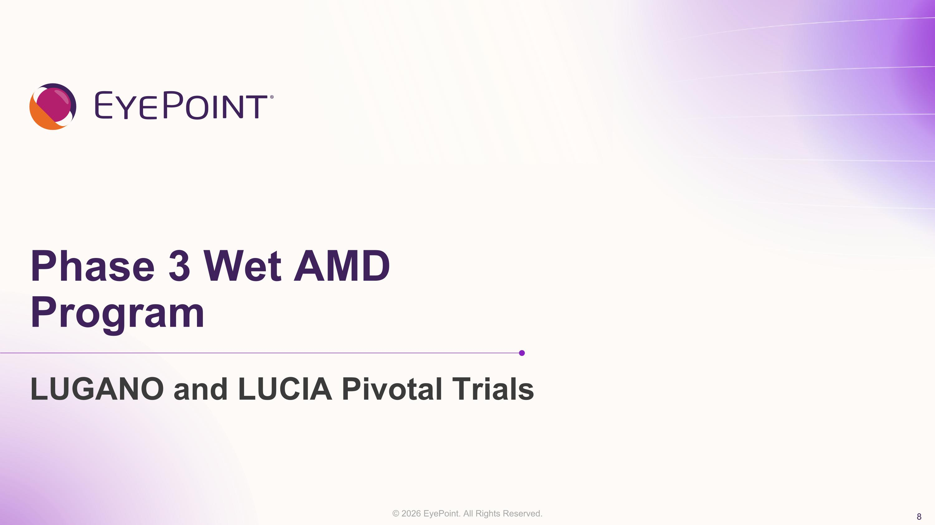
Phase 3 Wet AMD Program LUGANO and LUCIA Pivotal Trials

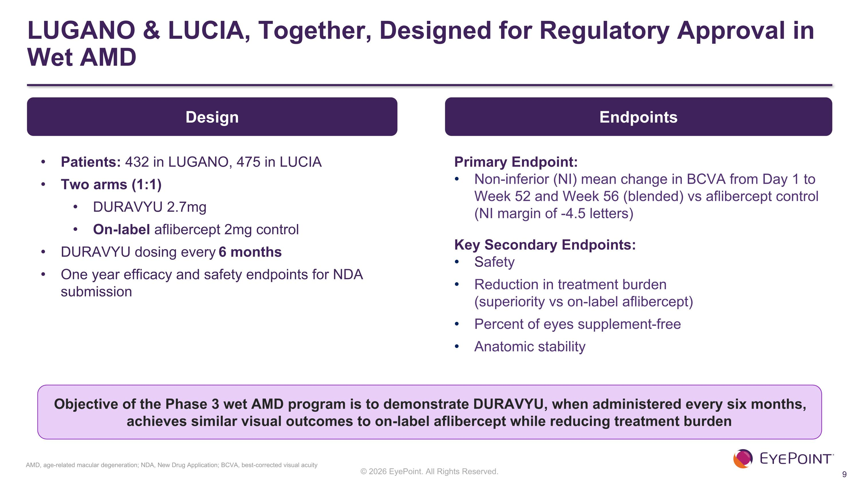
LUGANO & LUCIA, Together, Designed for Regulatory Approval in Wet AMD Endpoints Primary Endpoint: Non-inferior (NI) mean change in BCVA from Day 1 to Week 52 and Week 56 (blended) vs aflibercept control ?(NI margin of -4.5 letters) Key Secondary Endpoints: Safety Reduction in treatment burden ?(superiority vs on-label aflibercept) Percent of eyes supplement-free Anatomic stability Objective of the Phase 3 wet AMD program is to demonstrate DURAVYU, when administered every six months, achieves similar visual outcomes to on-label aflibercept while reducing treatment burden Design Patients: 432 in LUGANO, 475 in LUCIA Two arms (1:1) DURAVYU 2.7mg On-label aflibercept 2mg control DURAVYU dosing every 6 months One year efficacy and safety endpoints for NDA submission AMD, age-related macular degeneration; NDA, New Drug Application; BCVA, best-corrected visual acuity

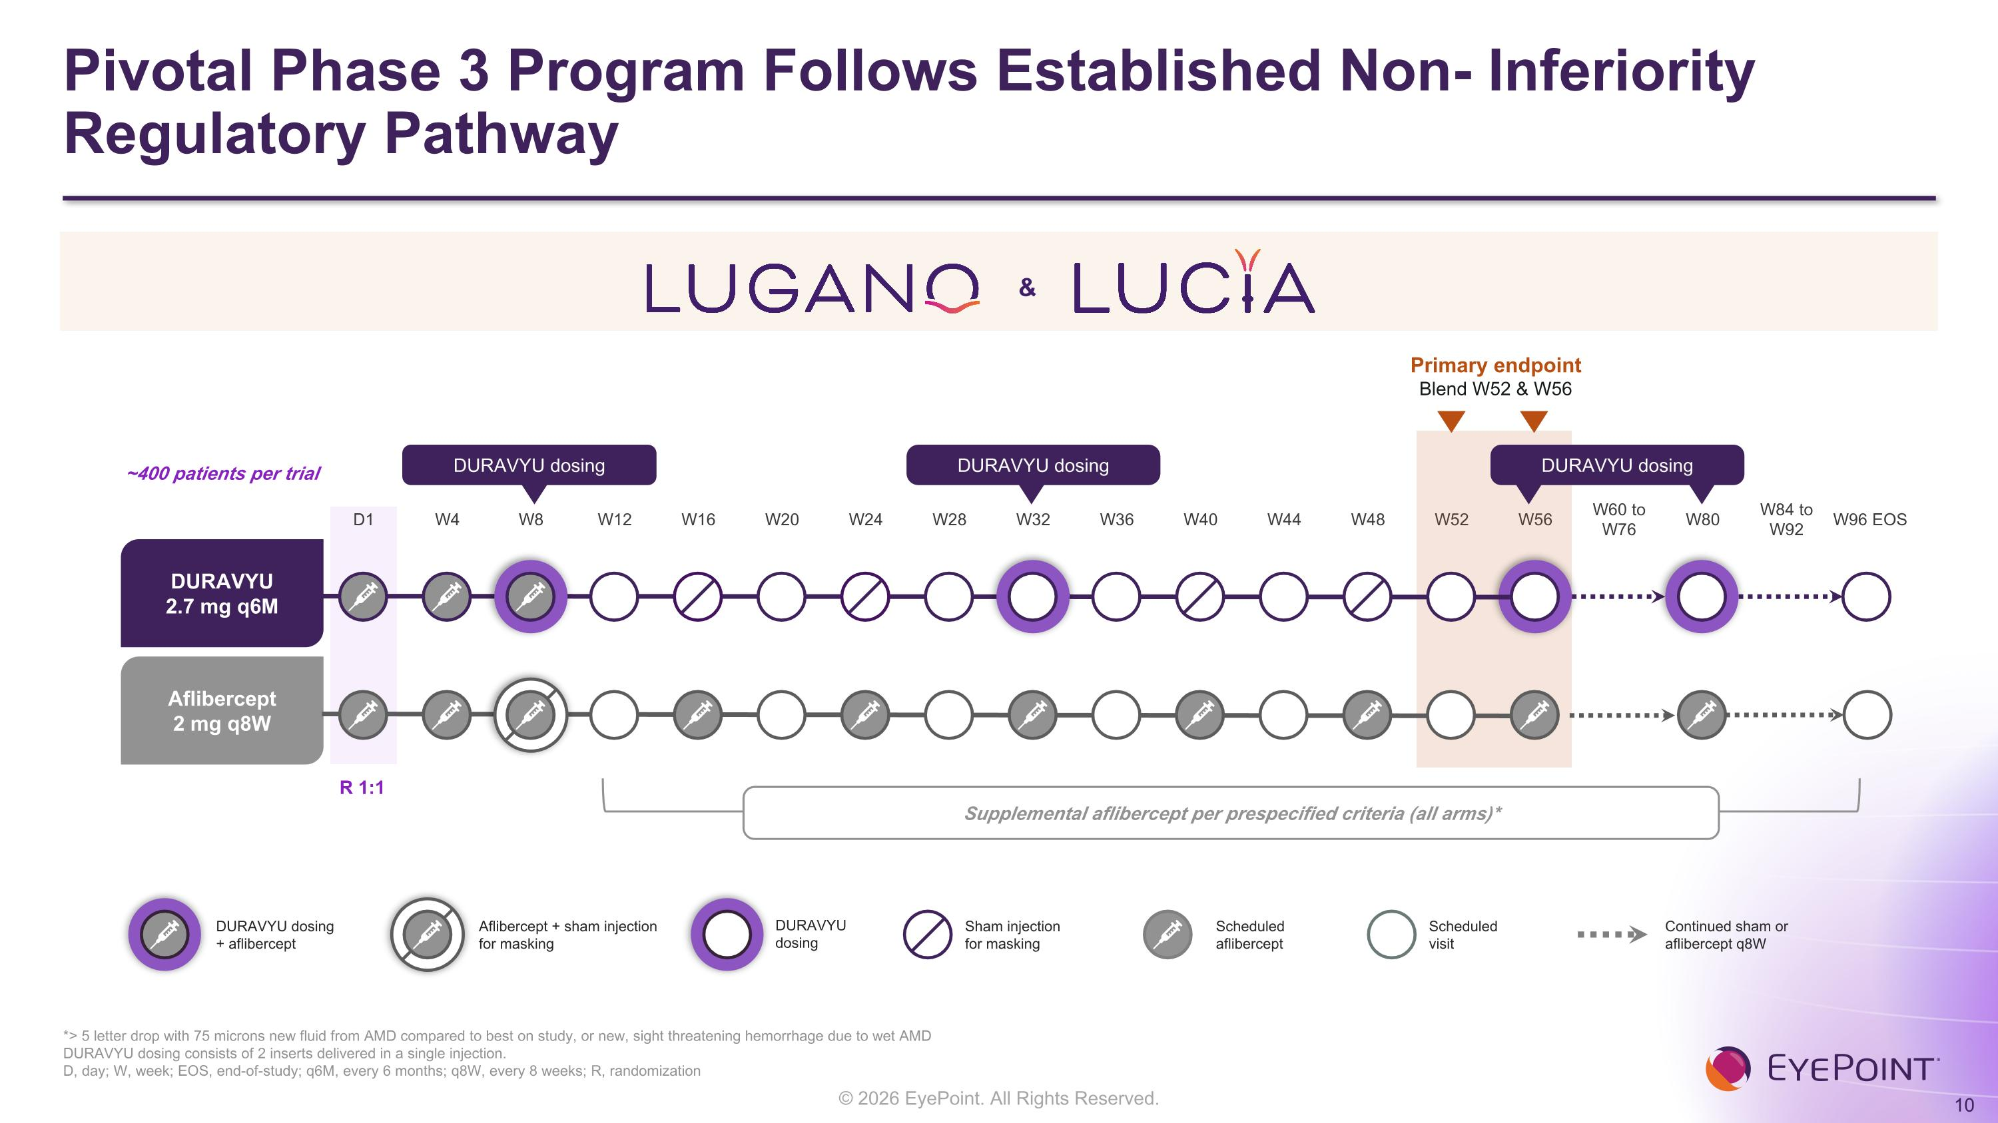
Pivotal Phase 3 Program Follows Established Non- Inferiority Regulatory Pathway *> 5 letter drop with 75 microns new fluid from AMD compared to best on study, or new, sight threatening hemorrhage due to wet AMD DURAVYU dosing consists of 2 inserts delivered in a single injection. D, day; W, week; EOS, end-of-study; q6M, every 6 months; q8W, every 8 weeks; R, randomization D1 W4 W8 W12 W16 W20 W24 W28 W32 W36 W40 W44 W48 W52 W56 W60 to W76 W80 W84 to W92 W96 EOS Primary endpoint Blend W52 & W56 DURAVYU 2.7 mg q6M Aflibercept 2 mg q8W DURAVYU dosing DURAVYU dosing DURAVYU dosing ~400 patients per trial R 1:1 Supplemental aflibercept per prespecified criteria (all arms)* Scheduled?aflibercept Scheduled?visit Sham injection?for masking Continued sham or?aflibercept q8W DURAVYU dosing?+ aflibercept Aflibercept + sham injection for masking DURAVYU?dosing &


LUGANO Topline Results

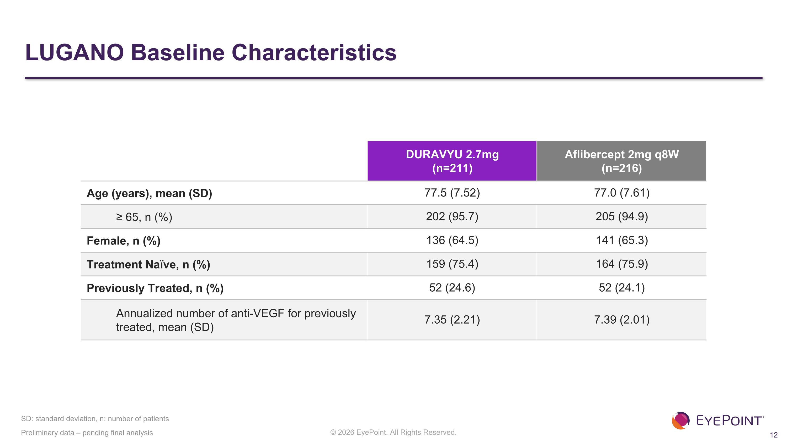
LUGANO Baseline Characteristics Preliminary data – pending final analysis DURAVYU 2.7mg (n=211) Aflibercept 2mg q8W (n=216) Age (years), mean (SD) 77.5 (7.52)​ 77.0 (7.61)​ ≥ 65, n (%) 202 (95.7)​ 205 (94.9)​ Female, n (%) 136 (64.5)​ 141 (65.3)​ Treatment Naïve, n (%) 159 (75.4)​ 164 (75.9)​ Previously Treated, n (%) 52 (24.6)​ 52 (24.1)​ Annualized number of anti-VEGF for previously treated, mean (SD)​ 7.35 (2.21)​ 7.39 (2.01)​ SD: standard deviation, n: number of patients

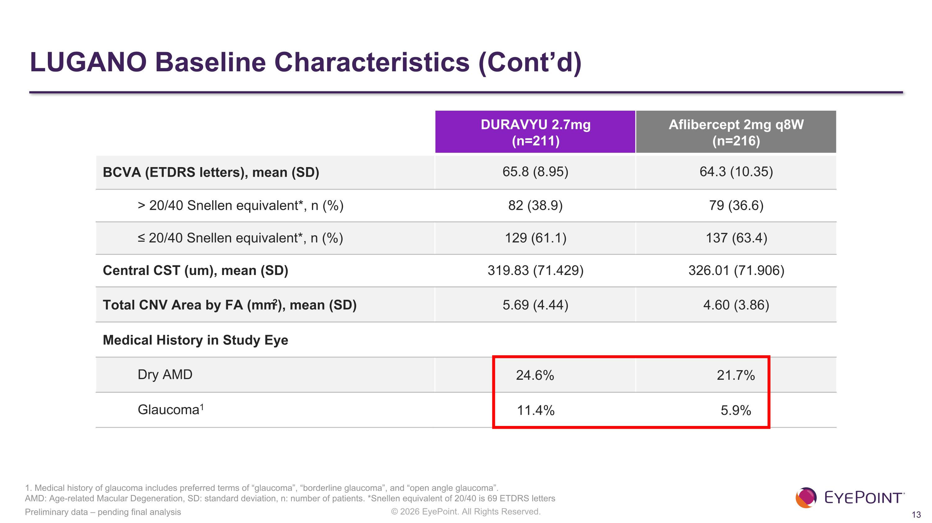
LUGANO Baseline Characteristics (Cont’d) DURAVYU 2.7mg (n=211) Aflibercept 2mg q8W (n=216) BCVA (ETDRS letters), mean (SD) 65.8 (8.95)​ 64.3 (10.35)​ > 20/40 Snellen equivalent*, n (%)​ 82 (38.9)​ 79 (36.6)​ ≤ 20/40 Snellen equivalent*, n (%)​ 129 (61.1)​ 137 (63.4)​ Central CST (um), mean (SD)​ 319.83 (71.429)​ 326.01 (71.906)​ Total CNV Area by FA (mm2), mean (SD) 5.69 (4.44) 4.60 (3.86) Medical History in Study Eye Dry AMD 24.6% 21.7% Glaucoma​1 11.4% 5.9% Preliminary data – pending final analysis 1. Medical history of glaucoma includes preferred terms of “glaucoma”, “borderline glaucoma”, and “open angle glaucoma”. ?AMD: Age-related Macular Degeneration, SD: standard deviation, n: number of patients. *Snellen equivalent of 20/40 is 69 ETDRS letters

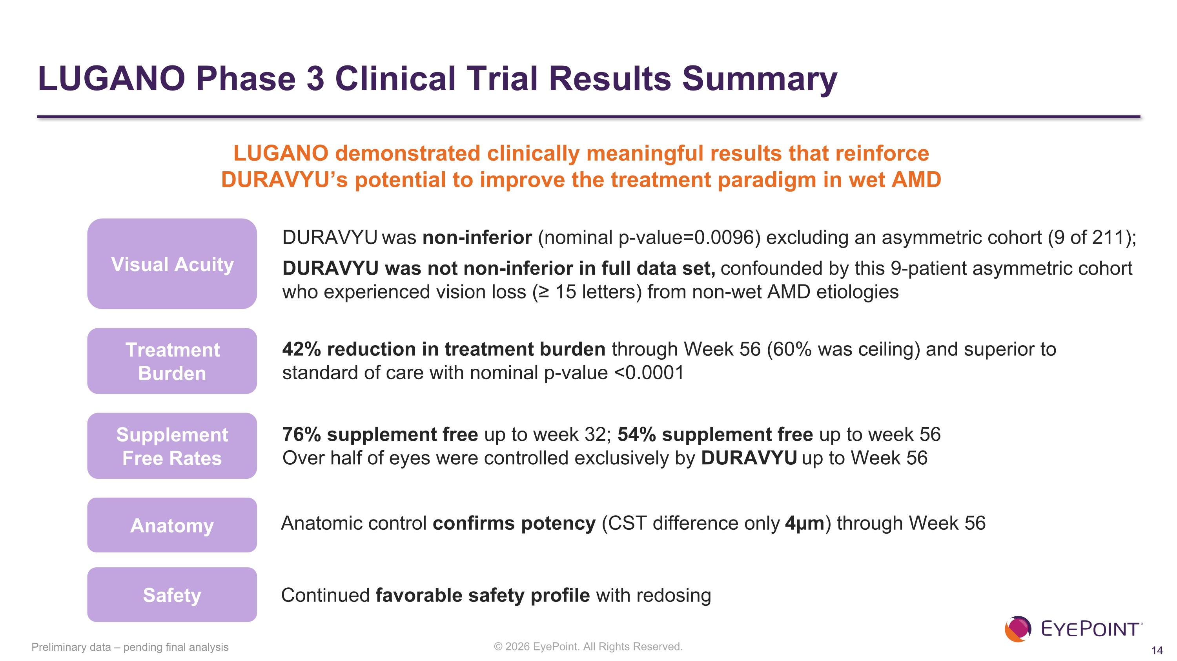
LUGANO Phase 3 Clinical Trial Results Summary Preliminary data – pending final analysis Visual Acuity DURAVYU was non-inferior (nominal p-value=0.0096) excluding an asymmetric cohort (9 of 211); DURAVYU was not non-inferior in full data set, confounded by this 9-patient asymmetric cohort who experienced vision loss (≥ 15 letters) from non-wet AMD etiologies Treatment Burden Safety Continued favorable safety profile with redosing 42% reduction in treatment burden through Week 56 (60% was ceiling) and superior to standard of care with nominal p-value <0.0001 Supplement ?Free Rates Anatomy Anatomic control confirms potency (CST difference only 4µm) through Week 56 76% supplement free up to week 32; 54% supplement free up to week 56 Over half of eyes were controlled exclusively by DURAVYU up to Week 56 LUGANO demonstrated clinically meaningful results that reinforce ?DURAVYU’s potential to improve the treatment paradigm in wet AMD


LUGANO Topline Results Visual Acuity

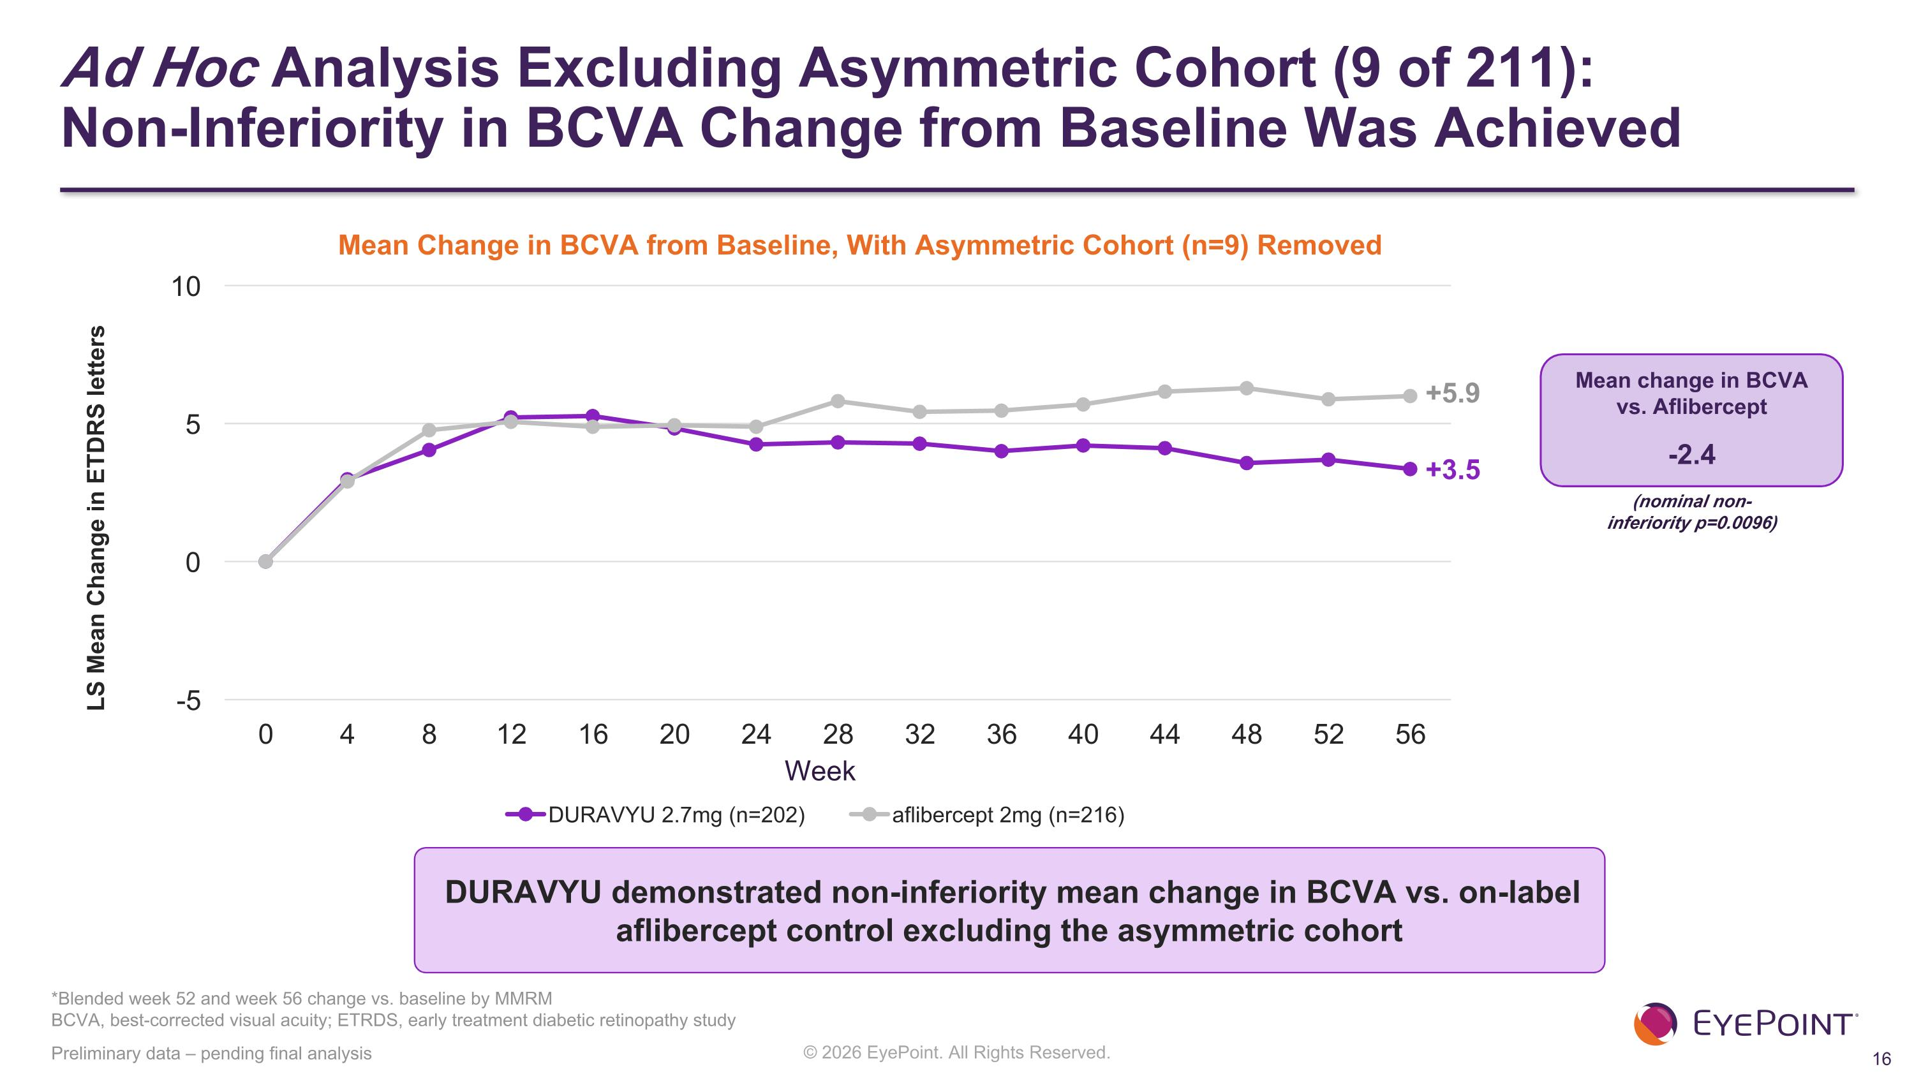
Ad Hoc Analysis Excluding Asymmetric Cohort (9 of 211): ?Non-Inferiority in BCVA Change from Baseline Was Achieved Preliminary data – pending final analysis DURAVYU demonstrated non-inferiority mean change in BCVA vs. on-label aflibercept control excluding the asymmetric cohort LS Mean Change in ETDRS letters Mean Change in BCVA from Baseline, With Asymmetric Cohort (n=9) Removed Week +5.9 +3.5 (nominal non-inferiority p=0.0096) Mean change in BCVA ?vs. Aflibercept -2.4 *Blended week 52 and week 56 change vs. baseline by MMRM?BCVA, best-corrected visual acuity; ETRDS, early treatment diabetic retinopathy study

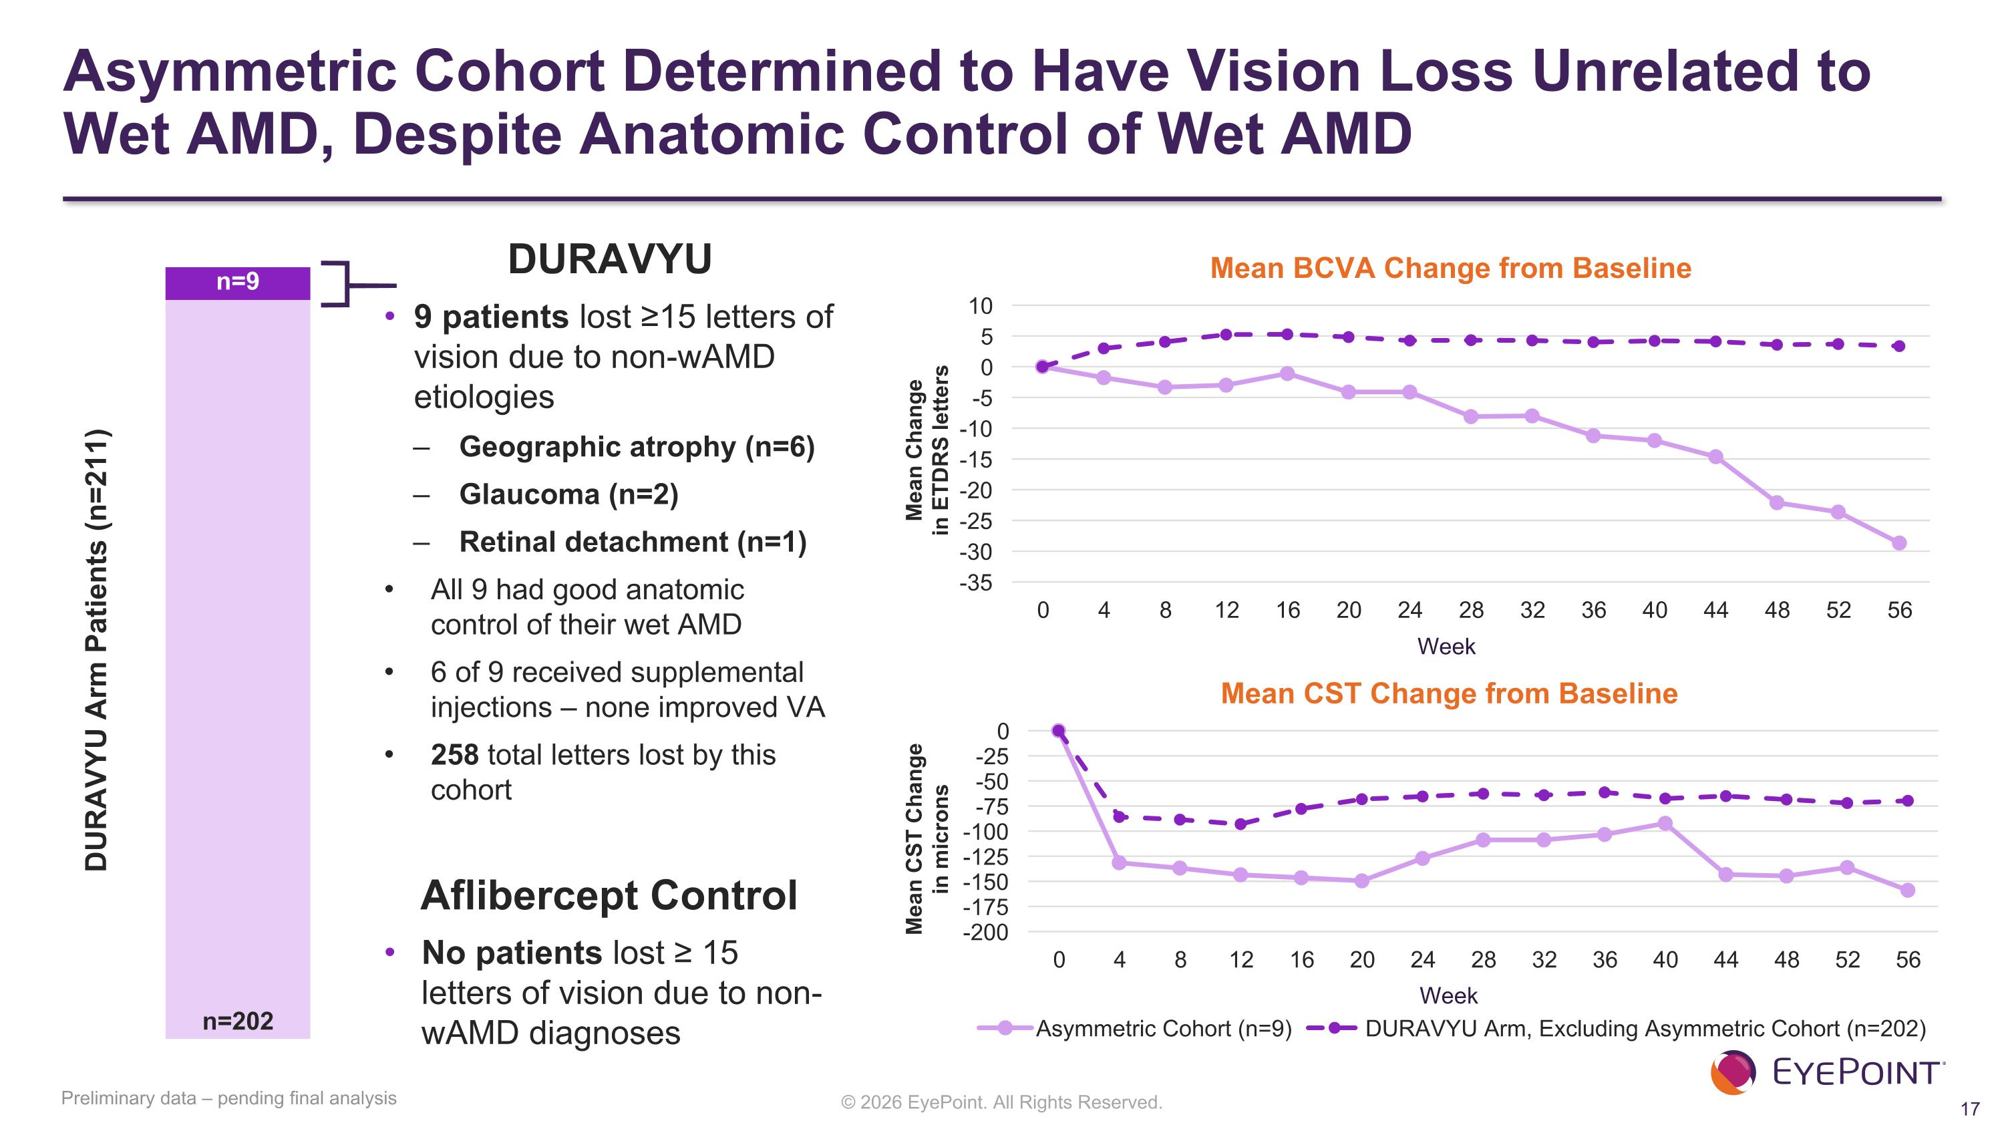
Asymmetric Cohort Determined to Have Vision Loss Unrelated to Wet AMD, Despite Anatomic Control of Wet AMD Preliminary data – pending final analysis n=202 n=9 Mean Change ?in ETDRS letters Mean BCVA Change from Baseline Week Mean CST Change from Baseline Mean CST Change ?in microns Week DURAVYU Arm Patients (n=211) DURAVYU 9 patients lost ≥15 letters of vision due to non-wAMD etiologies Geographic atrophy (n=6) Glaucoma (n=2) Retinal detachment (n=1) All 9 had good anatomic control of their wet AMD 6 of 9 received supplemental injections – none improved VA 258 total letters lost by this cohort Aflibercept Control No patients lost ≥ 15 letters of vision due to non-wAMD diagnoses

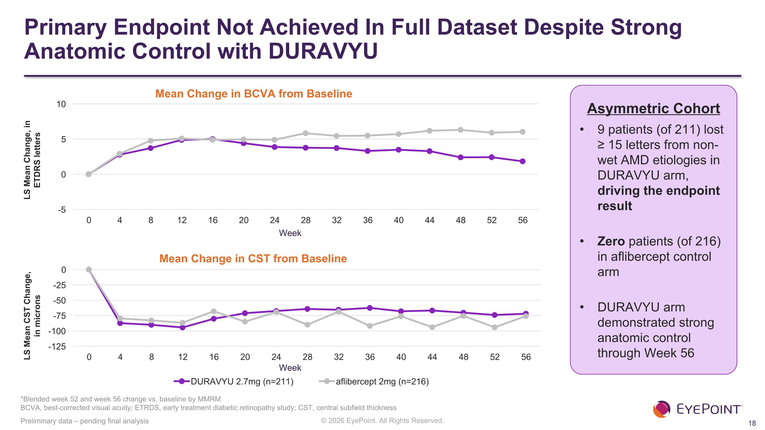
Primary Endpoint Not Achieved In Full Dataset Despite Strong Anatomic Control with DURAVYU LS Mean Change, in ?ETDRS letters *Blended week 52 and week 56 change vs. baseline by MMRM?BCVA, best-corrected visual acuity; ETRDS, early treatment diabetic retinopathy study; CST, central subfield thickness Preliminary data – pending final analysis Mean Change in BCVA from Baseline Week Asymmetric Cohort 9 patients (of 211) lost ≥ 15 letters from non-wet AMD etiologies in DURAVYU arm, driving the endpoint result Zero patients (of 216) in aflibercept control arm DURAVYU arm demonstrated strong anatomic control through Week 56 Mean Change in CST from Baseline LS Mean CST Change, ?in microns Week

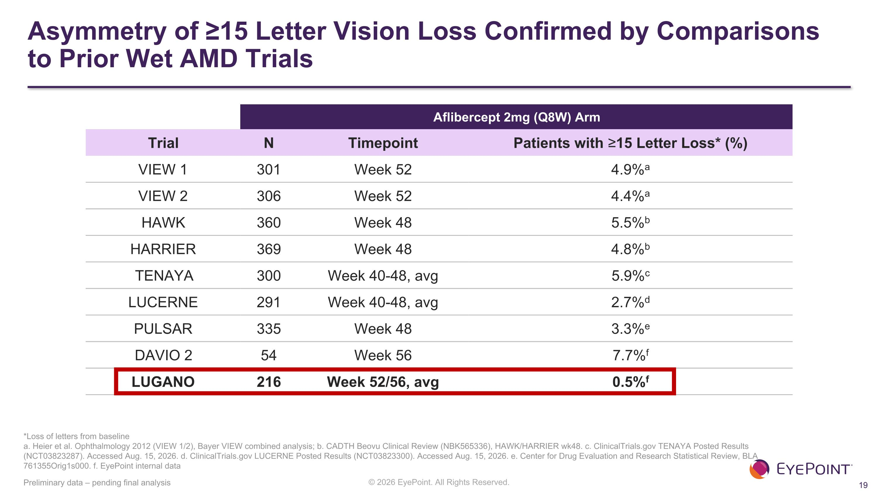
Asymmetry of ≥15 Letter Vision Loss Confirmed by Comparisons to Prior Wet AMD Trials Preliminary data – pending final analysis Aflibercept 2mg (Q8W) Arm Trial N Timepoint Patients with ≥15 Letter Loss* (%) VIEW 1 301 Week 52 4.9%a VIEW 2 306 Week 52 4.4%a HAWK 360 Week 48 5.5%b HARRIER 369 Week 48 4.8%b TENAYA 300 Week 40-48, avg 5.9%c LUCERNE 291 Week 40-48, avg 2.7%d PULSAR 335 Week 48 3.3%e DAVIO 2 54 Week 56 7.7%f LUGANO 216 Week 52/56, avg 0.5%f *Loss of letters from baseline a. Heier et al. Ophthalmology 2012 (VIEW 1/2), Bayer VIEW combined analysis; b. CADTH Beovu Clinical Review (NBK565336), HAWK/HARRIER wk48. c. ClinicalTrials.gov TENAYA Posted Results (NCT03823287). Accessed Aug. 15, 2026. d. ClinicalTrials.gov LUCERNE Posted Results (NCT03823300). Accessed Aug. 15, 2026. e. Center for Drug Evaluation and Research Statistical Review, BLA 761355Orig1s000. f. EyePoint internal data


What does our preliminary evaluation conclude?

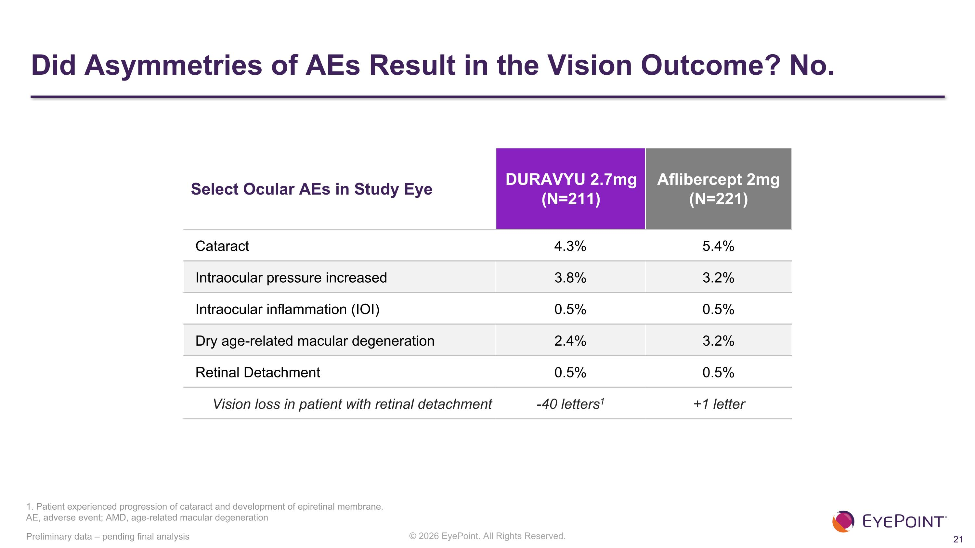
Select Ocular AEs in Study Eye DURAVYU 2.7mg (N=211) Aflibercept 2mg (N=221) Cataract 4.3% 5.4% Intraocular pressure increased 3.8% 3.2% Intraocular inflammation (IOI) 0.5% 0.5% Dry age-related macular degeneration 2.4% 3.2% Retinal Detachment 0.5% 0.5% Vision loss in patient with retinal detachment -40 letters1 +1 letter Did Asymmetries of AEs Result in the Vision Outcome? No. Preliminary data – pending final analysis 1. Patient experienced progression of cataract and development of epiretinal membrane. ?AE, adverse event; AMD, age-related macular degeneration

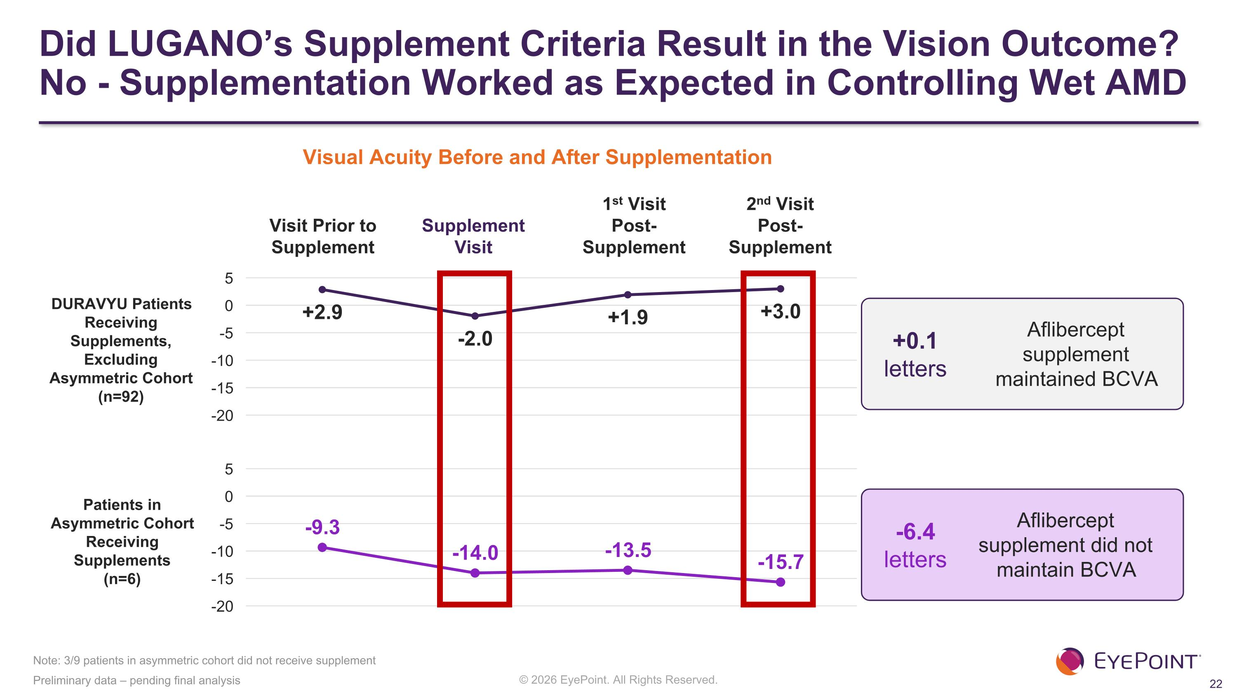
Did LUGANO’s Supplement Criteria Result in the Vision Outcome? No - Supplementation Worked as Expected in Controlling Wet AMD Preliminary data – pending final analysis Note: 3/9 patients in asymmetric cohort did not receive supplement Visit Prior to Supplement Supplement Visit 1st Visit ?Post-Supplement 2nd Visit ?Post-Supplement Visual Acuity Before and After Supplementation -6.4 letters +0.1 letters Aflibercept supplement did not maintain BCVA Aflibercept supplement maintained BCVA DURAVYU Patients Receiving Supplements, Excluding ?Asymmetric Cohort?(n=92) Patients in Asymmetric Cohort Receiving Supplements?(n=6)

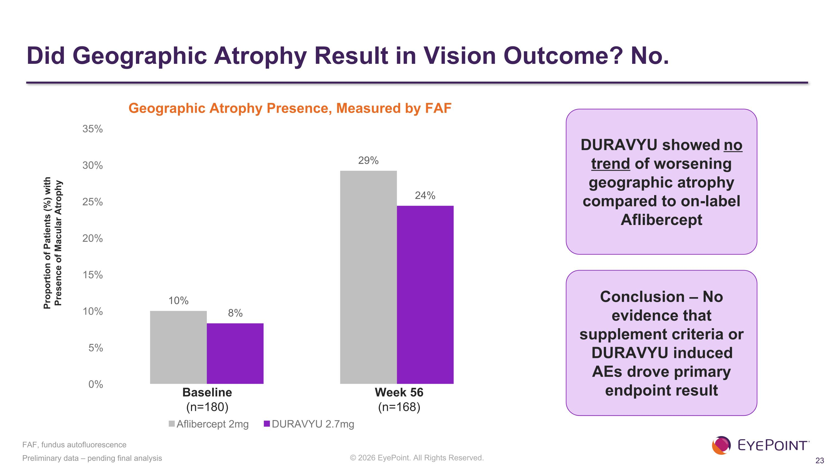
Did Geographic Atrophy Result in Vision Outcome? No. Preliminary data – pending final analysis DURAVYU showed no trend of worsening geographic atrophy compared to on-label Aflibercept Geographic Atrophy Presence, Measured by FAF Baseline?(n=180) Week 56?(n=168) Proportion of Patients (%) with Presence of Macular Atrophy FAF, fundus autofluorescence Conclusion – No evidence that supplement criteria or DURAVYU induced AEs drove primary endpoint result


LUGANO Topline Results Reduction in Treatment Burden & Supplement Free Rates

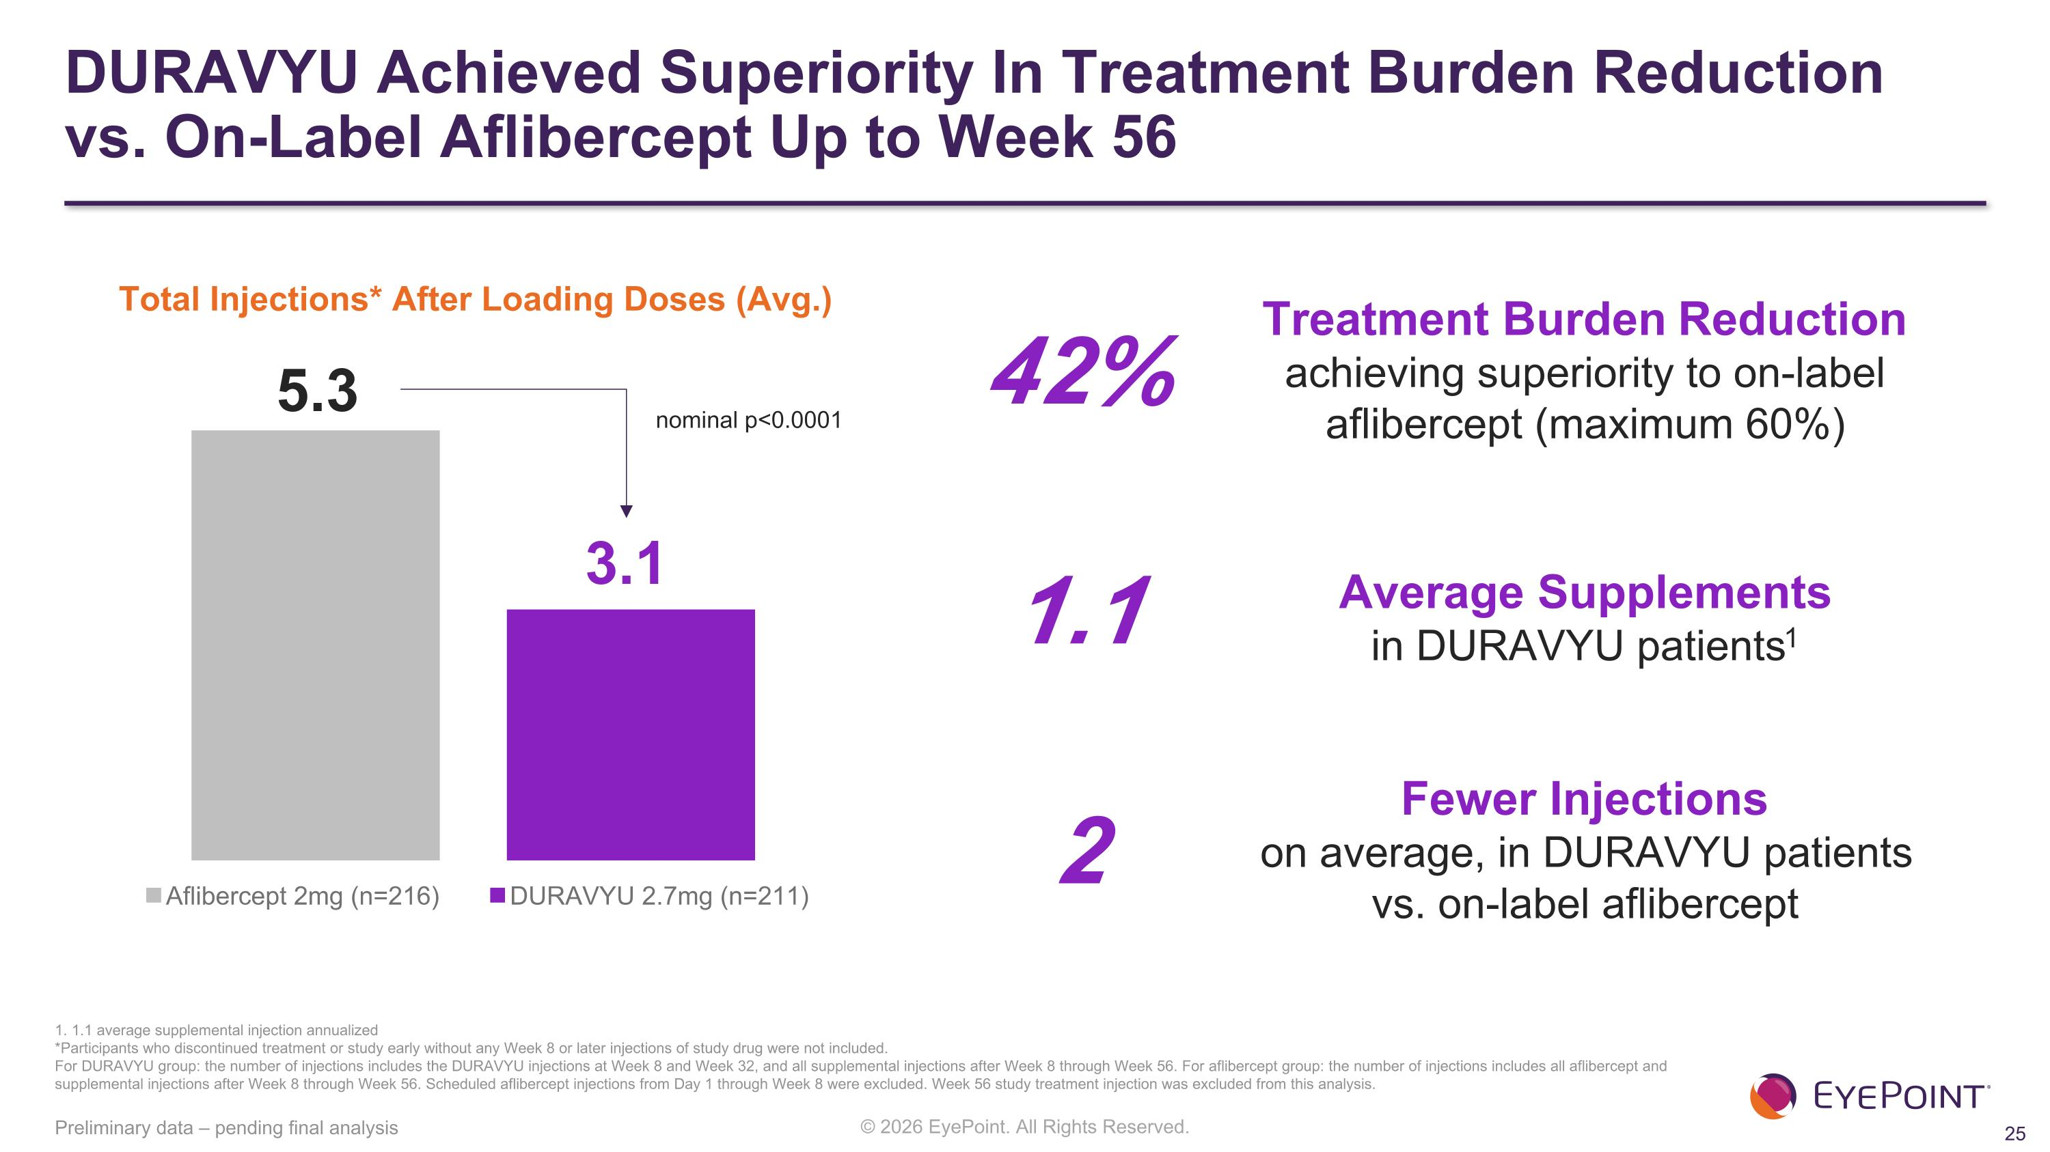
Average Supplements ?in DURAVYU patients1 DURAVYU Achieved Superiority In Treatment Burden Reduction ?vs. On-Label Aflibercept Up to Week 56 Preliminary data – pending final analysis Total Injections* After Loading Doses (Avg.) 1. 1.1 average supplemental injection annualized *Participants who discontinued treatment or study early without any Week 8 or later injections of study drug were not included.​ For DURAVYU group: the number of injections includes the DURAVYU injections at Week 8 and Week 32, and all supplemental injections after Week 8 through Week 56. For aflibercept group: the number of injections includes all aflibercept and supplemental injections after Week 8 through Week 56. Scheduled aflibercept injections from Day 1 through Week 8 were excluded. Week 56 study treatment injection was excluded from this analysis.​ 5.3 3.1 Treatment Burden Reduction ?achieving superiority to on-label ?aflibercept (maximum 60%) 42% Fewer Injections ?on average, in DURAVYU patients ?vs. on-label aflibercept 1.1 2 nominal p<0.0001

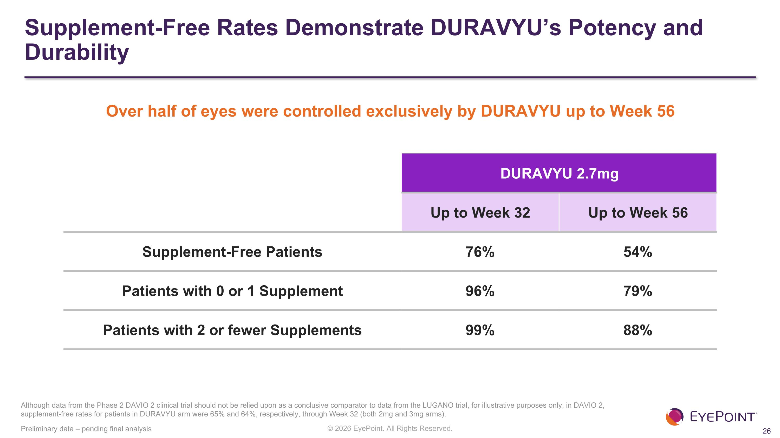
Supplement-Free Rates Demonstrate DURAVYU’s Potency and Durability Preliminary data – pending final analysis DURAVYU 2.7mg Up to Week 32 Up to Week 56 Supplement-Free Patients 76% 54% Patients with 0 or 1 Supplement 96% 79% Patients with 2 or fewer Supplements 99% 88% Although data from the Phase 2 DAVIO 2 clinical trial should not be relied upon as a conclusive comparator to data from the LUGANO trial, for illustrative purposes only, in DAVIO 2, supplement-free rates for patients in DURAVYU arm were 65% and 64%, respectively, through Week 32 (both 2mg and 3mg arms). Over half of eyes were controlled exclusively by DURAVYU up to Week 56

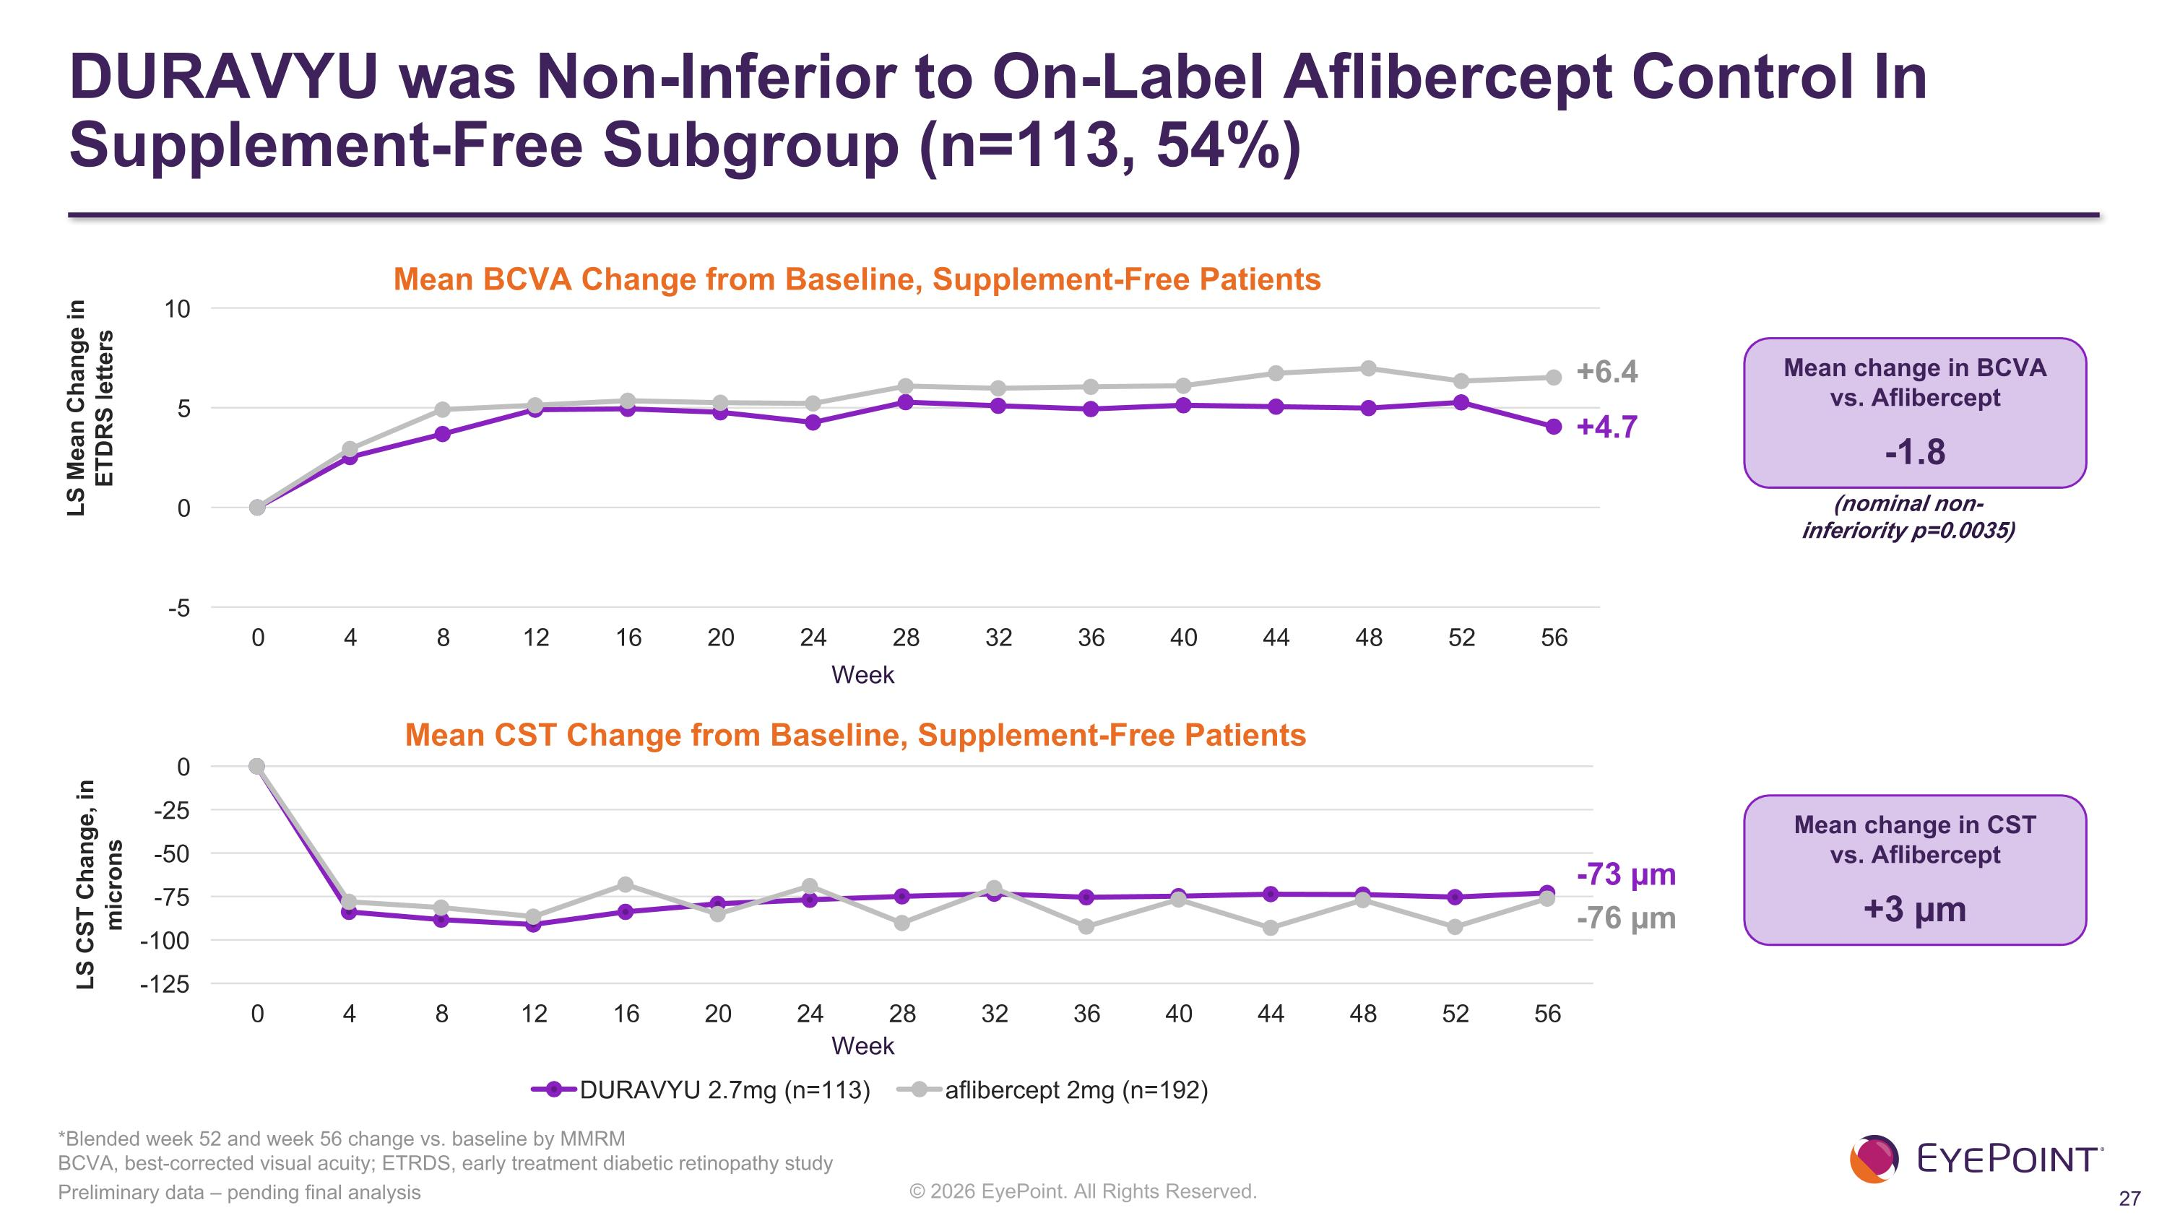
DURAVYU was Non-Inferior to On-Label Aflibercept Control In Supplement-Free Subgroup (n=113, 54%) -76 µm -73 µm +6.4 +4.7 (nominal non-inferiority p=0.0035) Preliminary data – pending final analysis LS Mean Change in ETDRS letters Mean BCVA Change from Baseline, Supplement-Free Patients Week Mean CST Change from Baseline, Supplement-Free Patients LS CST Change, in microns Week Mean change in CST ?vs. Aflibercept +3 µm Mean change in BCVA ?vs. Aflibercept -1.8 *Blended week 52 and week 56 change vs. baseline by MMRM?BCVA, best-corrected visual acuity; ETRDS, early treatment diabetic retinopathy study


LUGANO Topline Results Anatomic Control

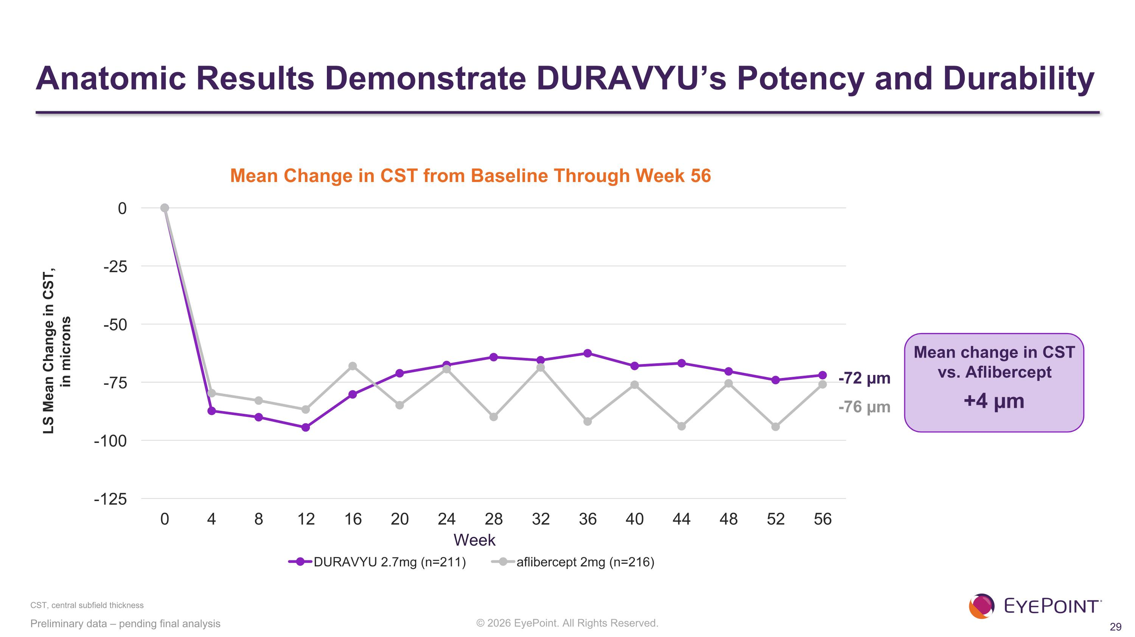
Anatomic Results Demonstrate DURAVYU’s Potency and Durability LS Mean Change in CST, in microns CST, central subfield thickness Preliminary data – pending final analysis Mean Change in CST from Baseline Through Week 56 Week -76 µm -72 µm Mean change in CST vs. Aflibercept +4 µm

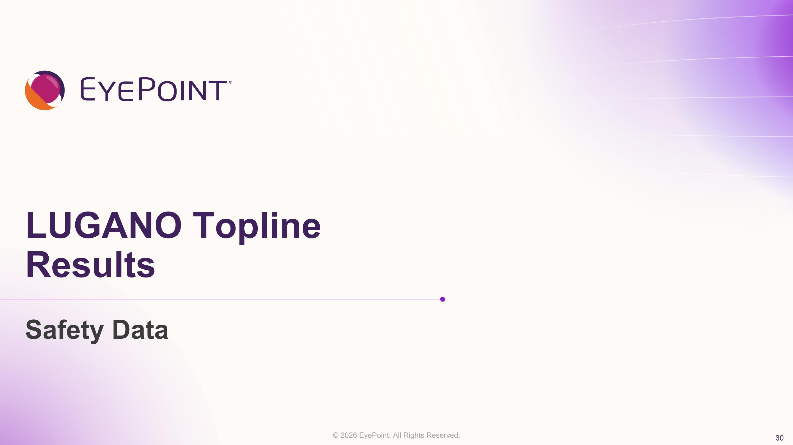
LUGANO Topline Results Safety Data

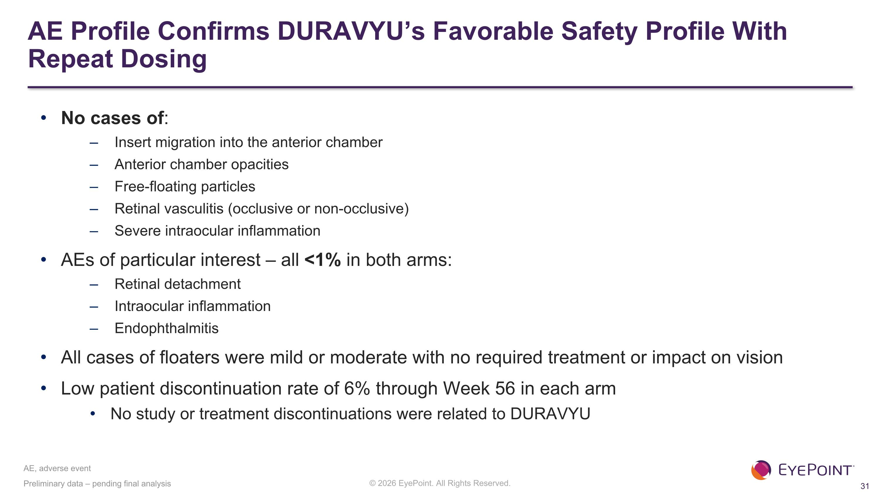
AE Profile Confirms DURAVYU’s Favorable Safety Profile With Repeat Dosing No cases of: Insert migration into the anterior chamber Anterior chamber opacities Free-floating particles Retinal vasculitis (occlusive or non-occlusive) Severe intraocular inflammation AEs of particular interest – all <1% in both arms: Retinal detachment Intraocular inflammation Endophthalmitis All cases of floaters were mild or moderate with no required treatment or impact on vision Low patient discontinuation rate of 6% through Week 56 in each arm No study or treatment discontinuations were related to DURAVYU Preliminary data – pending final analysis AE, adverse event

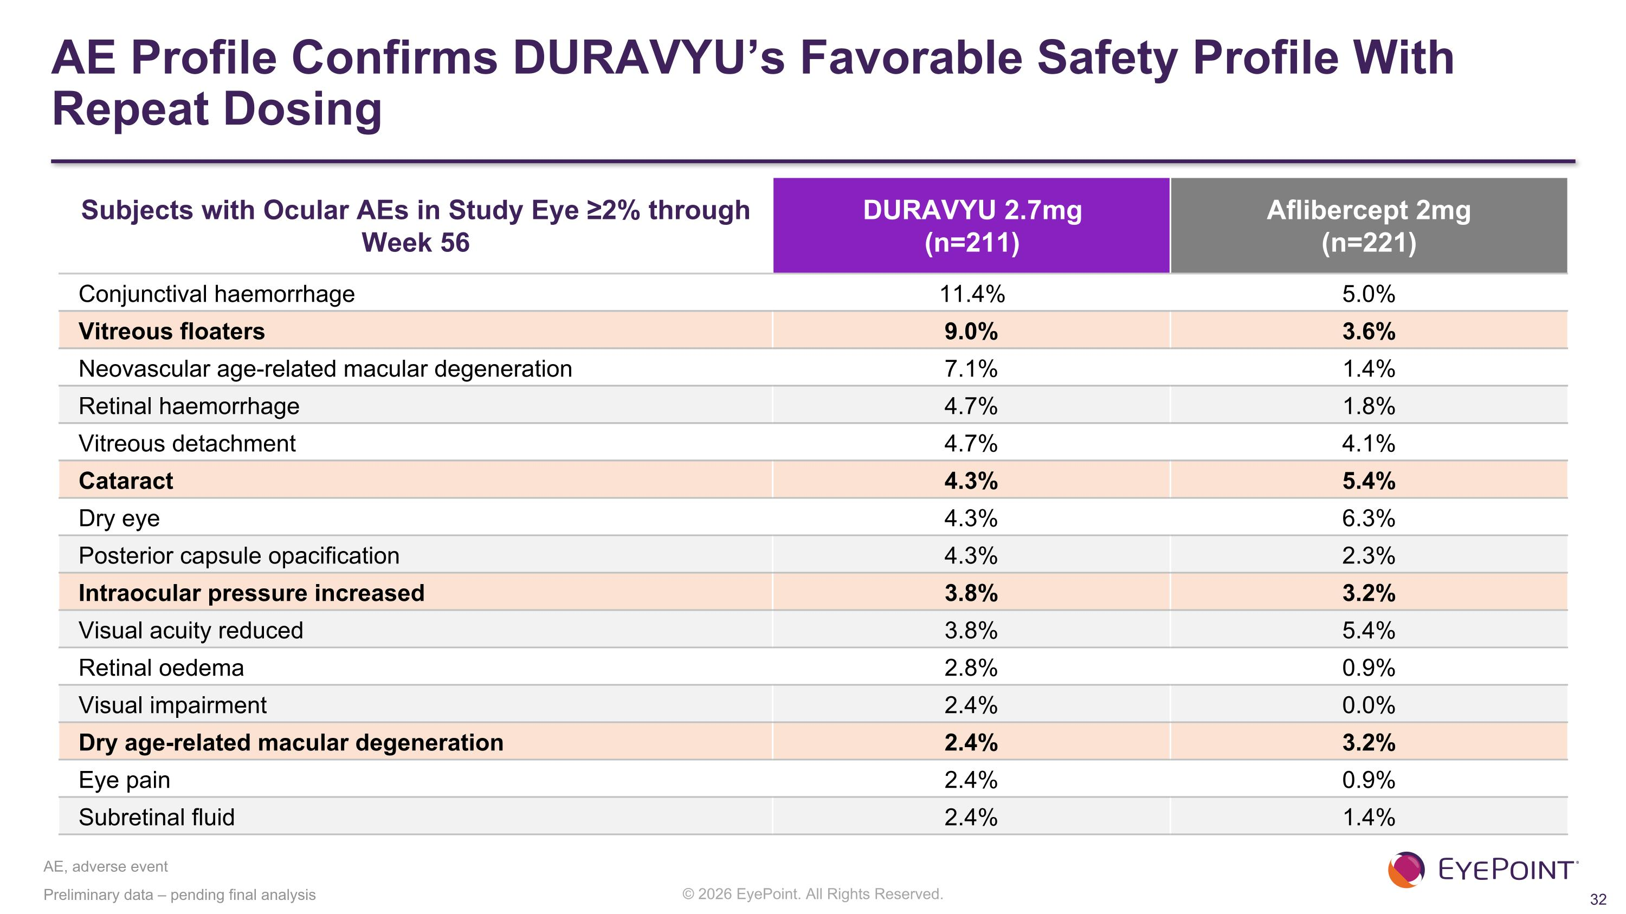
Preliminary data – pending final analysis Subjects with Ocular AEs in Study Eye ≥2% through Week 56 DURAVYU 2.7mg (n=211) Aflibercept 2mg (n=221) Conjunctival haemorrhage 11.4% 5.0% Vitreous floaters 9.0% 3.6% Neovascular age-related macular degeneration 7.1% 1.4% Retinal haemorrhage 4.7% 1.8% Vitreous detachment 4.7% 4.1% Cataract 4.3% 5.4% Dry eye 4.3% 6.3% Posterior capsule opacification 4.3% 2.3% Intraocular pressure increased 3.8% 3.2% Visual acuity reduced 3.8% 5.4% Retinal oedema 2.8% 0.9% Visual impairment 2.4% 0.0% Dry age-related macular degeneration 2.4% 3.2% Eye pain 2.4% 0.9% Subretinal fluid 2.4% 1.4% AE, adverse event AE Profile Confirms DURAVYU’s Favorable Safety Profile With Repeat Dosing


Conclusions & ?Next Steps

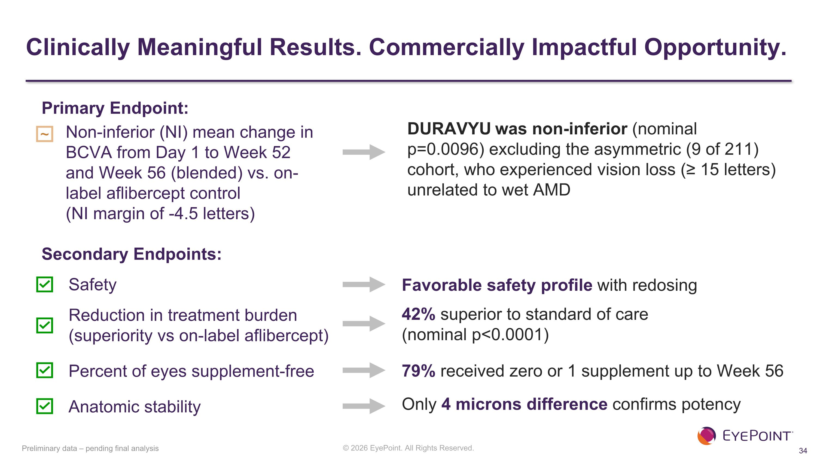
Clinically Meaningful Results. Commercially Impactful Opportunity. Secondary Endpoints: Safety Reduction in treatment burden ?(superiority vs on-label aflibercept) Percent of eyes supplement-free Anatomic stability ~ 42% superior to standard of care ?(nominal p<0.0001) 79% received zero or 1 supplement up to Week 56 Only 4 microns difference confirms potency Favorable safety profile with redosing Non-inferior (NI) mean change in BCVA from Day 1 to Week 52 and Week 56 (blended) vs. on-label aflibercept control ?(NI margin of -4.5 letters) DURAVYU was non-inferior (nominal ?p=0.0096) excluding the asymmetric (9 of 211) cohort, who experienced vision loss (≥ 15 letters) unrelated to wet AMD Primary Endpoint: Preliminary data – pending final analysis

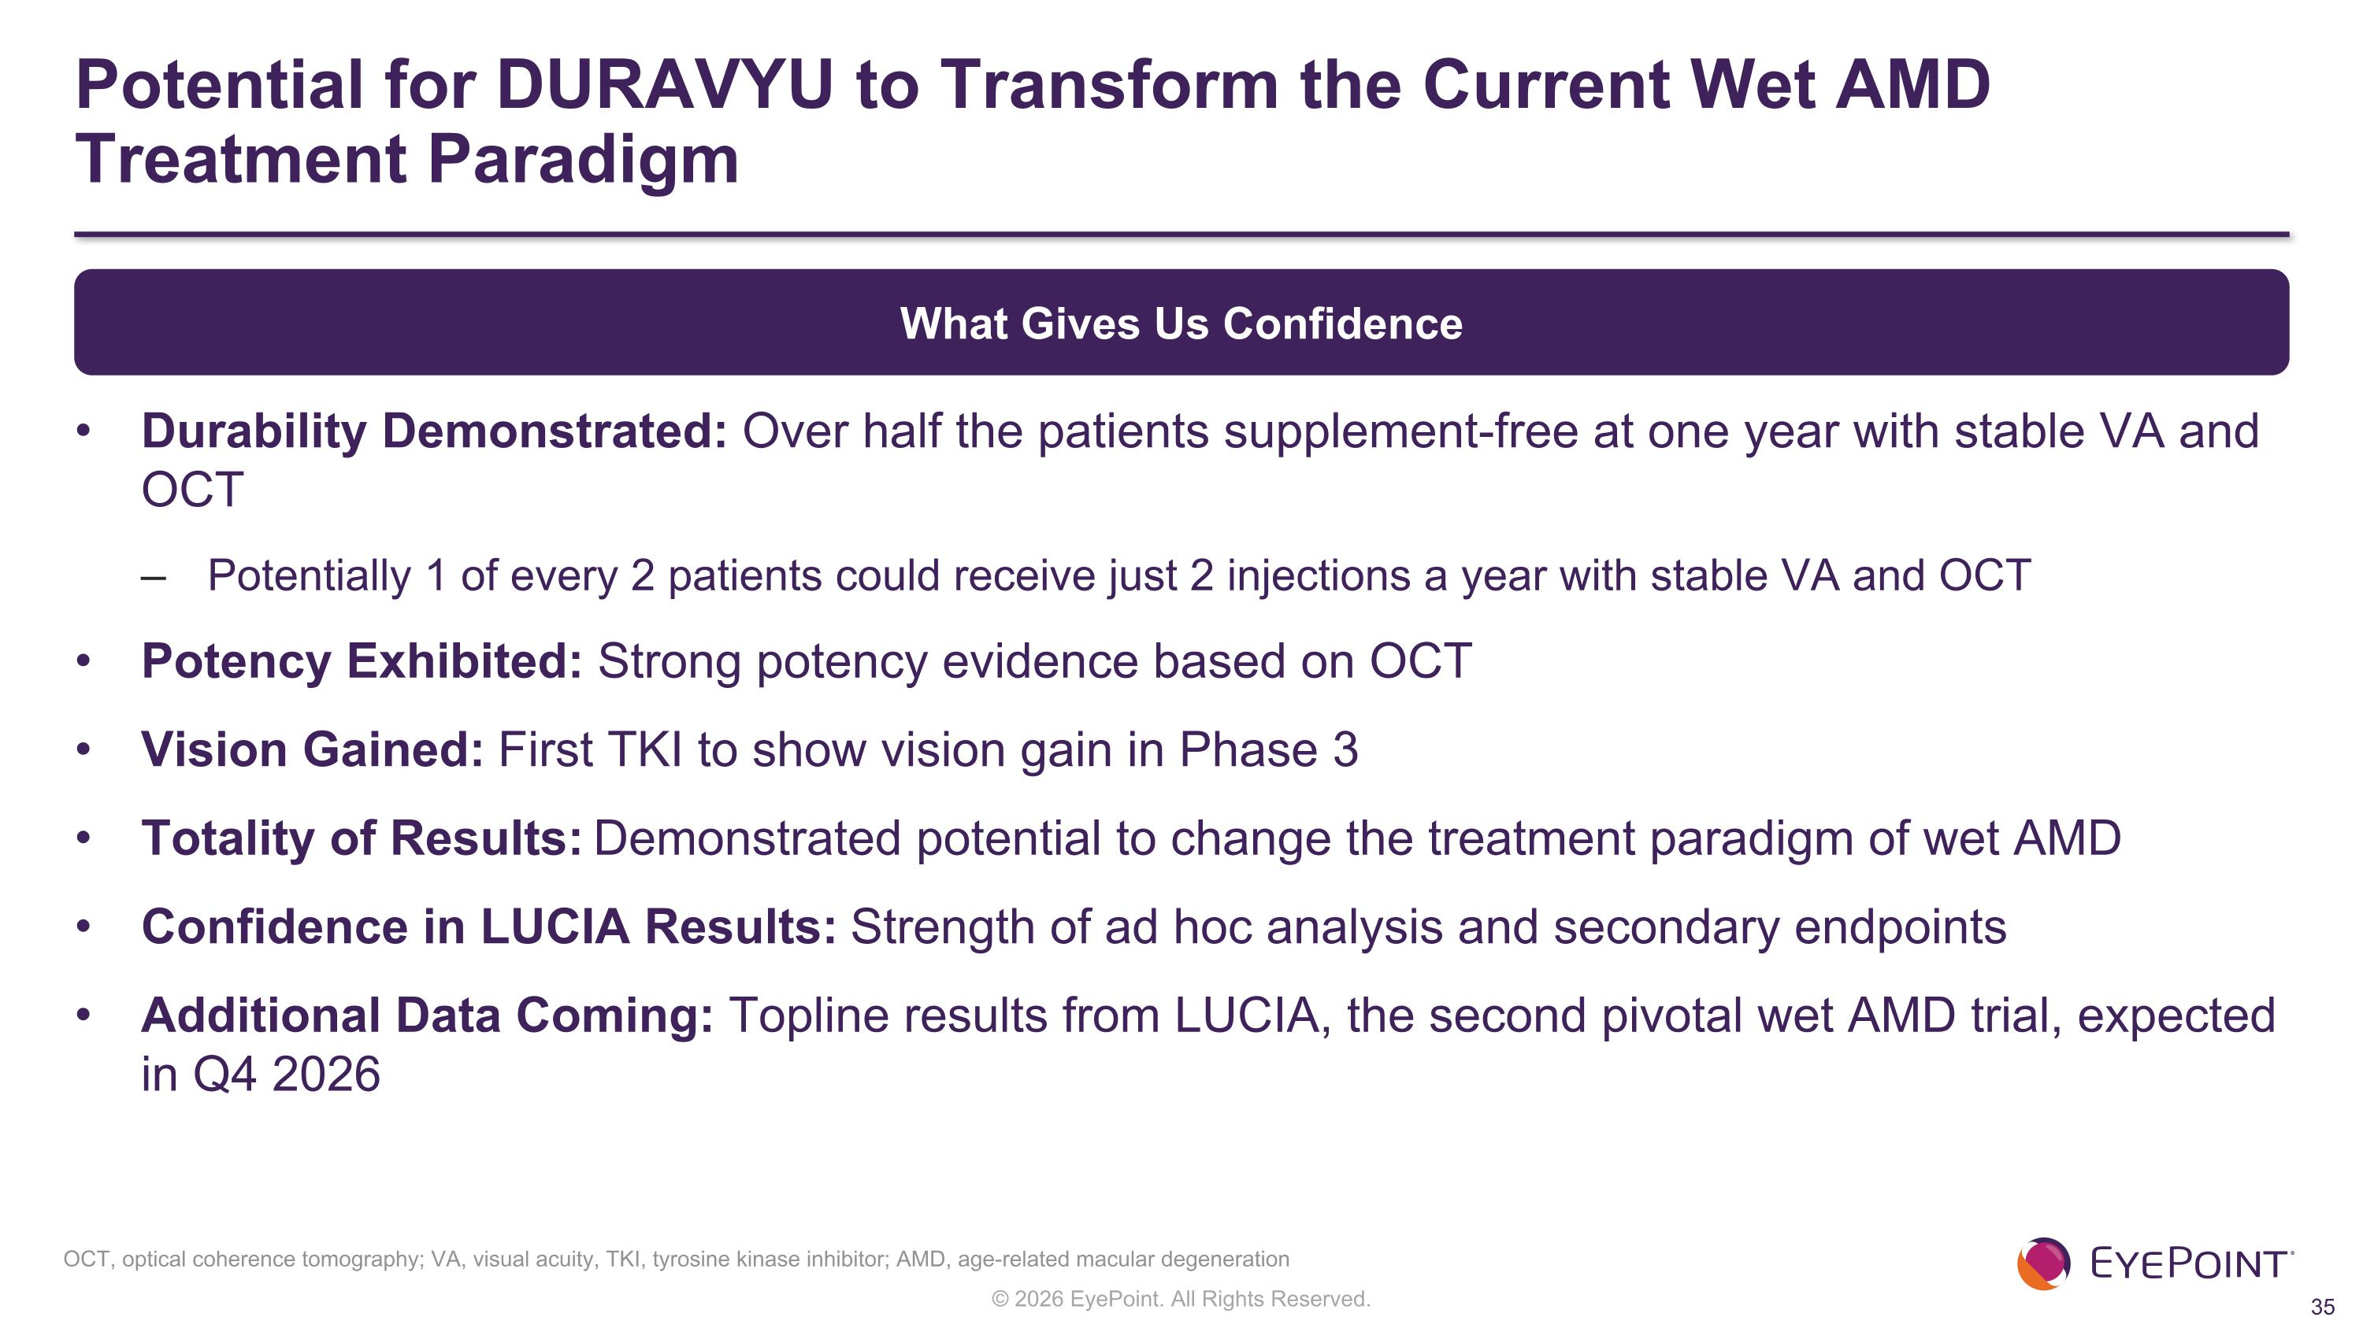
Potential for DURAVYU to Transform the Current Wet AMD Treatment Paradigm Durability Demonstrated: Over half the patients supplement-free at one year with stable VA and OCT Potentially 1 of every 2 patients could receive just 2 injections a year with stable VA and OCT Potency Exhibited: Strong potency evidence based on OCT Vision Gained: First TKI to show vision gain in Phase 3 Totality of Results: Demonstrated potential to change the treatment paradigm of wet AMD Confidence in LUCIA Results: Strength of ad hoc analysis and secondary endpoints Additional Data Coming: Topline results from LUCIA, the second pivotal wet AMD trial, expected in Q4 2026 What Gives Us Confidence OCT, optical coherence tomography; VA, visual acuity, TKI, tyrosine kinase inhibitor; AMD, age-related macular degeneration

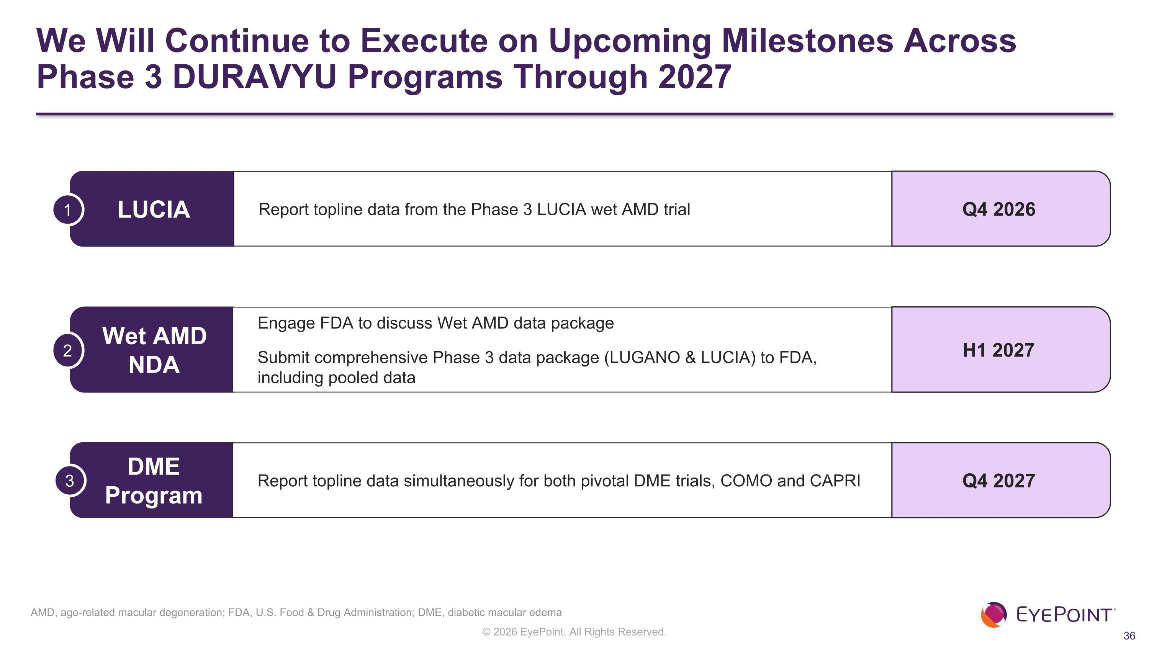
We Will Continue to Execute on Upcoming Milestones Across Phase 3 DURAVYU Programs Through 2027 LUCIA Report topline data from the Phase 3 LUCIA wet AMD trial Q4 2026 1 Wet AMD NDA Engage FDA to discuss Wet AMD data package Submit comprehensive Phase 3 data package (LUGANO & LUCIA) to FDA, including pooled data H1 2027 2 DME Program Report topline data simultaneously for both pivotal DME trials, COMO and CAPRI Q4 2027 3 AMD, age-related macular degeneration; FDA, U.S. Food & Drug Administration; DME, diabetic macular edema


Thank You

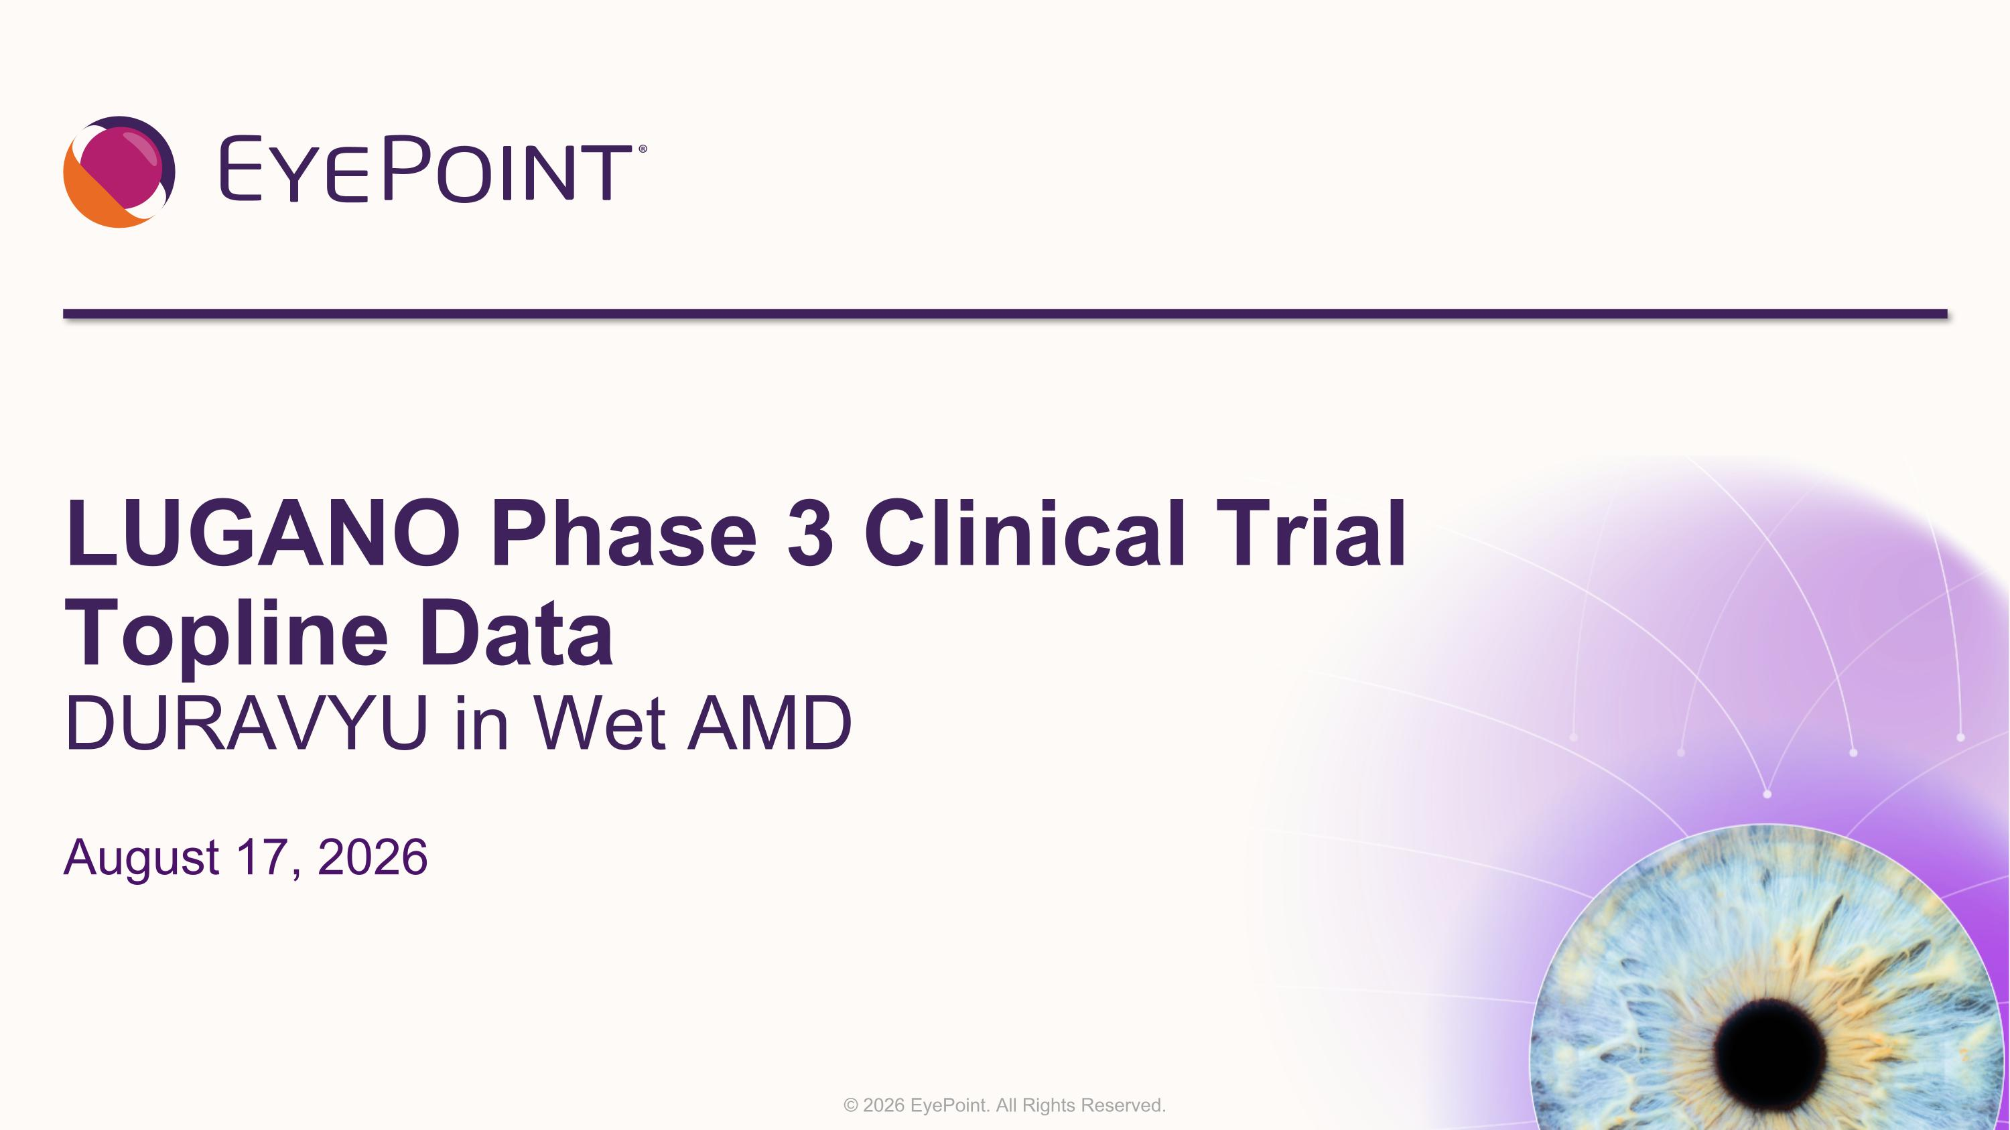
LUGANO Phase 3 Clinical Trial Topline Data DURAVYU in Wet AMD August 17, 2026

